Shipping Vegetables across Icy De Selby’s Strait

You are the manager of a fresh vegetable company in the fictional town of Brillig. You need to plan shipments to the town of Wabe, across De Selby’s Strait based on 72-hour forecasts. It takes the ship approximately 1.5 hours to cross De Selby’s Strait.

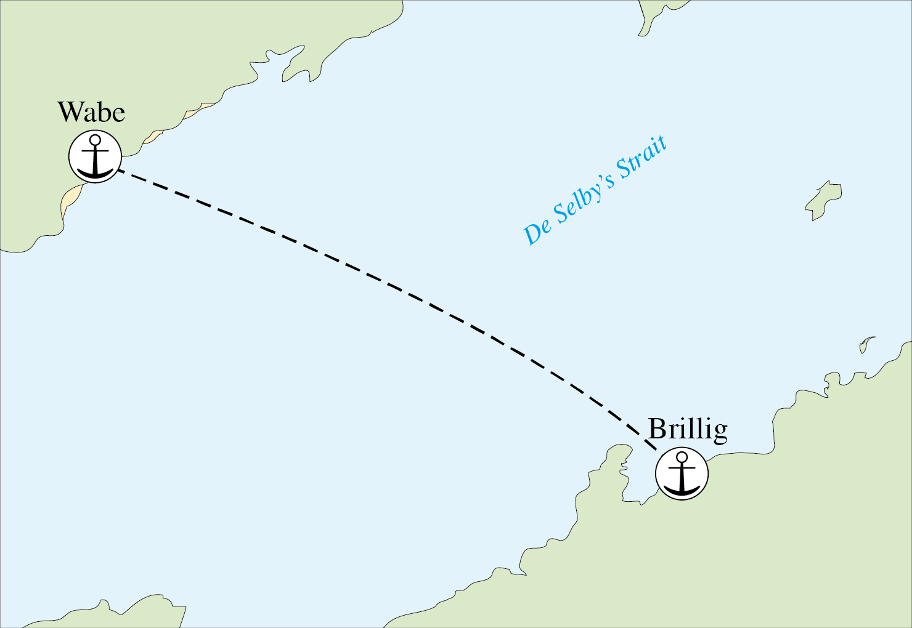

De Selby’s Strait is often completely frozen, but the thickness of the ice is uncertain. There are two ships you can use. The small ship can only crush through ice up to 1 meter thick and costs £1,000 to use for the delivery. The large ship can crush through ice up to 5 meters thick and costs £5,000 to use for the delivery. If you send the small ship, but the ice is thicker than 1 meter, the ship must turn around and your vegetables will spoil, resulting in £8,000 of losses, not including the £1,000 you paid for the small ship.

£1,000 | Cost for using small ship  (ice up to 1-meter thick)
£5,000 | Cost for using large ship  (ice up to 5-meters thick)
£8,000 | Loss for sending the small ship and the ice is greater than  1-meter thick
£0 | Loss for sending the large ship if the ice is less than or equal to  1-meter thick

You will receive a series of forecasts for ice thickness and questions pertaining to them.

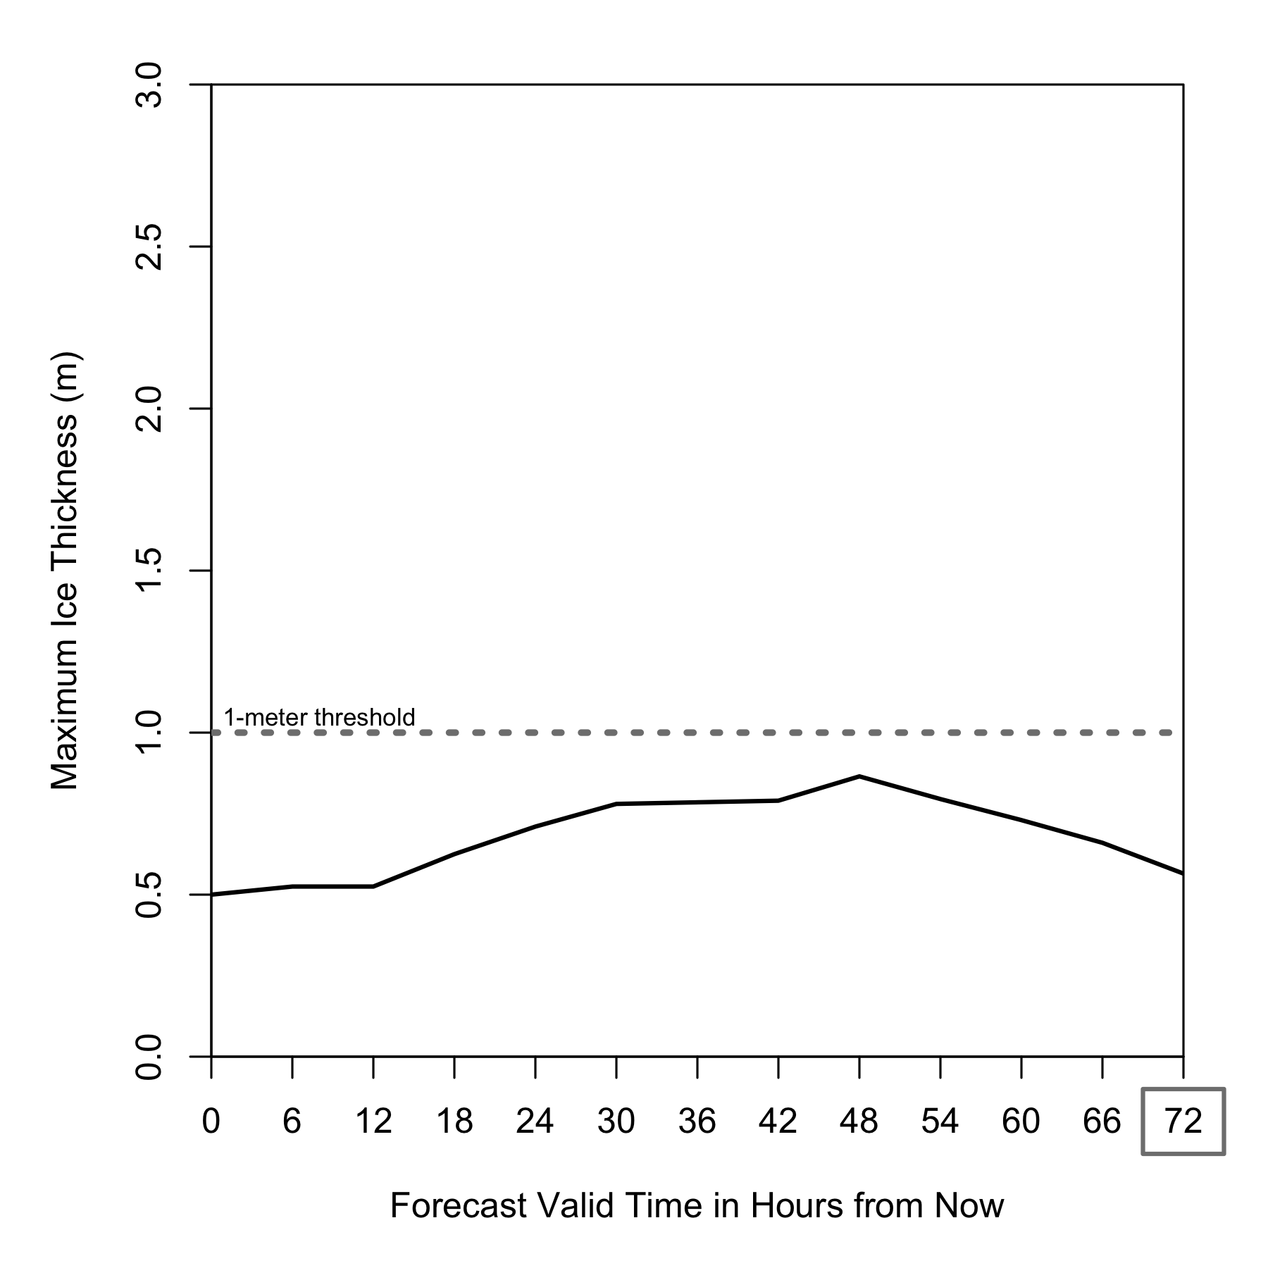
- Given the forecast above, which boat do you recommend for shipping 72 hours from now? (circle one)

Small ship Large ship

- How confident are you in your decision? (Mark on the line)
Extremely confident

Not at all confident

- What is your single value forecast for ice thickness 72 hours from now? _______ meters

- What is the thickest you predict the ice to be 72 hours from now? _______ meters

- What is the thinnest you predict the ice to be 72 hours from now? _______ meters

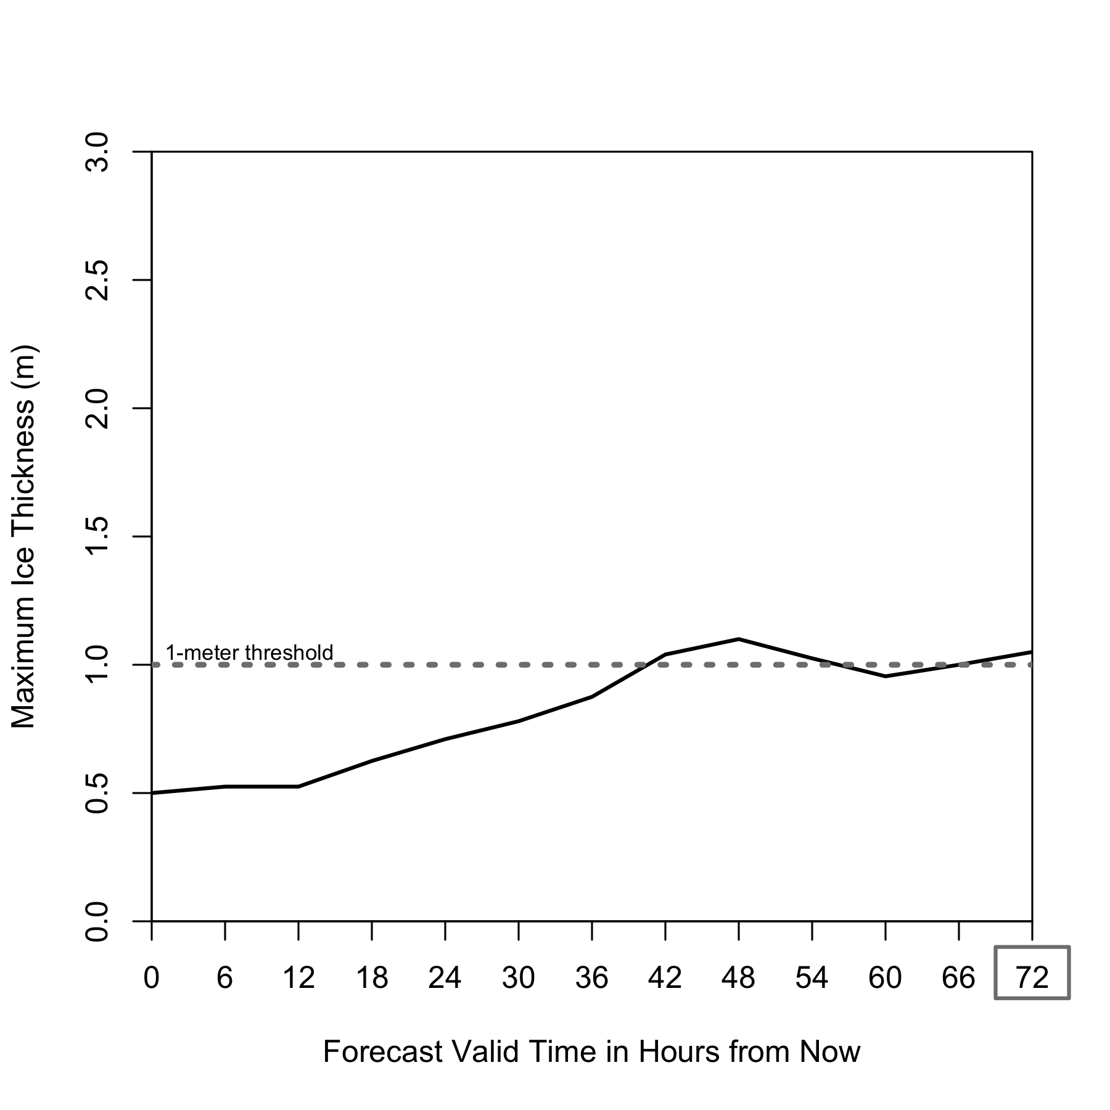

- Given the forecast above, which boat do you recommend for shipping 72 hours from now? (circle one)

Small ship Large ship

- How confident are you in your decision? (Mark on the line)
Extremely confident

Not at all confident

- What is your single value forecast for ice thickness 72 hours from now? _______ meters

- What is the thickest you predict the ice to be 72 hours from now? _______ meters

- What is the thinnest you predict the ice to be 72 hours from now? _______ meters

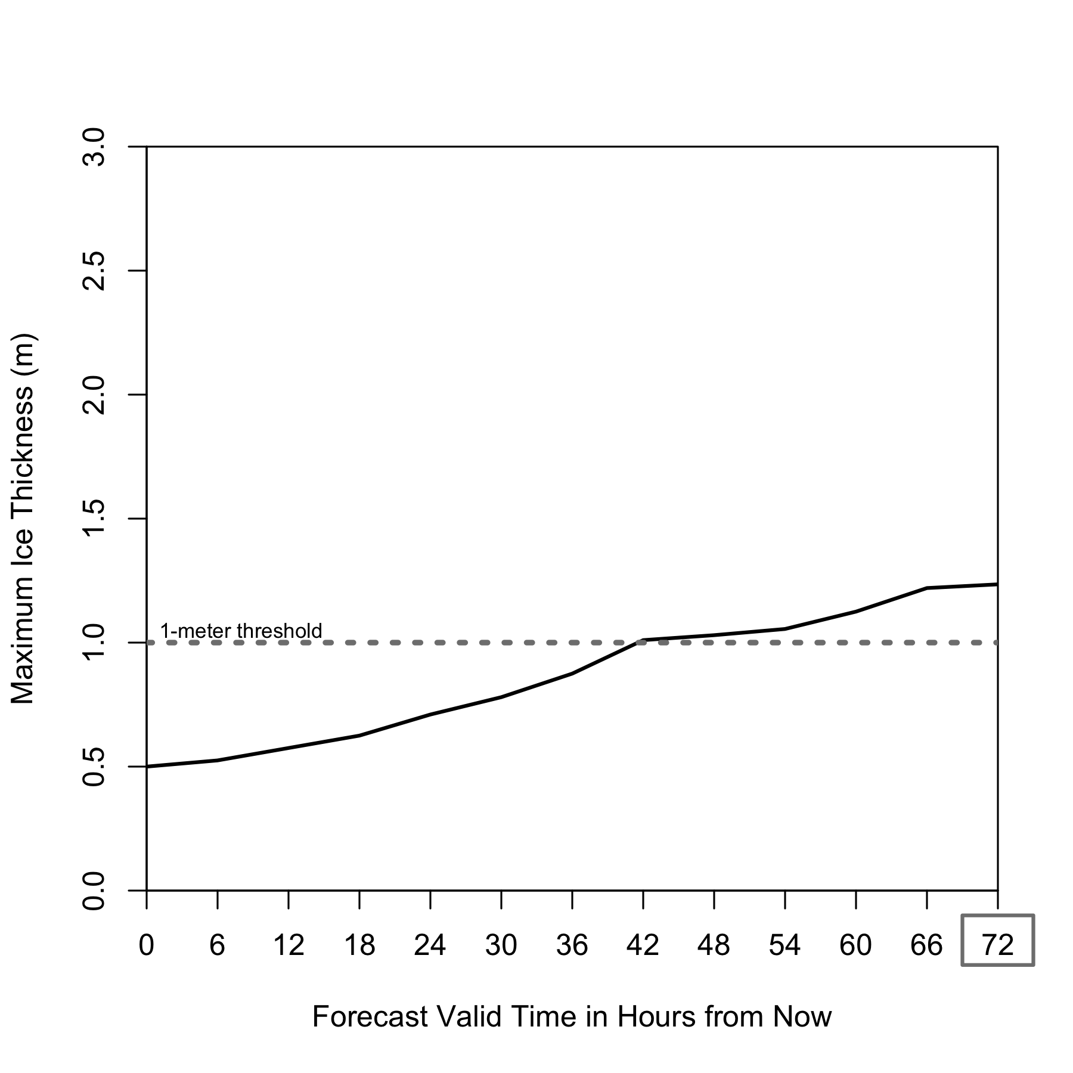
- Given the forecast above, which boat do you recommend for shipping 72 hours from now? (circle one)

Small ship Large ship

- How confident are you in your decision? (Mark on the line)
Extremely confident

Not at all confident

- What is your single value forecast for ice thickness 72 hours from now? _______ meters

- What is the thickest you predict the ice to be 72 hours from now? _______ meters

- What is the thinnest you predict the ice to be 72 hours from now? _______ meters
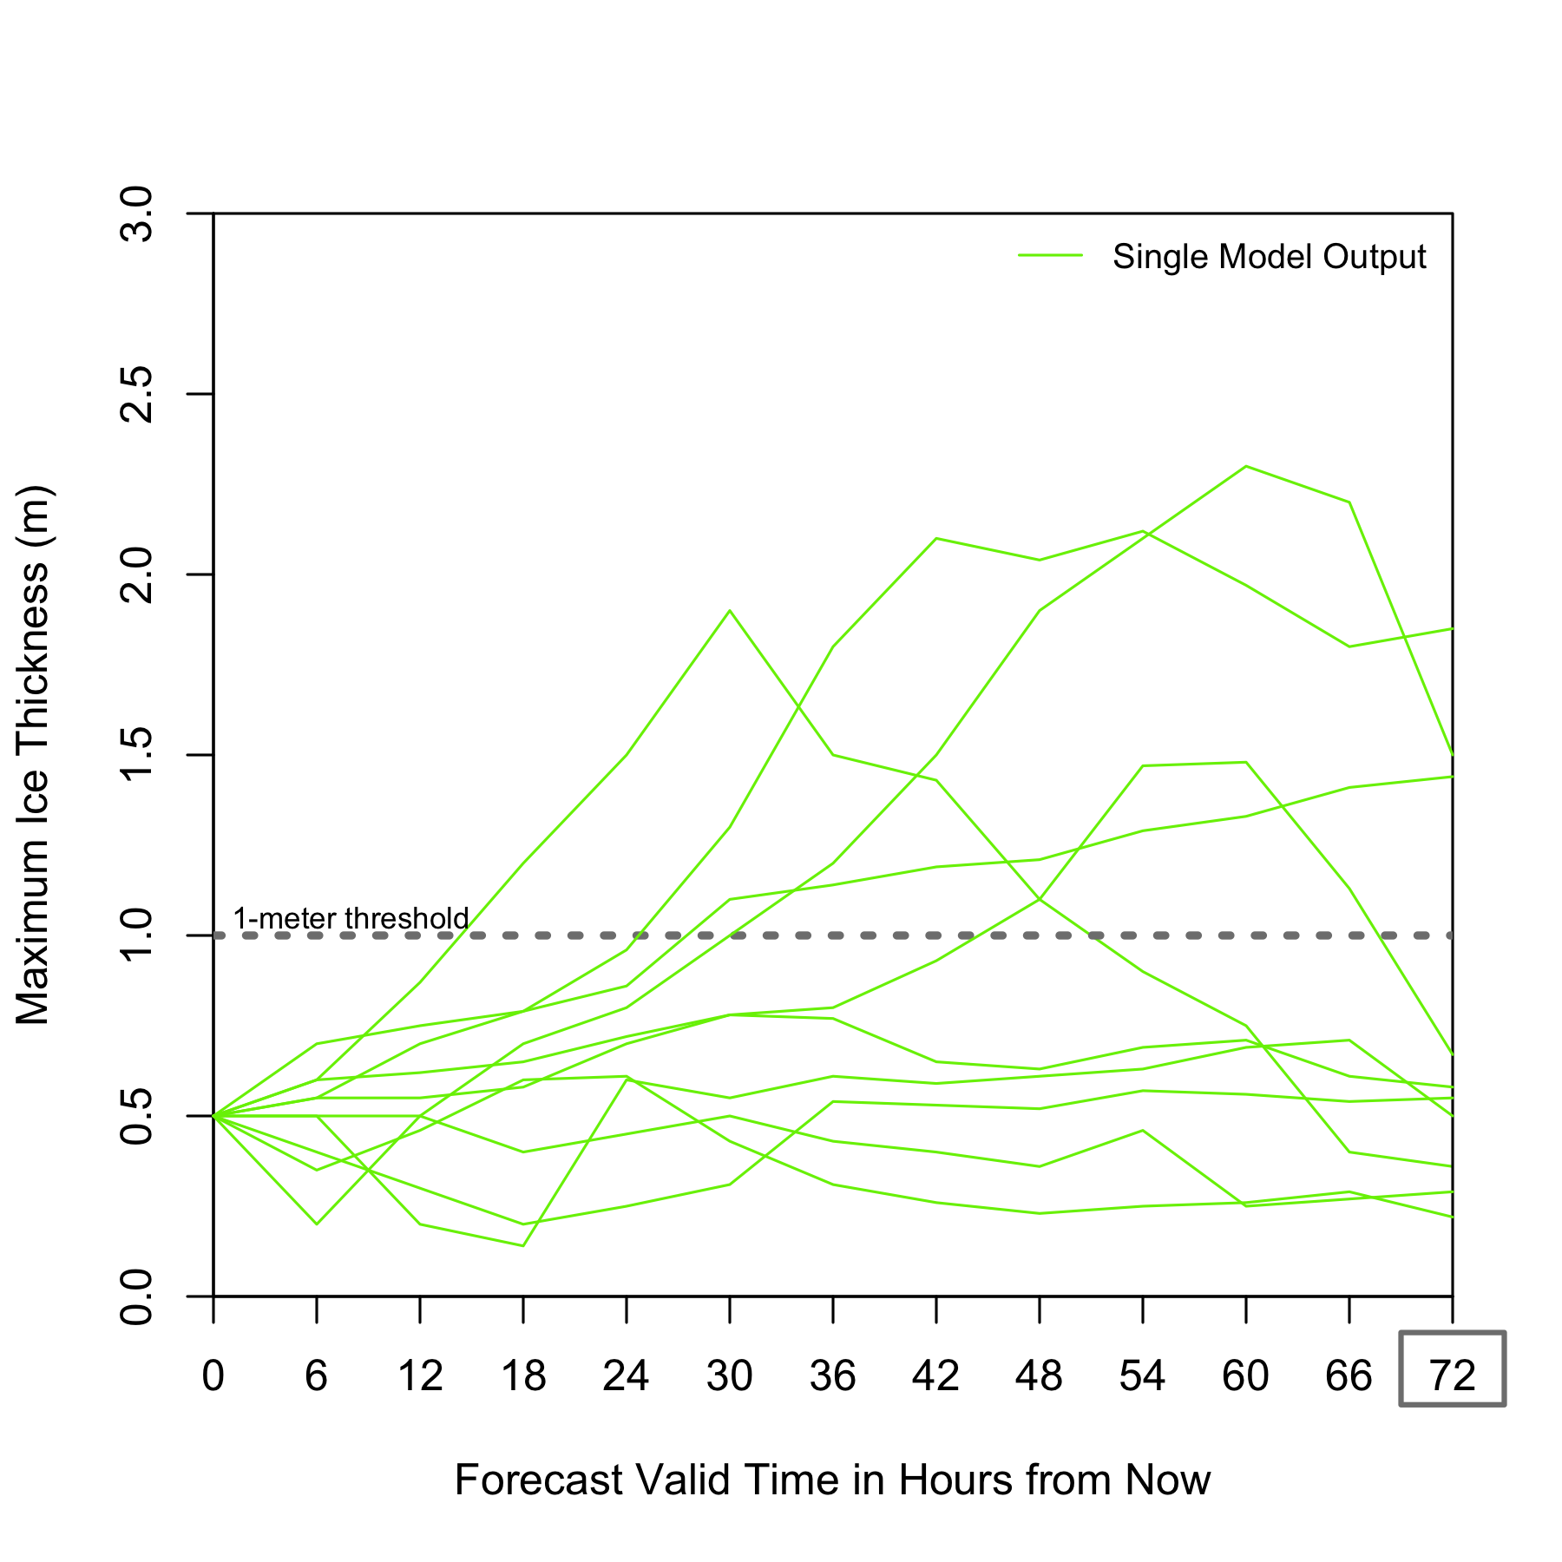
- Given the forecast above, which boat do you recommend for shipping 72 hours from now? (circle one)

Small ship Large ship

- How confident are you in your decision? (Mark on the line)
Extremely confident

Not at all confident

- What is your single value forecast for ice thickness 72 hours from now? _______ meters

- What is the thickest you predict the ice to be 72 hours from now? _______ meters

- What is the thinnest you predict the ice to be 72 hours from now? _______ meters

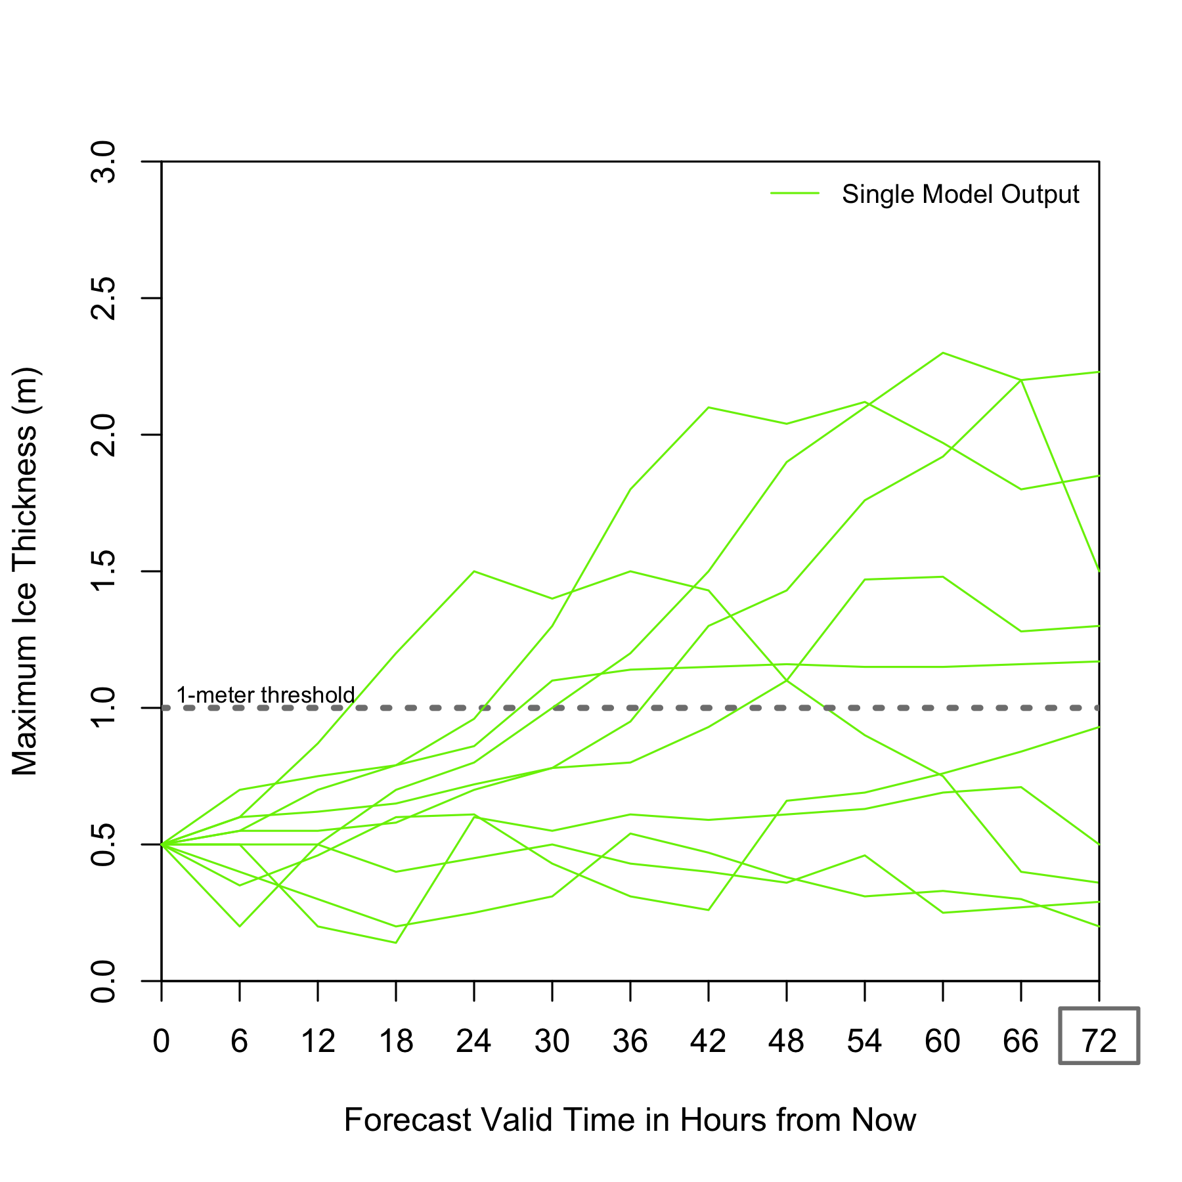

- Given the forecast above, which boat do you recommend for shipping 72 hours from now? (circle one)

Small ship Large ship

- How confident are you in your decision? (Mark on the line)
Extremely confident

Not at all confident

- What is your single value forecast for ice thickness 72 hours from now? _______ meters

- What is the thickest you predict the ice to be 72 hours from now? _______ meters

- What is the thinnest you predict the ice to be 72 hours from now? _______ meters
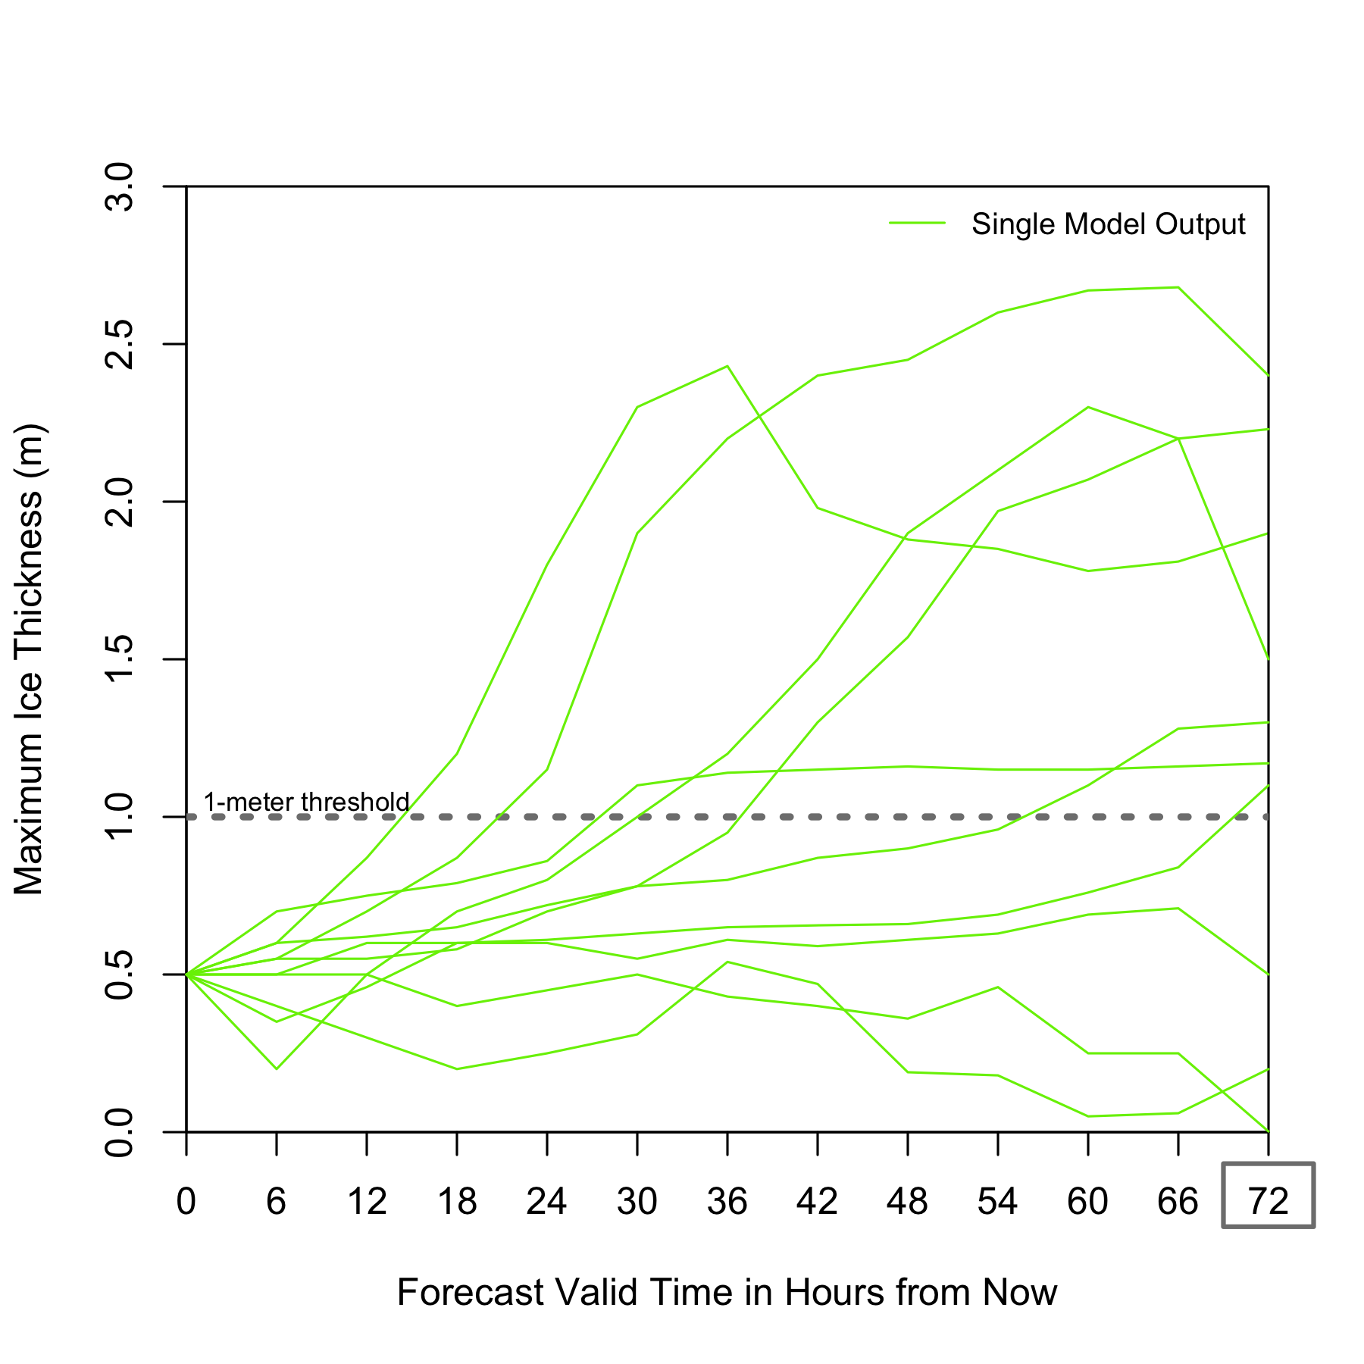

- Given the forecast above, which boat do you recommend for shipping 72 hours from now? (circle one)

Small ship Large ship

- How confident are you in your decision? (Mark on the line)
Extremely confident

Not at all confident

- What is your single value forecast for ice thickness 72 hours from now? _______ meters

- What is the thickest you predict the ice to be 72 hours from now? _______ meters

- What is the thinnest you predict the ice to be 72 hours from now? _______ meters
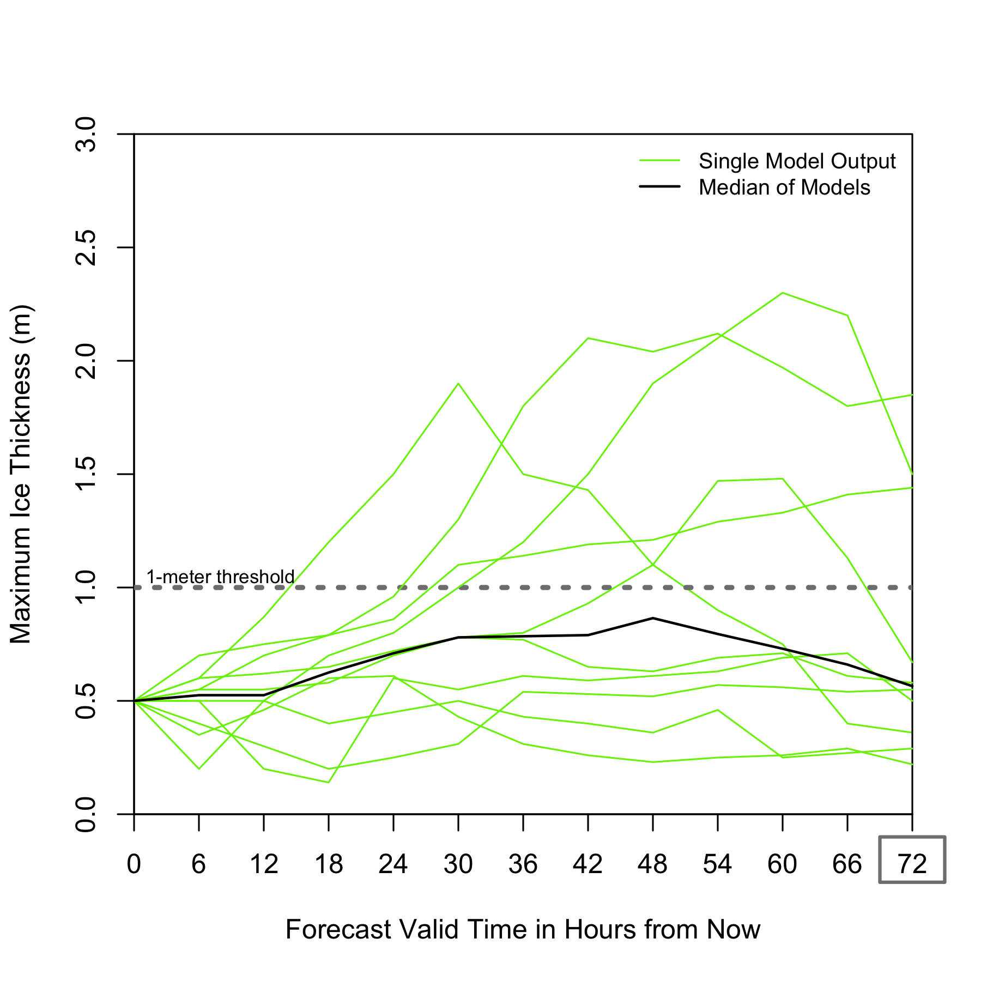
- Given the forecast above, which boat do you recommend for shipping 72 hours from now? (circle one)

Small ship Large ship

- How confident are you in your decision? (Mark on the line)
Extremely confident

Not at all confident

- What is your single value forecast for ice thickness 72 hours from now? _______ meters

- What is the thickest you predict the ice to be 72 hours from now? _______ meters

- What is the thinnest you predict the ice to be 72 hours from now? _______ meters
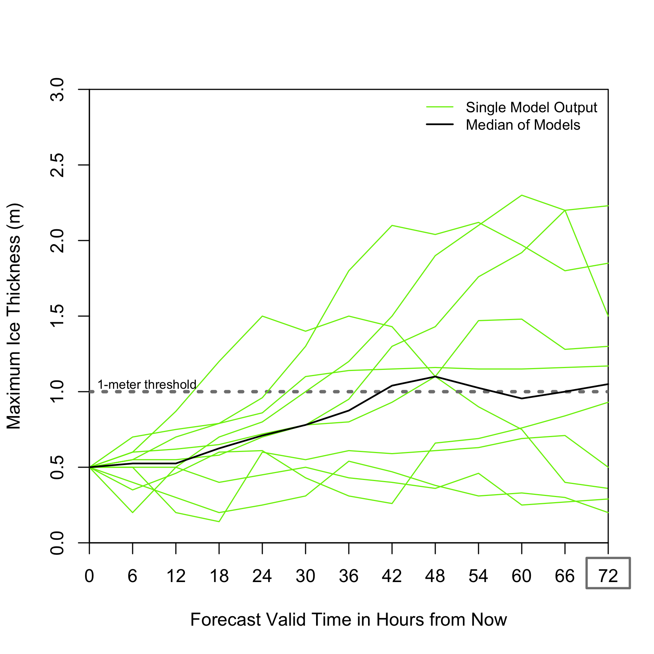
- Given the forecast above, which boat do you recommend for shipping 72 hours from now? (circle one)

Small ship Large ship

- How confident are you in your decision? (Mark on the line)
Extremely confident

Not at all confident

- What is your single value forecast for ice thickness 72 hours from now? _______ meters

- What is the thickest you predict the ice to be 72 hours from now? _______ meters

- What is the thinnest you predict the ice to be 72 hours from now? _______ meters
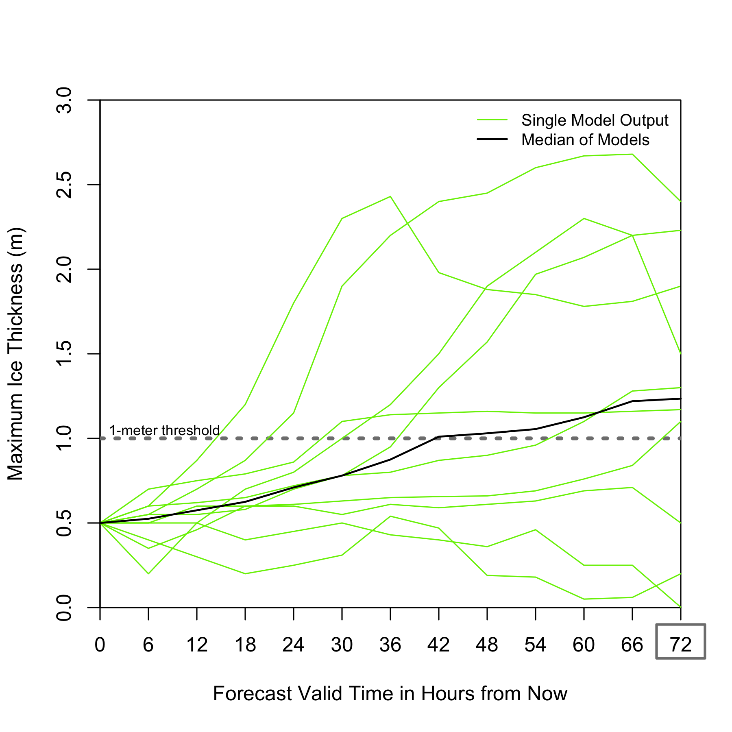
- Given the forecast above, which boat do you recommend for shipping 72 hours from now? (circle one)

Small ship Large ship

- How confident are you in your decision? (Mark on the line)
Extremely confident

Not at all confident

- What is your single value forecast for ice thickness 72 hours from now? _______ meters

- What is the thickest you predict the ice to be 72 hours from now? _______ meters

- What is the thinnest you predict the ice to be 72 hours from now? _______ meters
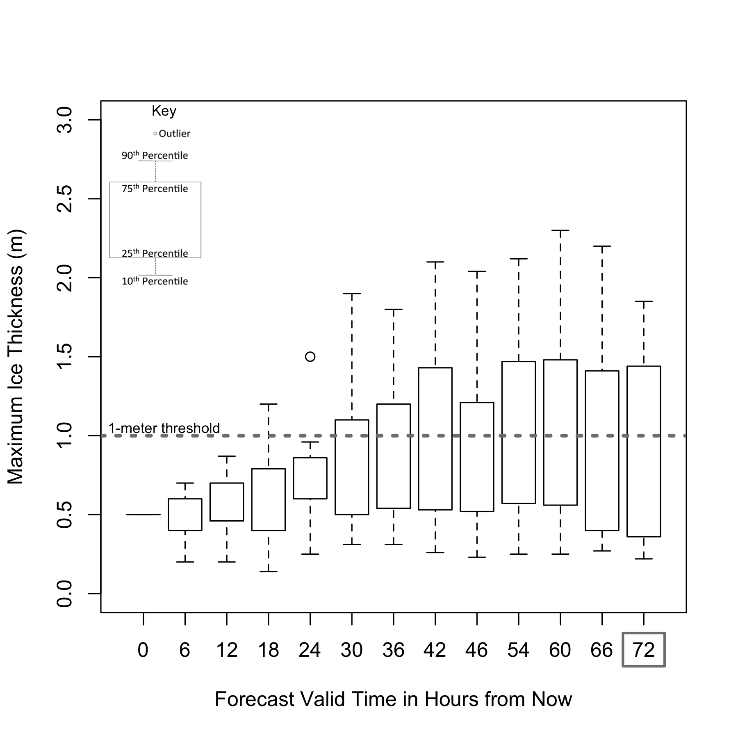

- Given the forecast above, which boat do you recommend for shipping 72 hours from now? (circle one)

Small ship Large ship

- How confident are you in your decision? (Mark on the line)
Extremely confident

Not at all confident

- What is your single value forecast for ice thickness 72 hours from now? _______ meters

- What is the thickest you predict the ice to be 72 hours from now? _______ meters

- What is the thinnest you predict the ice to be 72 hours from now? _______ meters
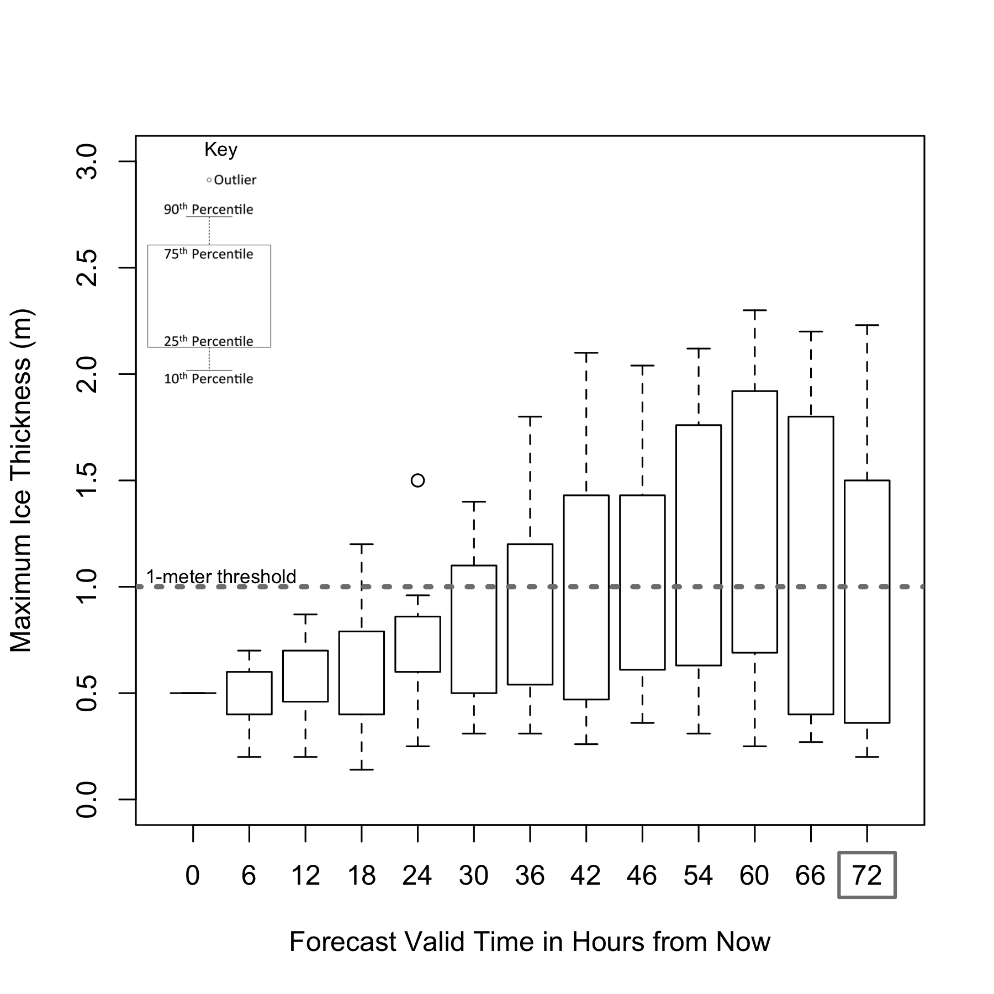

- Given the forecast above, which boat do you recommend for shipping 72 hours from now? (circle one)

Small ship Large ship

- How confident are you in your decision? (Mark on the line)
Extremely confident

Not at all confident

- What is your single value forecast for ice thickness 72 hours from now? _______ meters

- What is the thickest you predict the ice to be 72 hours from now? _______ meters

- What is the thinnest you predict the ice to be 72 hours from now? _______ meters
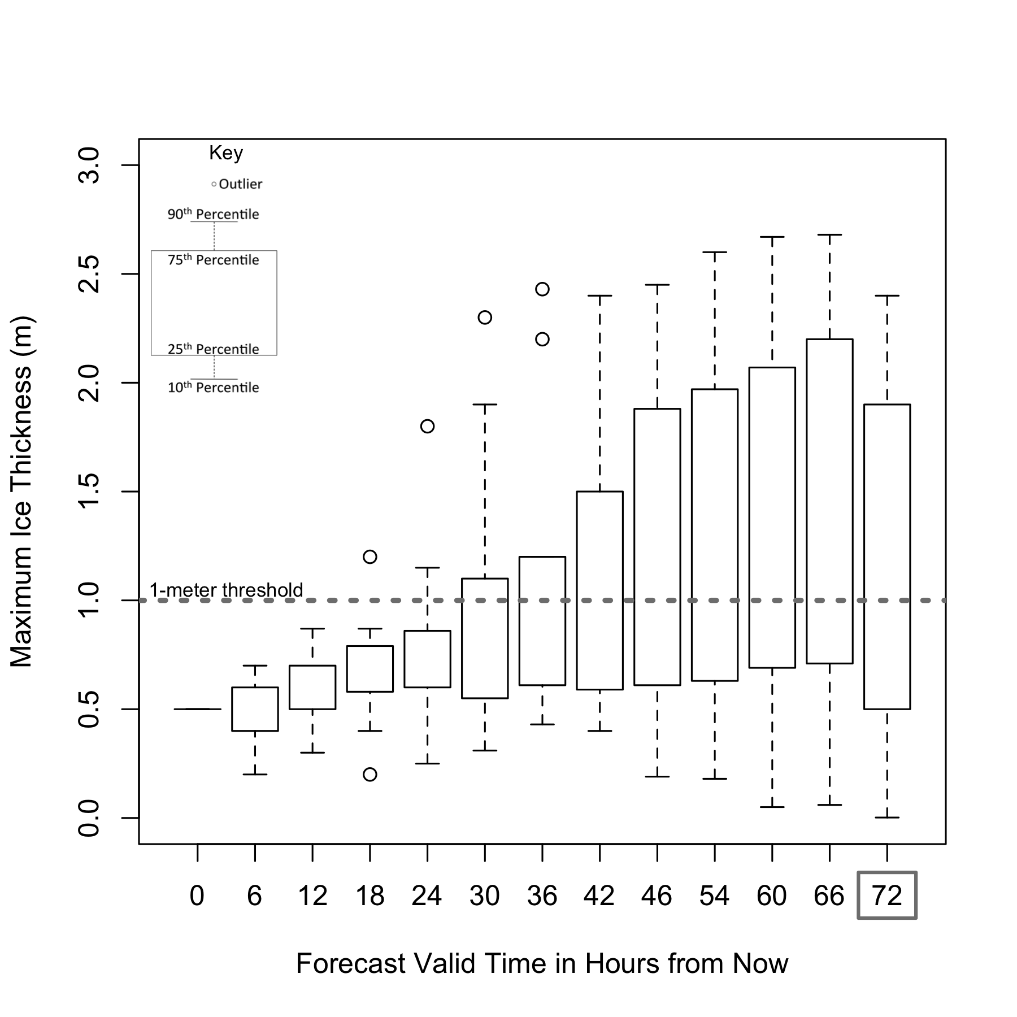

- Given the forecast above, which boat do you recommend for shipping 72 hours from now? (circle one)

Small ship Large ship

- How confident are you in your decision? (Mark on the line)
Extremely confident

Not at all confident

- What is your single value forecast for ice thickness 72 hours from now? _______ meters

- What is the thickest you predict the ice to be 72 hours from now? _______ meters

- What is the thinnest you predict the ice to be 72 hours from now? _______ meters
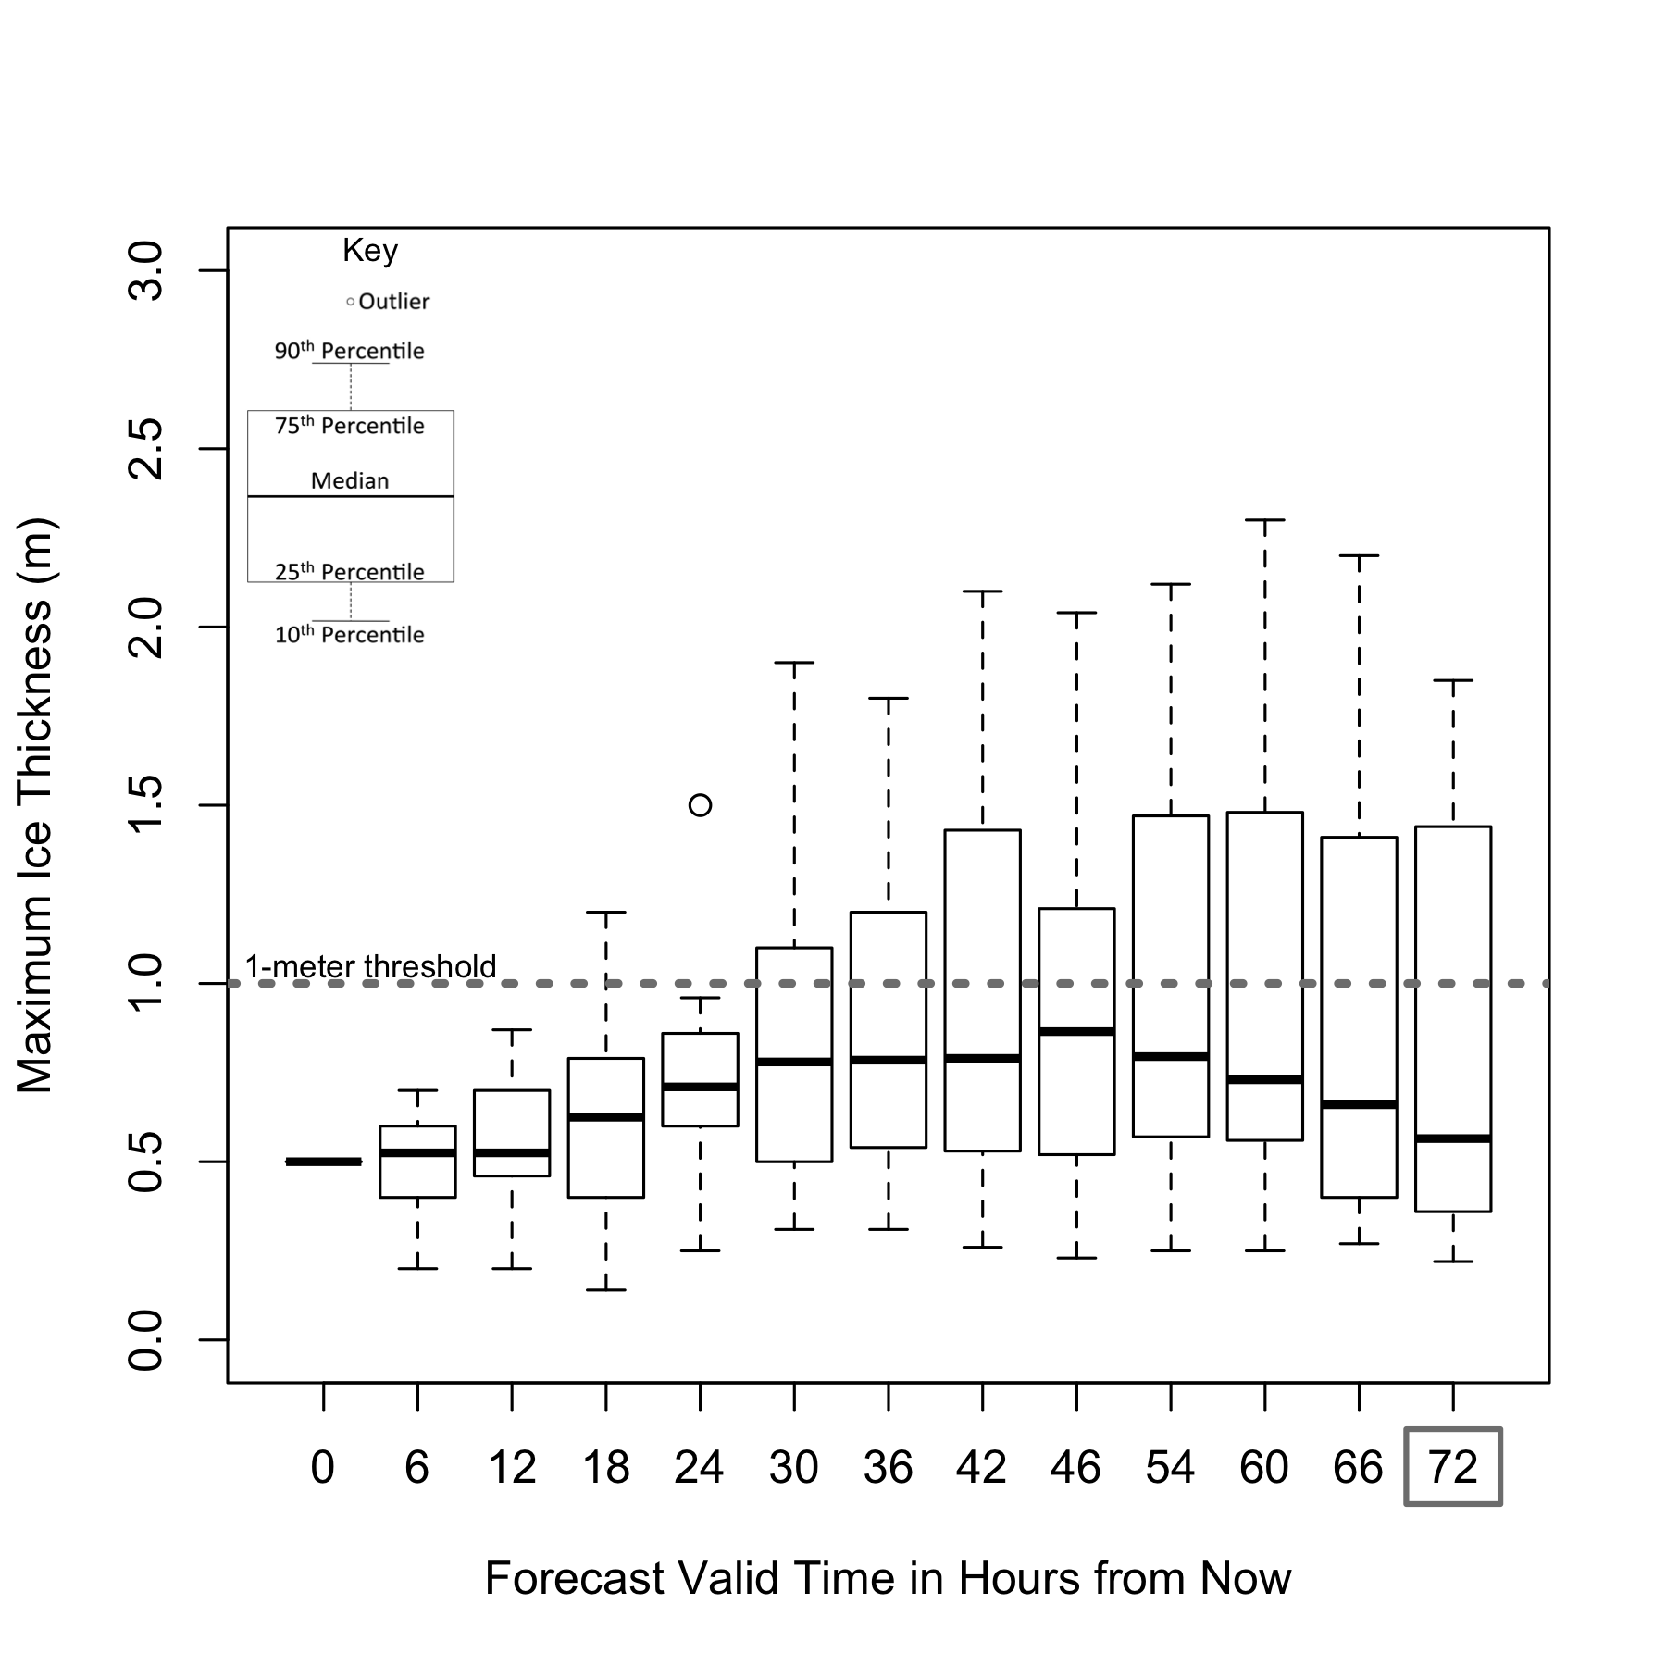
- Given the forecast above, which boat do you recommend for shipping 72 hours from now? (circle one)

Small ship Large ship

- How confident are you in your decision? (Mark on the line)
Extremely confident

Not at all confident

- What is your single value forecast for ice thickness 72 hours from now? _______ meters

- What is the thickest you predict the ice to be 72 hours from now? _______ meters

- What is the thinnest you predict the ice to be 72 hours from now? _______ meters
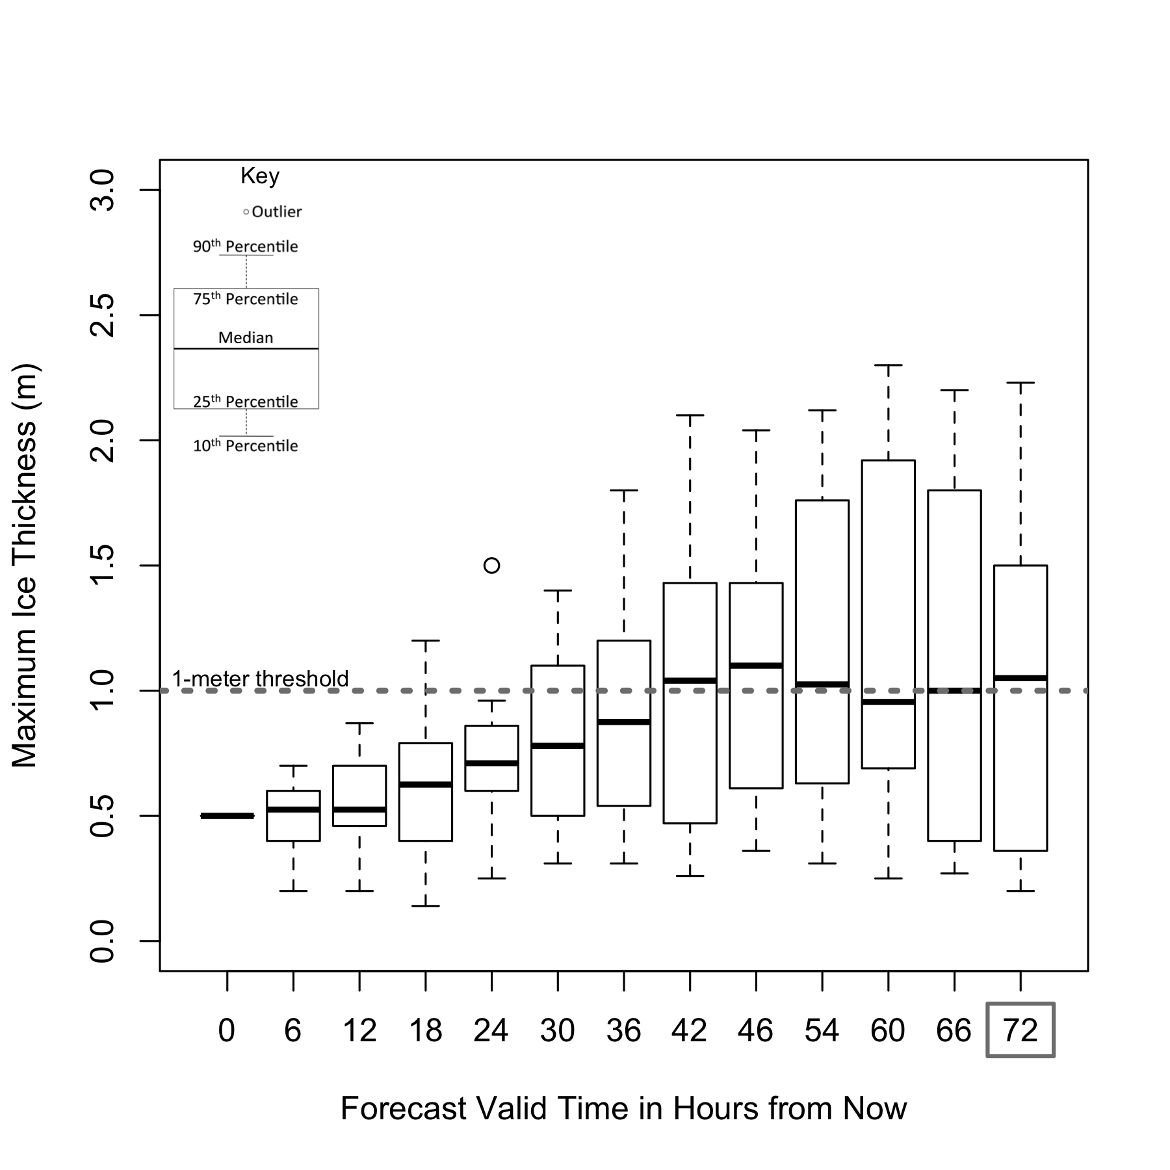
- Given the forecast above, which boat do you recommend for shipping 72 hours from now? (circle one)

Small ship Large ship

- How confident are you in your decision? (Mark on the line)
Extremely confident

Not at all confident

- What is your single value forecast for ice thickness 72 hours from now? _______ meters

- What is the thickest you predict the ice to be 72 hours from now? _______ meters

- What is the thinnest you predict the ice to be 72 hours from now? _______ meters
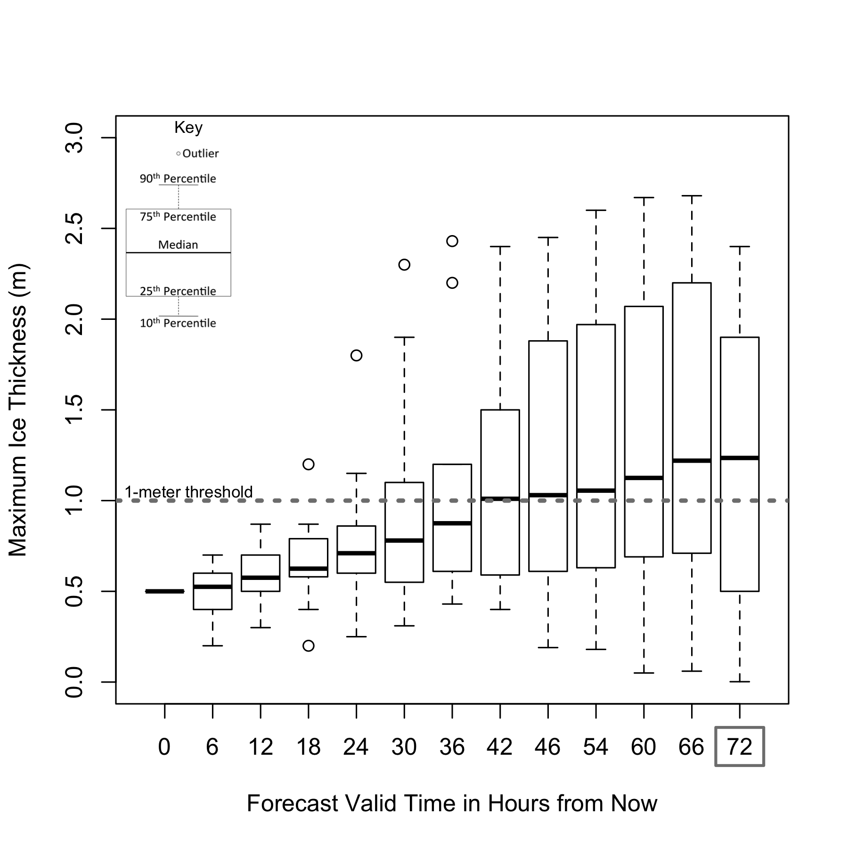
- Given the forecast above, which boat do you recommend for shipping 72 hours from now? (circle one)

Small ship Large ship

- How confident are you in your decision? (Mark on the line)
Extremely confident

Not at all confident

- What is your single value forecast for ice thickness 72 hours from now? _______ meters

- What is the thickest you predict the ice to be 72 hours from now? _______ meters

- What is the thinnest you predict the ice to be 72 hours from now? _______ meters
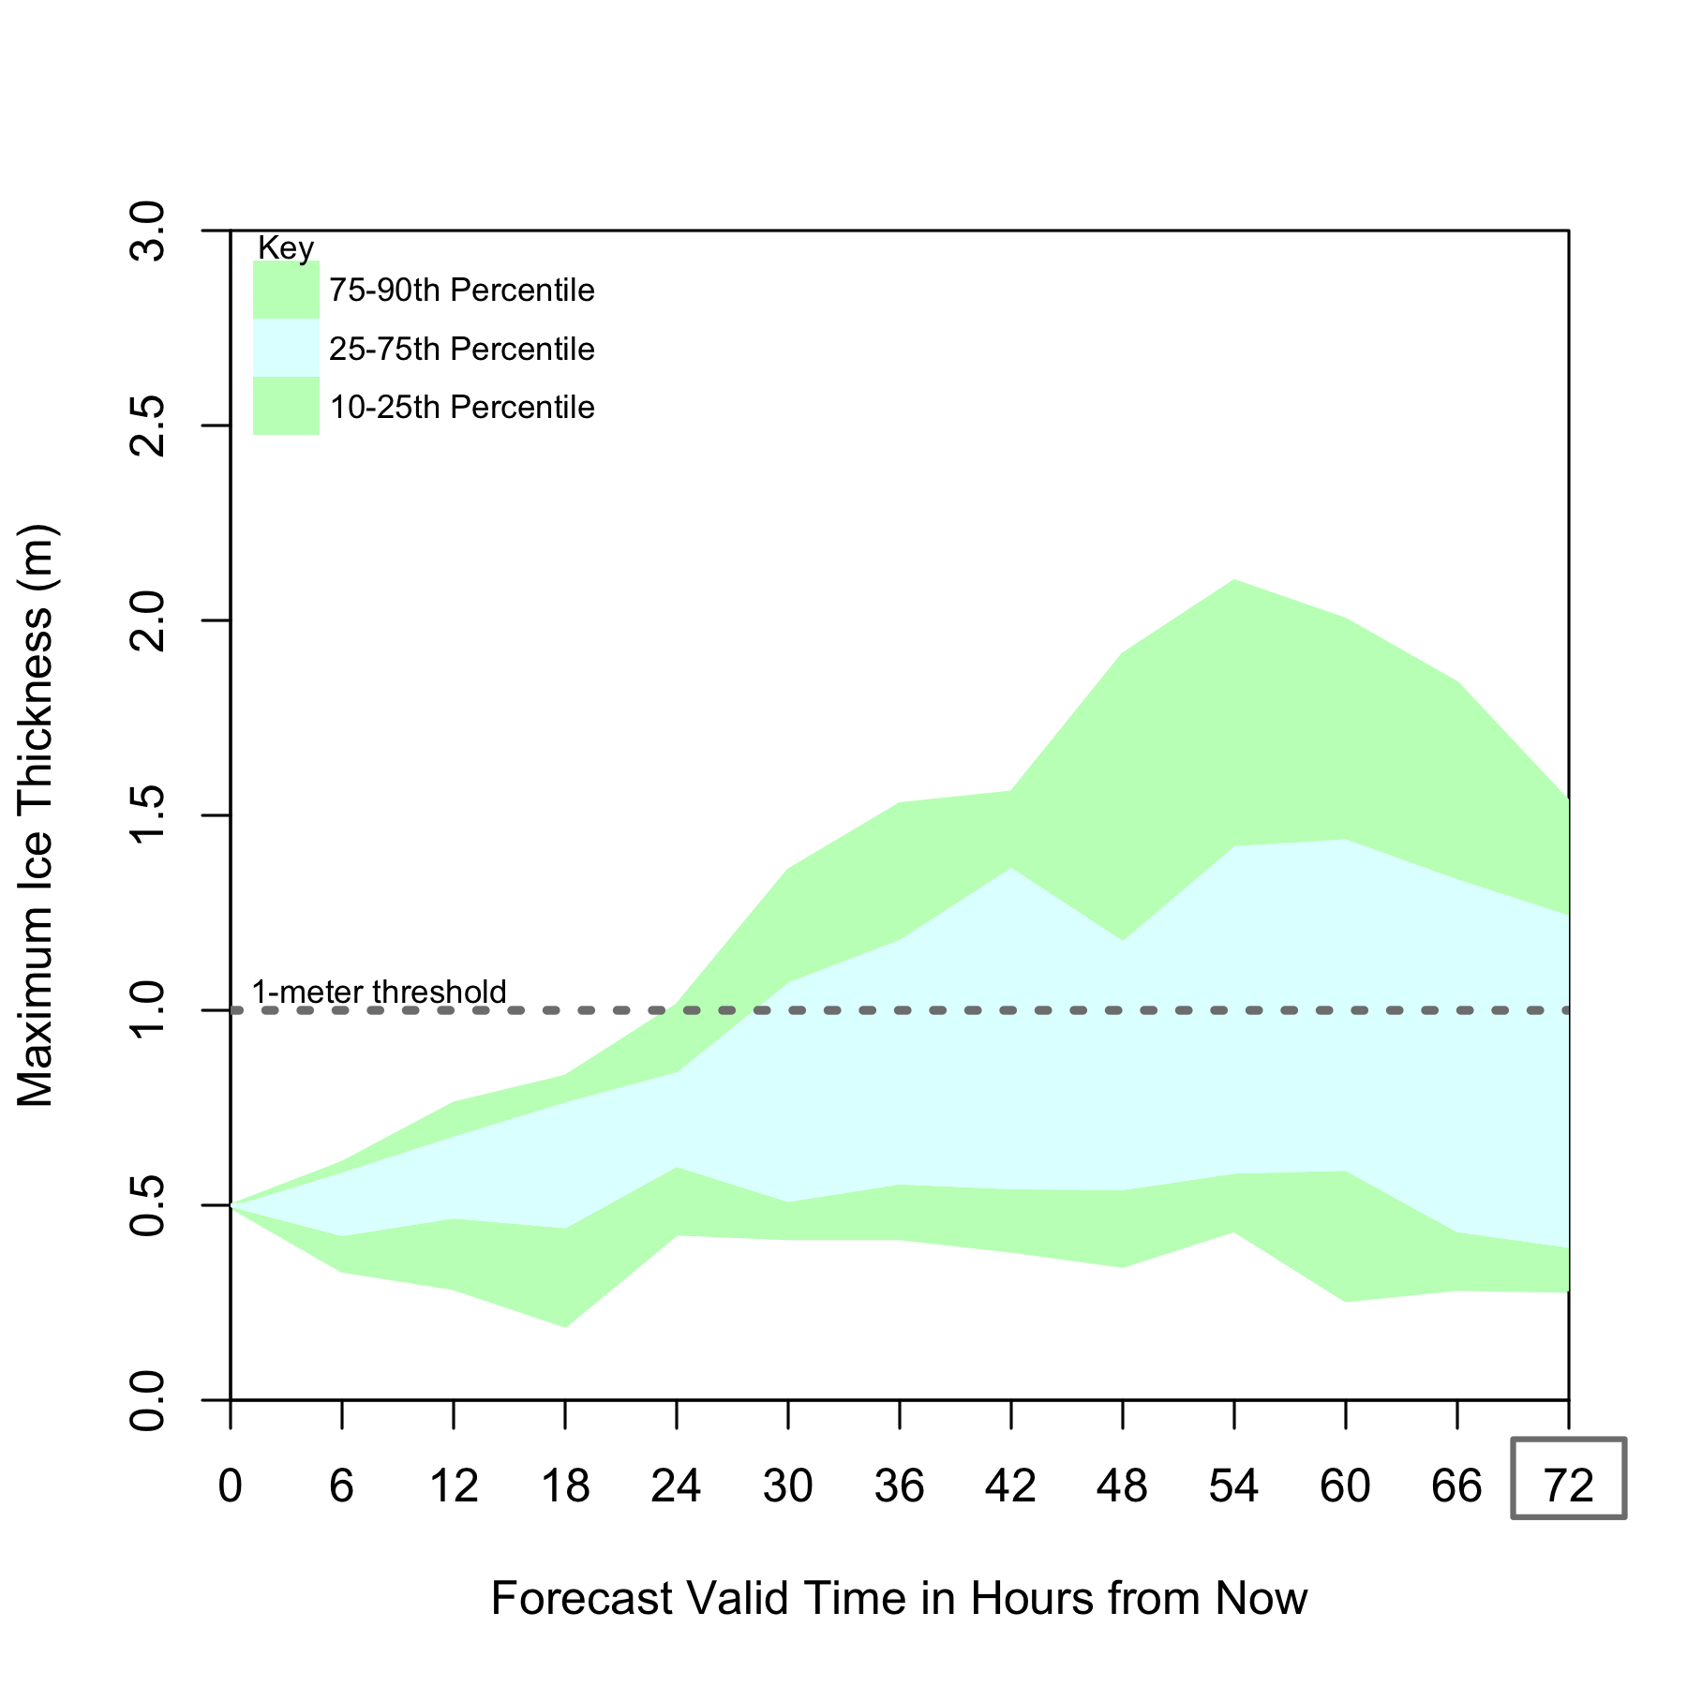
- Given the forecast above, which boat do you recommend for shipping 72 hours from now? (circle one)

Small ship Large ship

- How confident are you in your decision? (Mark on the line)
Extremely confident

Not at all confident

- What is your single value forecast for ice thickness 72 hours from now? _______ meters

- What is the thickest you predict the ice to be 72 hours from now? _______ meters

- What is the thinnest you predict the ice to be 72 hours from now? _______ meters
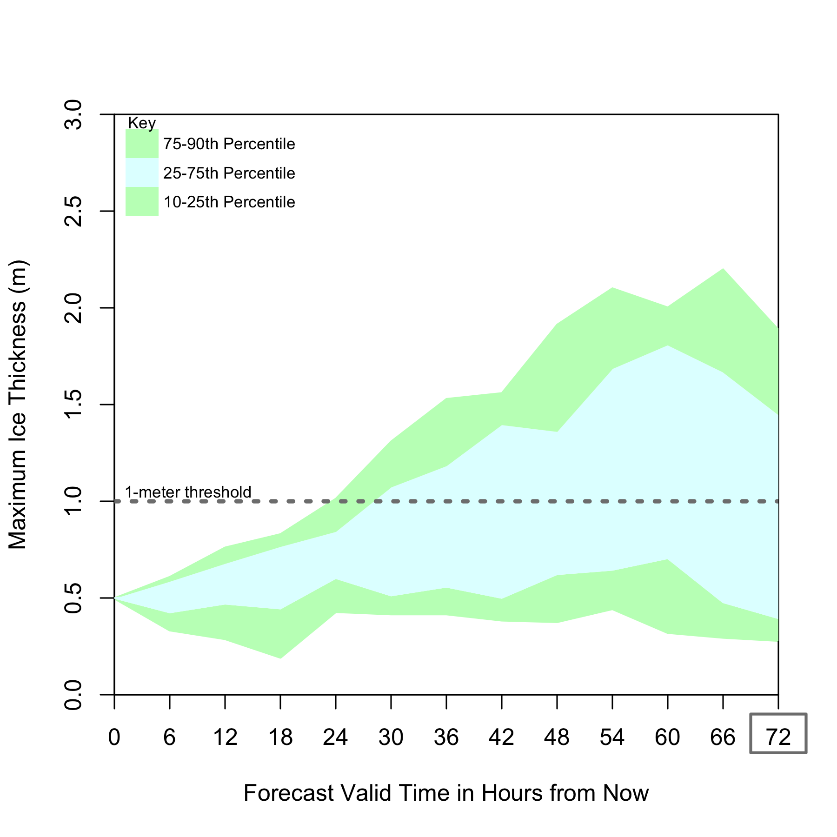
- Given the forecast above, which boat do you recommend for shipping 72 hours from now? (circle one)

Small ship Large ship

- How confident are you in your decision? (Mark on the line)
Extremely confident

Not at all confident

- What is your single value forecast for ice thickness 72 hours from now? _______ meters

- What is the thickest you predict the ice to be 72 hours from now? _______ meters

- What is the thinnest you predict the ice to be 72 hours from now? _______ meters
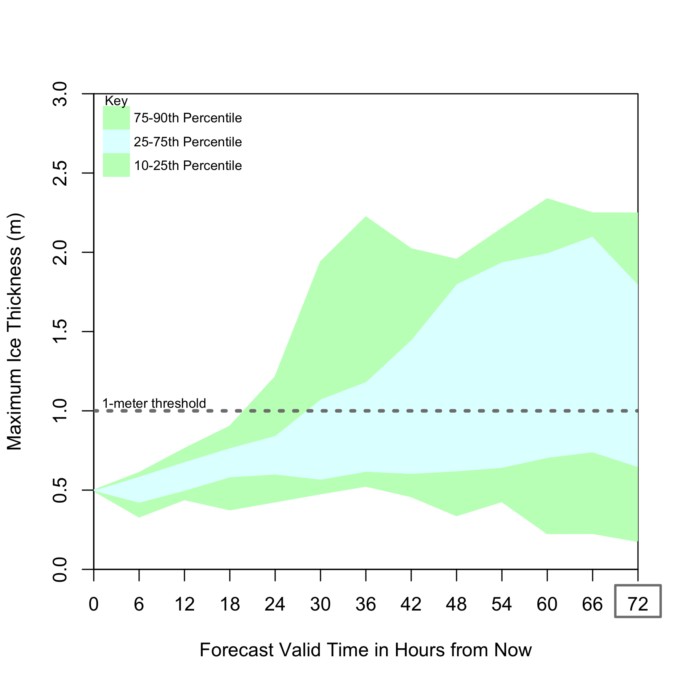
- Given the forecast above, which boat do you recommend for shipping 72 hours from now? (circle one)

Small ship Large ship

- How confident are you in your decision? (Mark on the line)
Extremely confident

Not at all confident

- What is your single value forecast for ice thickness 72 hours from now? _______ meters

- What is the thickest you predict the ice to be 72 hours from now? _______ meters

- What is the thinnest you predict the ice to be 72 hours from now? _______ meters
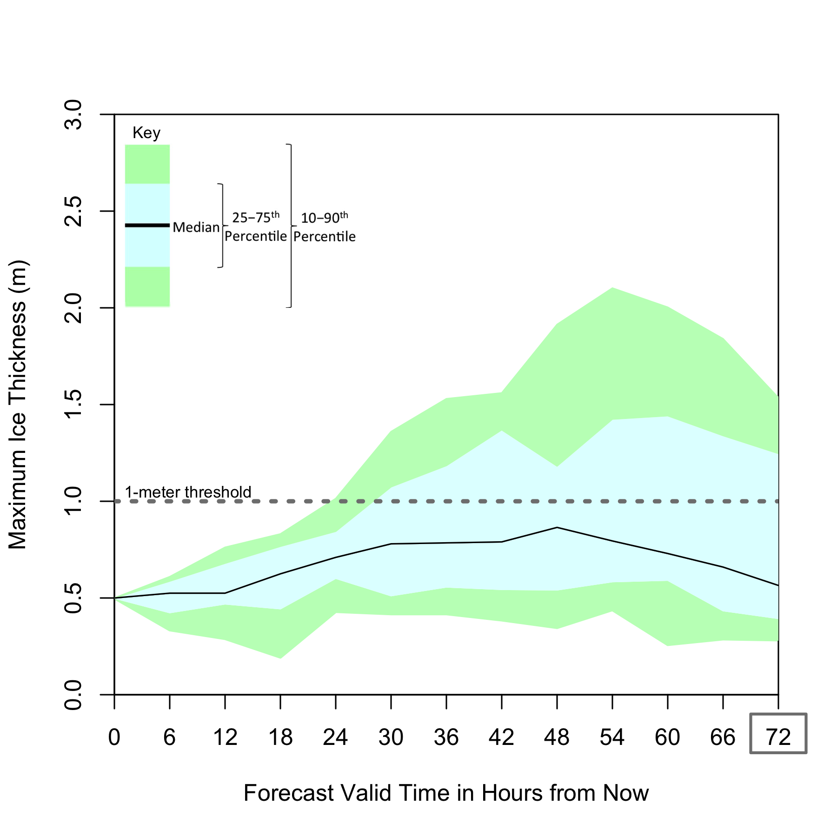
- Given the forecast above, which boat do you recommend for shipping 72 hours from now? (circle one)

Small ship Large ship

- How confident are you in your decision? (Mark on the line)
Extremely confident

Not at all confident

- What is your single value forecast for ice thickness 72 hours from now? _______ meters

- What is the thickest you predict the ice to be 72 hours from now? _______ meters

- What is the thinnest you predict the ice to be 72 hours from now? _______ meters
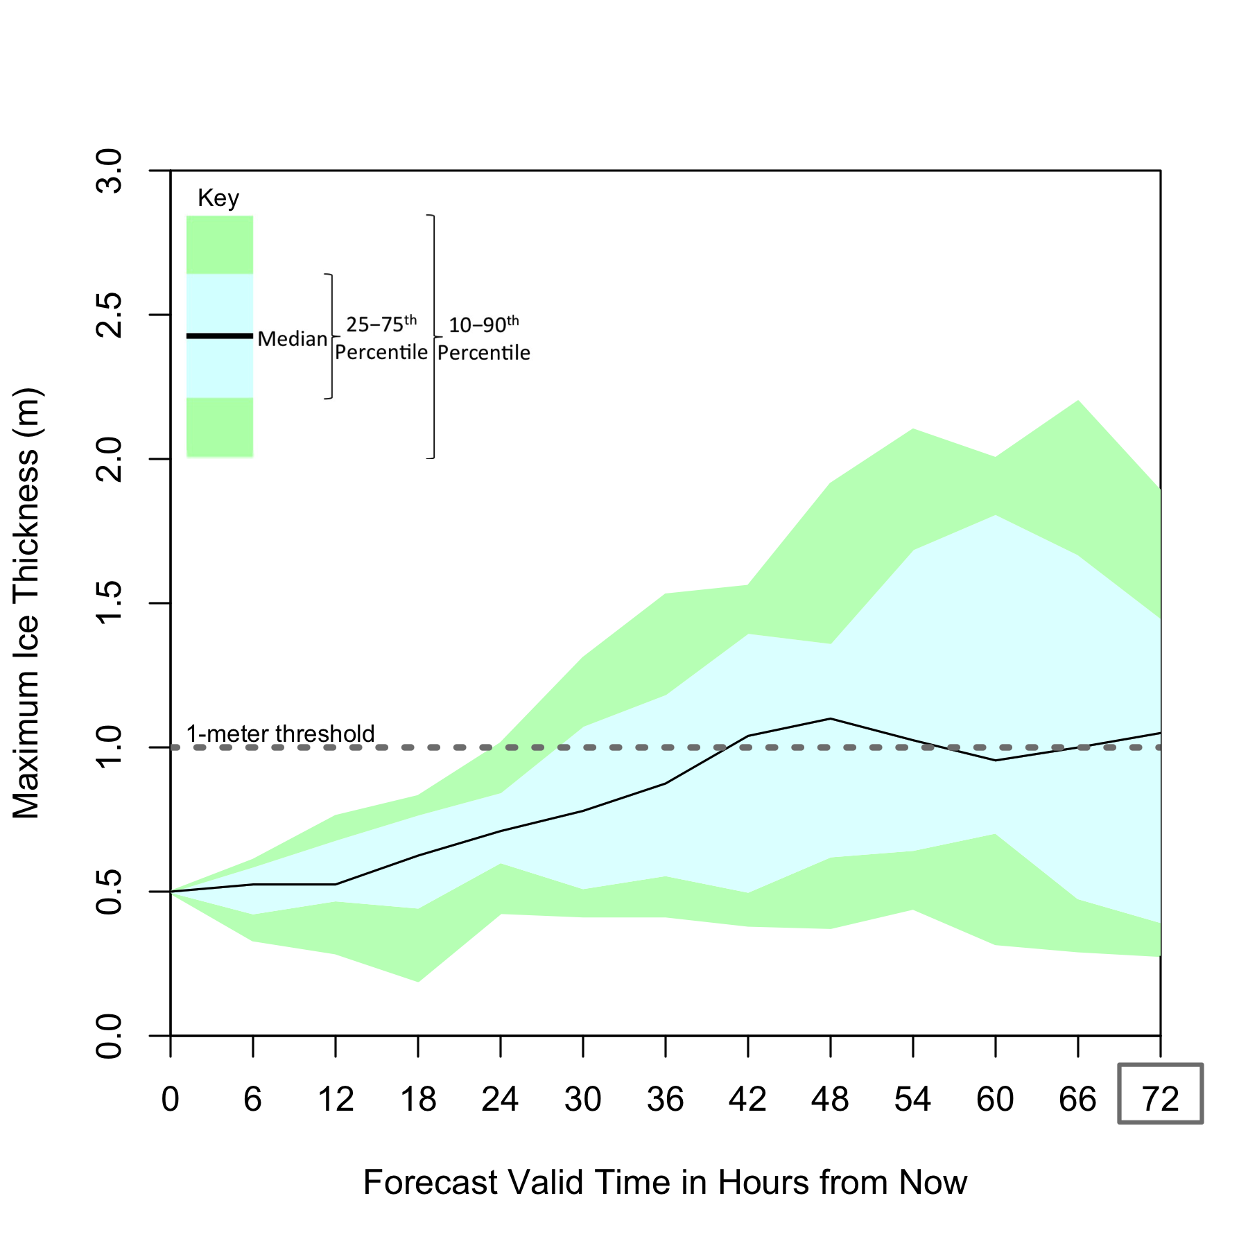
- Given the forecast above, which boat do you recommend for shipping 72 hours from now? (circle one)

Small ship Large ship

- How confident are you in your decision? (Mark on the line)
Extremely confident

Not at all confident

- What is your single value forecast for ice thickness 72 hours from now? _______ meters

- What is the thickest you predict the ice to be 72 hours from now? _______ meters

- What is the thinnest you predict the ice to be 72 hours from now? _______ meters
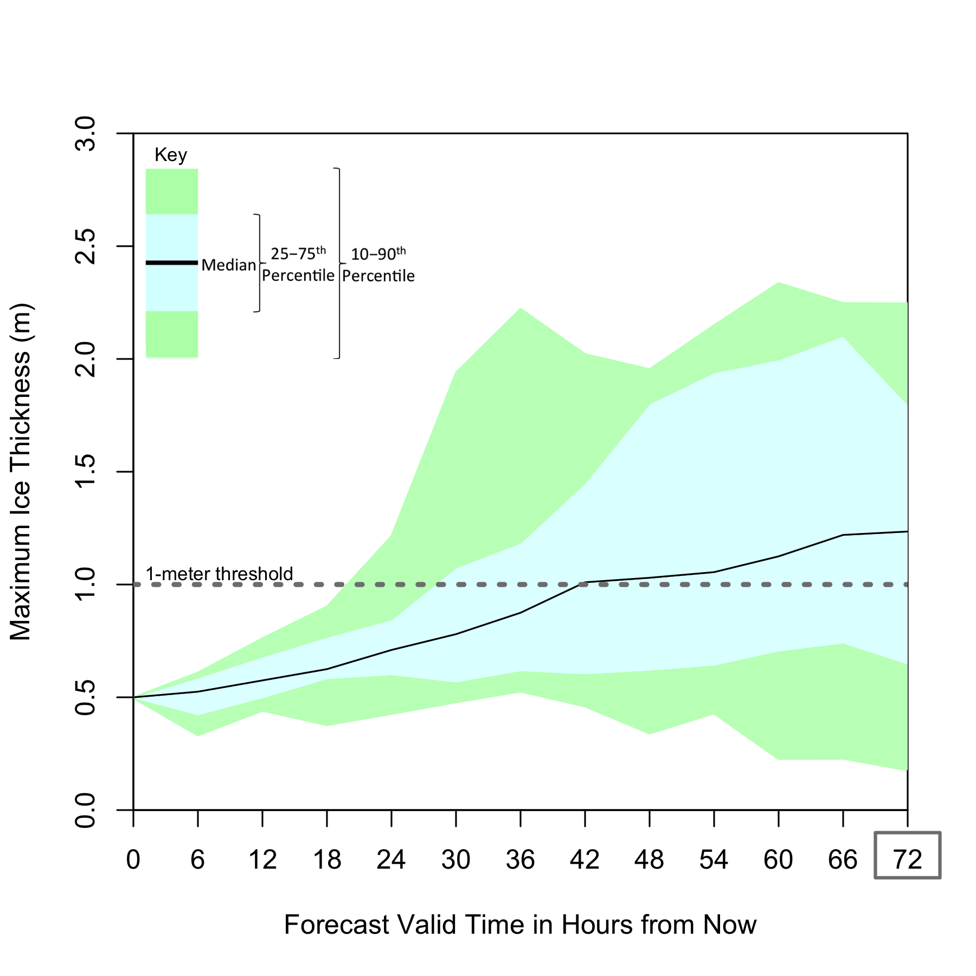
- Given the forecast above, which boat do you recommend for shipping 72 hours from now? (circle one)

Small ship Large ship

- How confident are you in your decision? (Mark on the line)
Extremely confident

Not at all confident

- What is your single value forecast for ice thickness 72 hours from now? _______ meters

- What is the thickest you predict the ice to be 72 hours from now? _______ meters

- What is the thinnest you predict the ice to be 72 hours from now? _______ meters

- How important is knowing the degree of uncertainty in risk information you use in your decision-making? (Mark on the line)
Extremely important
Not at all important

- How useful is knowing the degree of uncertainty in risk information you use in your decision-making? (Mark on the line)
Extremely useful
Not at all useful

- To be more confident in your decision-making, what further information would you need from forecasts? Please explain.
_____________________________________________________________________________________________

_____________________________________________________________________________________________

_____________________________________________________________________________________________

_____________________________________________________________________________________________

_____________________________________________________________________________________________

- What is your degree in?______________________________________________________________

- How many years of your degree course have you completed? __________ years

- What is your age? _______________

- What is your gender? _______________

- If you have any further comments, please write them below.

_____________________________________________________________________________________________

_____________________________________________________________________________________________
_____________________________________________________________________________________________
_____________________________________________________________________________________________

