Macintosh HD:Users:kelseymulder:Downloads:nerc-logo-bw.eps.pdf

Macintosh HD:Users:kelseymulder:Downloads:nerc-logo-bw.eps.pdf  
School of Mathematical and Physical Science

|  |
| --- |
| Researcher (principal): Andrew Charlton-Perez  Email: a.j.charlton-perez@reading.ac.uk  Phone: +44 (0)118 378 6023  Researcher: Kelsey Mulder  Email: k.mulder@reading.ac.uk |
|  |

Lyle Building Room 302E

Whiteknights

Reading, RG6 6BX  
 +44 (0)118 378 6187

Information Sheet for consent to participate in a research study

**Summary of the Research:** The Robust Assessment and Communication of Environmental Risk (RACER) team is network of researchers who want to improve the assessment, quantification, and communication of uncertainty and risk in natural hazards such as flooding, earthquakes, tsunamis, wind storms, cold weather, and volcanic ash. We are funded by the NERC under the Probability Uncertainty and Risk in the Environment programme.  
 **Purpose of the Research Study:** We are trying to bridge the gap between the scientists providing the uncertainty information about volcanic ash forecasts and end-users by developing improved tools for communicating uncertain information.  
  
**Procedures:** You are being asked if you wish to participate in this survey because of your involvement with creating or using volcanic ash forecasts. If you agree to take part, we would like you to complete a paper-based survey asking you to make flight decisions given ***hypothetical*** volcanic ash forecasts.  
  
**Do I have to take part?** Participation in this study is voluntary. If you decide to participate, you are free not to answer any question or discontinue participation at any time.  
  
**Length of participation:** The survey will take 20−30 minutes.

**Compensation:** Participants will not be paid for their time.  
  
**Confidentiality:** Your participation in this survey is strictly confidential. If you consent, data will be anonymised and stored in a repository for others to use. In published reports, there will be no information included that will make it possible to identify the research participants. Any reference to results or quotes from the survey will be anonymous.  
  
**Ethical Review:** This project has been reviewed by the University Research Ethics Committee and has been given a favourable ethical opinion for conduct.  
  
**Contact information:** If you have any questions about the research or would like to receive the results of our research, please contact Kelsey J. Mulder ([k.mulder@reading.ac.uk](mailto:k.mulder@reading.ac.uk))Macintosh HD:Users:kelseymulder:Downloads:nerc-logo-bw.eps.pdf

**Part A**

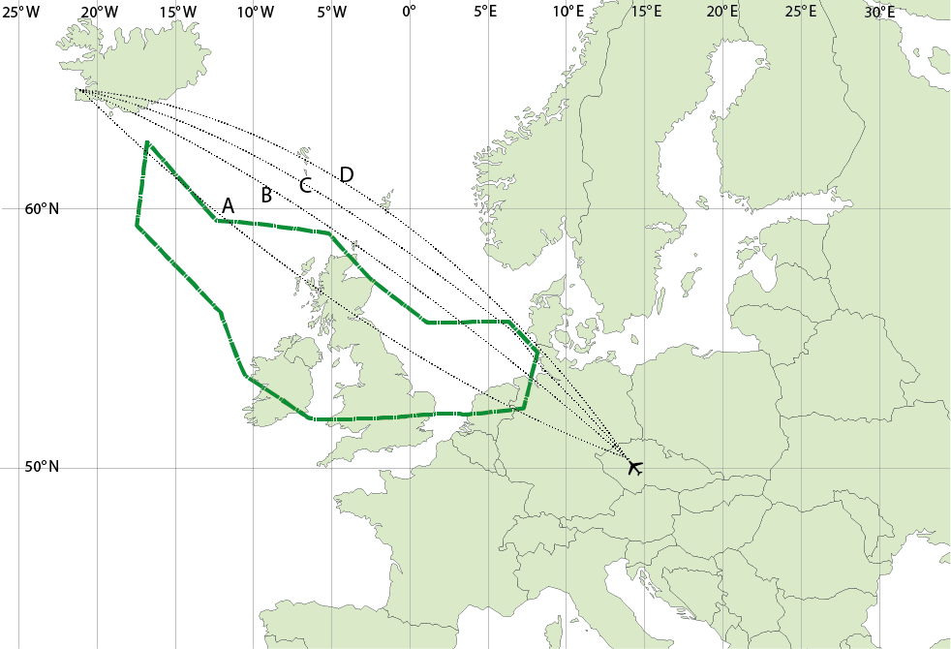

­**—**Forecasted extent of any level of volcanic ash

This image shows four flight paths as well as the forecasted extent of any level of volcanic ash from an eruption for all cruising altitudes. The forecast was issued 3 hours ago and is valid now, when these flights will take off. Assume you are approved to fly through medium levels of ash concentration (2000–4000 µg/m3) and are flying at a constant altitude. Please answer the following questions about this image.

Would you approve each of the following flight paths? (circle Yes or No)

*How confident are you in your decision?*

Not at all confident Extremely confident

1. Flight path A? *Yes* / *No*
2. Flight path B? *Yes* / *No*
3. Flight path C? *Yes* / *No*
4. Flight path D? *Yes* / *No*
5. What information influenced your decision to fly/not fly?

__________________________________________________________________________________________________

__________________________________________________________________________________________________

__________________________________________________________________________________________________

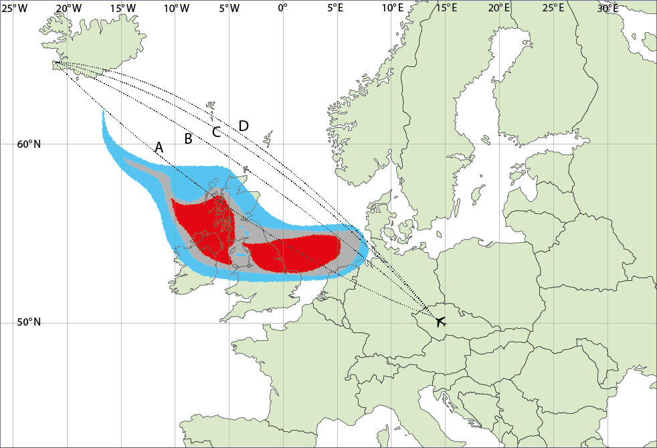

■ 200–2000 µg/m3, ■ 2000–4000 µg/m3, ■ >4000 µg/m3

This image shows four flight paths as well as the forecasted extent of different peak concentrations of volcanic ash from an eruption for all cruising altitudes. The forecast was issued 3 hours ago and is valid now, when these flights will take off. Assume you are approved to fly through medium levels of ash concentration (2000–4000 µg/m3) and are flying at a constant altitude. Please answer the following questions about this image.

Would you approve each of the following flight paths? (circle Yes or No)

*How confident are you in your decision?*

Not at all confident Extremely confident

1. Flight path A? *Yes* / *No*
2. Flight path B? *Yes* / *No*
3. Flight path C? *Yes* / *No*
4. Flight path D? *Yes* / *No*
5. What information influenced your decision to fly/not fly?

__________________________________________________________________________________________________

__________________________________________________________________________________________________

__________________________________________________________________________________________________

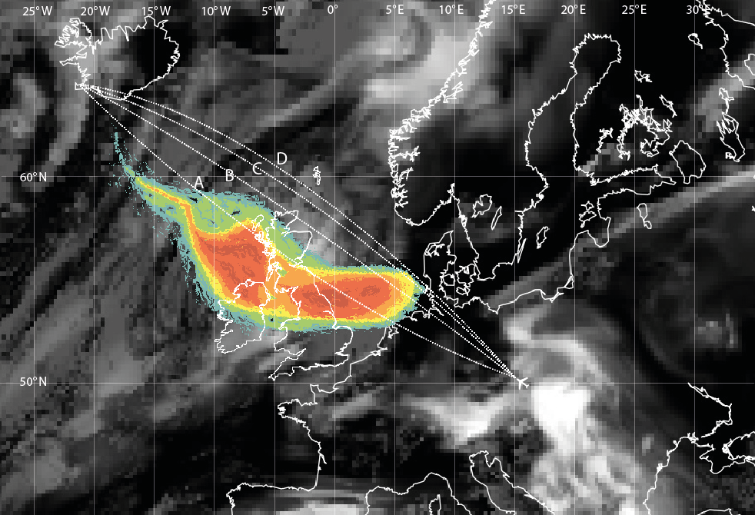

**Ash density µg/m3**  
■ 5000

■ 4000

■ 3000

■ 2000

■ 1000

■ 500

This image shows four flight paths as well as a model analysis of satellite data of the current extent of different peak concentrations of volcanic ash from an eruption for all cruising altitudes. The analysis is valid for right now, when these flights will take off. Assume you are approved to fly through medium levels of ash concentration (2000–4000 µg/m3) and are flying at a constant altitude. Please answer the following questions about this image.

Would you approve each of the following flight paths? (circle Yes or No)

*How confident are you in your decision?*

Not at all confident Extremely confident

1. Flight path A? *Yes* / *No*
2. Flight path B? *Yes* / *No*
3. Flight path C? *Yes* / *No*
4. Flight path D? *Yes* / *No*
5. What information influenced your decision to fly/not fly?

__________________________________________________________________________________________________

__________________________________________________________________________________________________

__________________________________________________________________________________________________

__________________________________________________________________________________________________

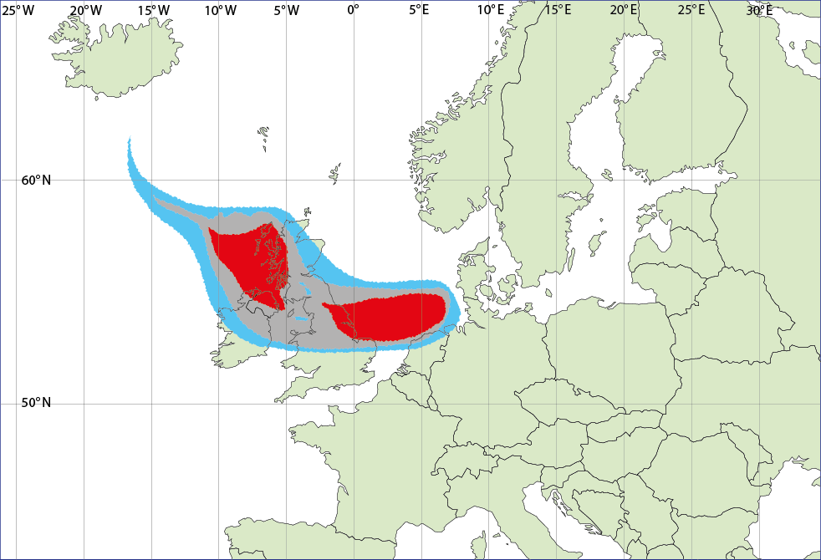

■ 200–2000 µg/m3, ■ 2000–4000 µg/m3, ■ >4000 µg/m3

This image shows the forecasted extent of different peak concentrations of volcanic ash from an eruption for all cruising altitudes. The forecast was issued 3 hours ago and is valid now. Assume you are approved to fly through medium levels of ash concentration (2000–4000 µg/m3) and are flying at a constant altitude. Please answer the following questions about this image.

1. Draw an area on the map representing your personal recommendation for a no fly zone.
2. How confident are you in your decision? (Mark on the line)

Extremely confident

Not at all confident

1. Please provide rationale for where you drew your no fly zone.

_____________________________________________________________________________________________

_____________________________________________________________________________________________

_____________________________________________________________________________________________

_____________________________________________________________________________________________

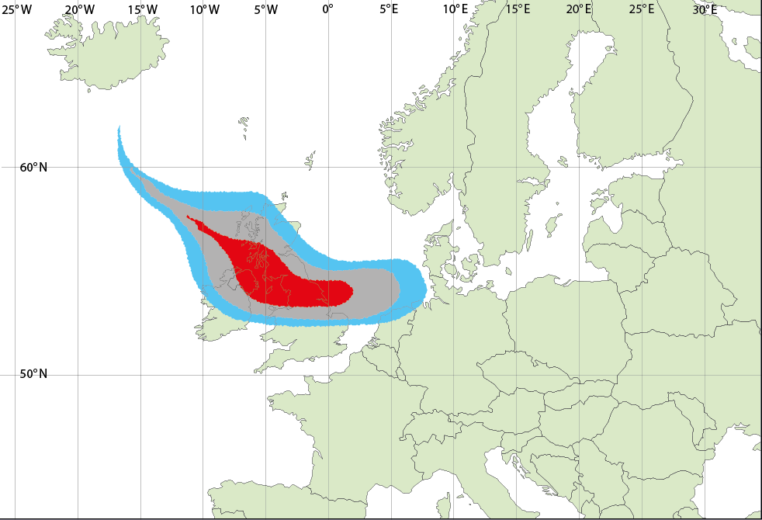

■ 200–2000 µg/m3, ■ 2000–4000 µg/m3, ■ >4000 µg/m3

This image shows the forecasted extent of different peak concentrations of volcanic ash from an eruption for all cruising altitudes. The forecast was issued 3 hours ago and is valid now. Assume you are approved to fly through medium levels of ash concentration (2000–4000 µg/m3) and are flying at a constant altitude. Please answer the following questions about this image.

1. Draw an area on the map representing your personal recommendation for a no fly zone.
2. How confident are you in your decision? (Mark on the line)

Extremely confident

Not at all confident

1. Please provide rationale for where you drew your no fly zone.

____________________________________________________________________________________________

_____________________________________________________________________________________________

_____________________________________________________________________________________________

_____________________________________________________________________________________________

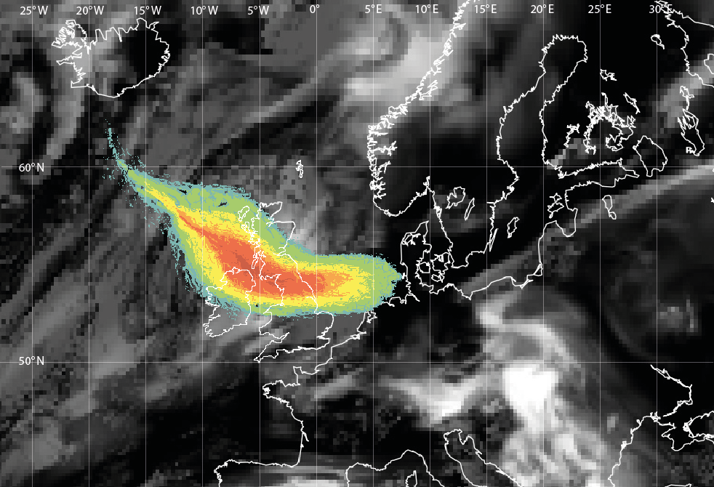

**Ash density µg/m3**  
■ 5000

■ 4000

■ 3000

■ 2000

■ 1000

■ 500

This image shows model analysis of satellite data of the current extent of different peak concentrations of volcanic ash from an eruption for all cruising altitudes. The analysis is valid for right now. Assume you are approved to fly through medium levels of ash concentration (2000–4000 µg/m3) and are flying at a constant altitude. Please answer the following questions about this image.

1. Draw an area on the map representing your personal recommendation for a no fly zone.
2. How confident are you in your decision? (Mark on the line)

Extremely confident

Not at all confident

1. Please provide rationale for where you drew your no fly zone.

____________________________________________________________________________________________

_____________________________________________________________________________________________

_____________________________________________________________________________________________

_____________________________________________________________________________________________

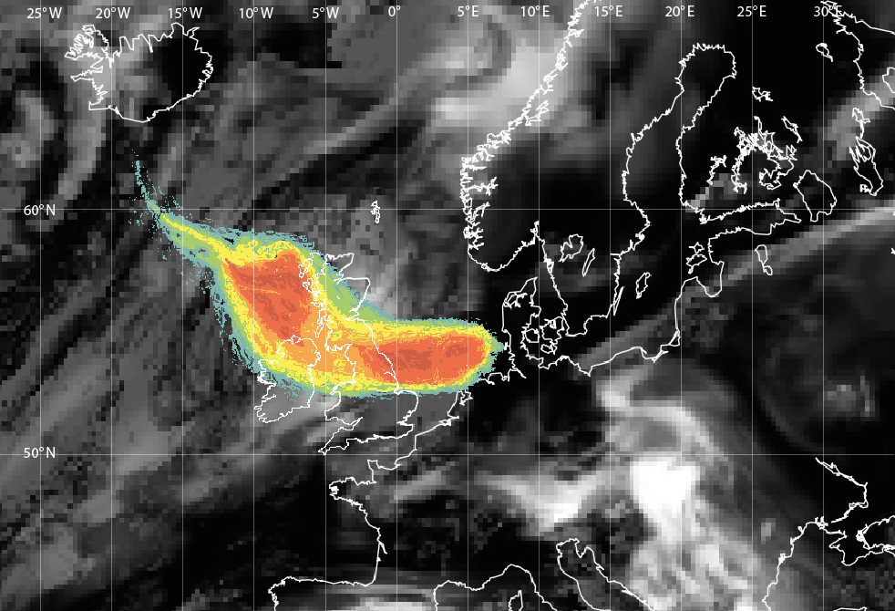

**Ash density µg/m3**  
■ 5000

■ 4000

■ 3000

■ 2000

■ 1000

■ 500

This image shows model analysis of satellite data of the current extent of different peak concentrations of volcanic ash from an eruption for all cruising altitudes. The analysis is valid for right now. Assume you are approved to fly through medium levels of ash concentration (2000–4000 µg/m3) and are flying at a constant altitude. Please answer the following questions about this image.

1. Draw an area on the map representing your personal recommendation for a no fly zone.
2. How confident are you in your decision? (Mark on the line)

Extremely confident

Not at all confident

1. Please provide rationale for where you drew your no fly zone.

____________________________________________________________________________________________

_____________________________________________________________________________________________

_____________________________________________________________________________________________

_____________________________________________________________________________________________

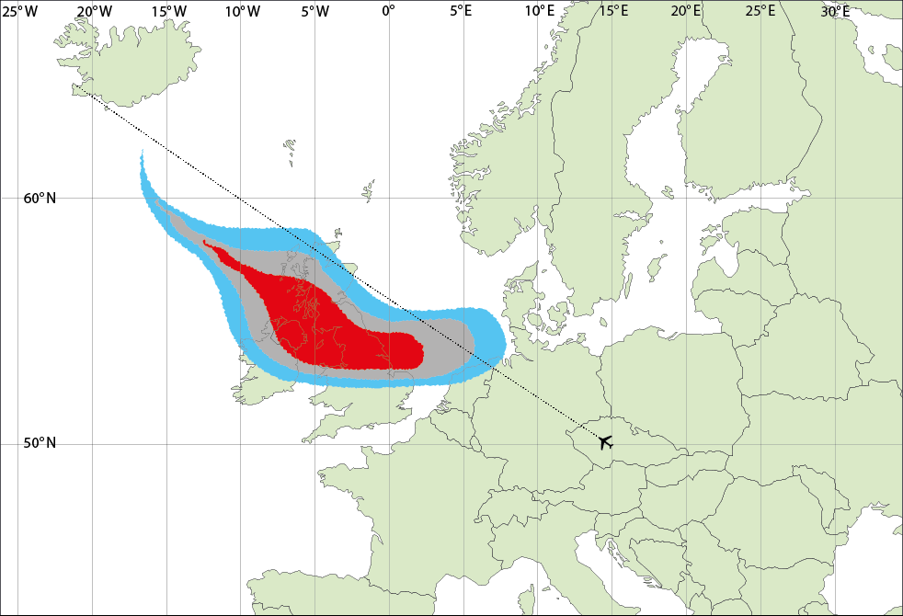 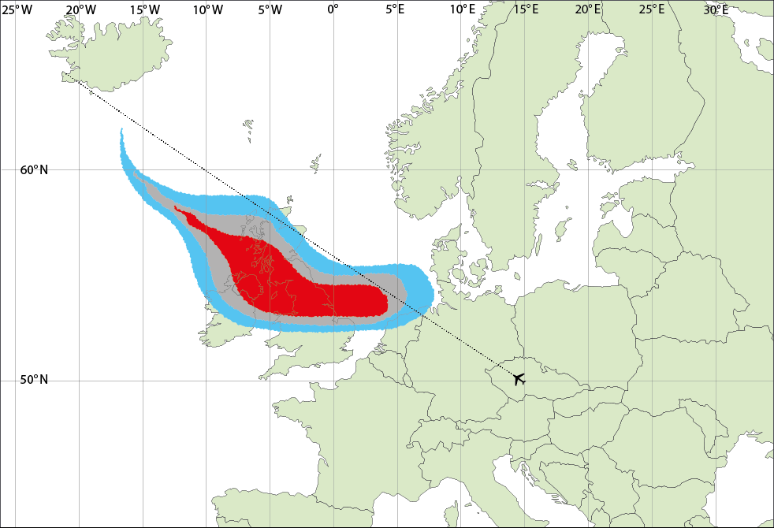

■ 200–2000 µg/m3, ■ 2000–4000 µg/m3, ■ >4000 µg/m3

This image shows the forecasted extent of different peak concentrations of volcanic ash from an eruption for all cruising altitudes from two different models. The same flight path is shown on both forecasts. Both forecasts were issued 3 hours ago and are valid now, when this flight will take off. Assume you are approved to fly through medium levels of ash concentration (2000–4000 µg/m3) and are flying at a constant altitude. Please answer the following questions about this image.

1. Would you approve the flight path? (circle one)

Yes No

1. How confident are you in your decision? (Mark on the line)

Not at all confident

Extremely confident

1. What information influenced your decision to fly/not fly?

_____________________________________________________________________________________________

_____________________________________________________________________________________________

_____________________________________________________________________________________________

_____________________________________________________________________________________________

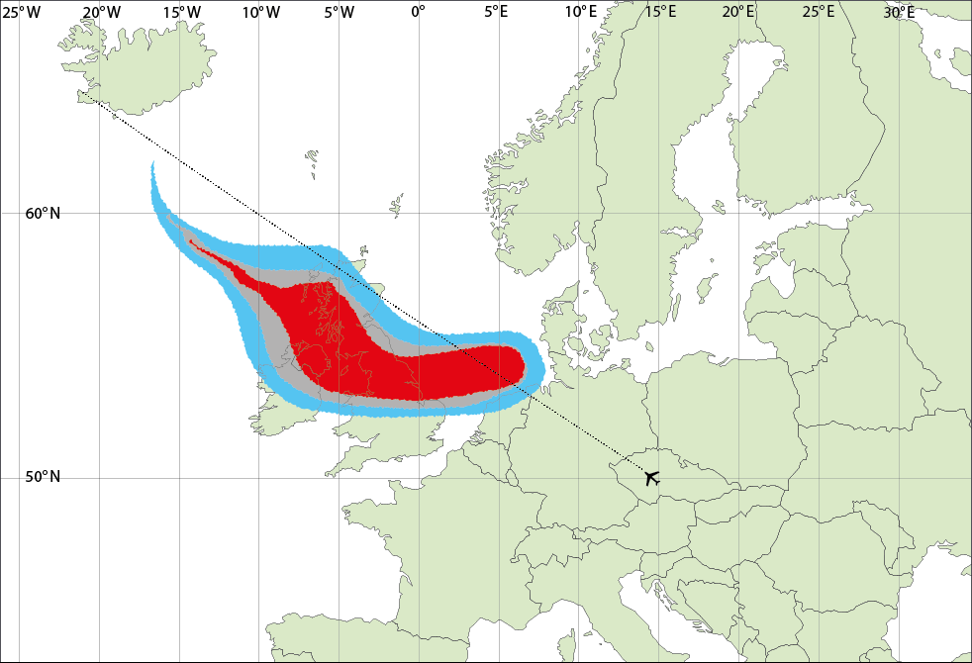 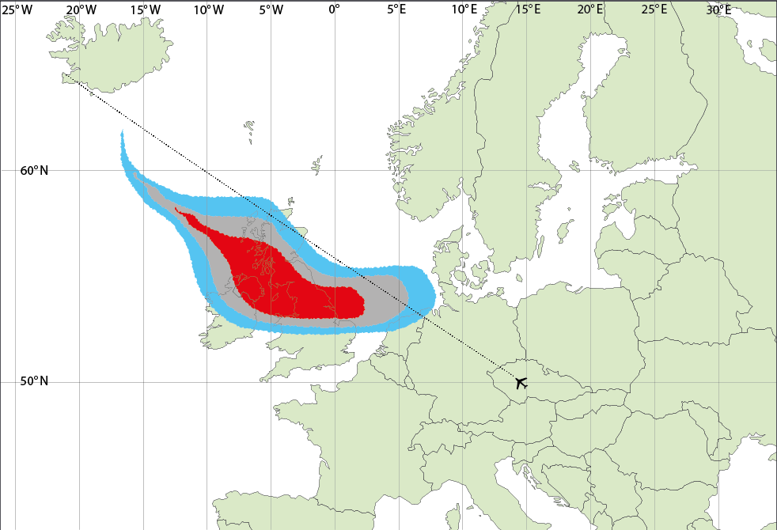

■ 200–2000 µg/m3, ■ 2000–4000 µg/m3, ■ >4000 µg/m3

This image shows the forecasted extent of different peak concentrations of volcanic ash from an eruption for all cruising altitudes from two different models. The same flight path is shown on both forecasts. Both forecasts were issued 3 hours ago and are valid now, when this flight will take off. Assume you are approved to fly through medium levels of ash concentration (2000–4000 µg/m3) and are flying at a constant altitude. Please answer the following questions about this image.

1. Would you approve the flight path? (circle one)

Yes No

1. How confident are you in your decision? (Mark on the line)

Extremely confident

Not at all confident

1. What information influenced your decision to fly/not fly?

_____________________________________________________________________________________________

_____________________________________________________________________________________________

_____________________________________________________________________________________________

_____________________________________________________________________________________________

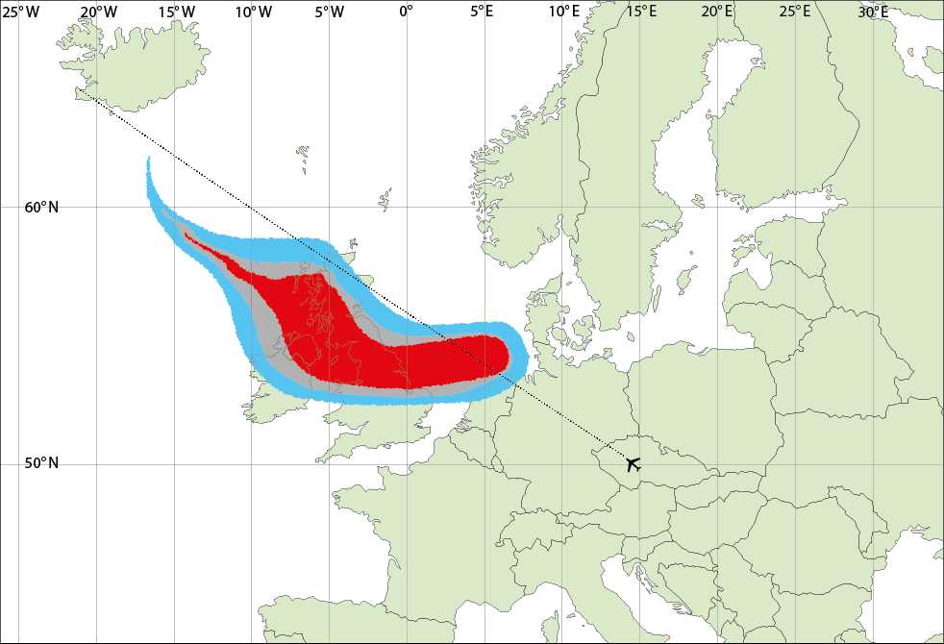 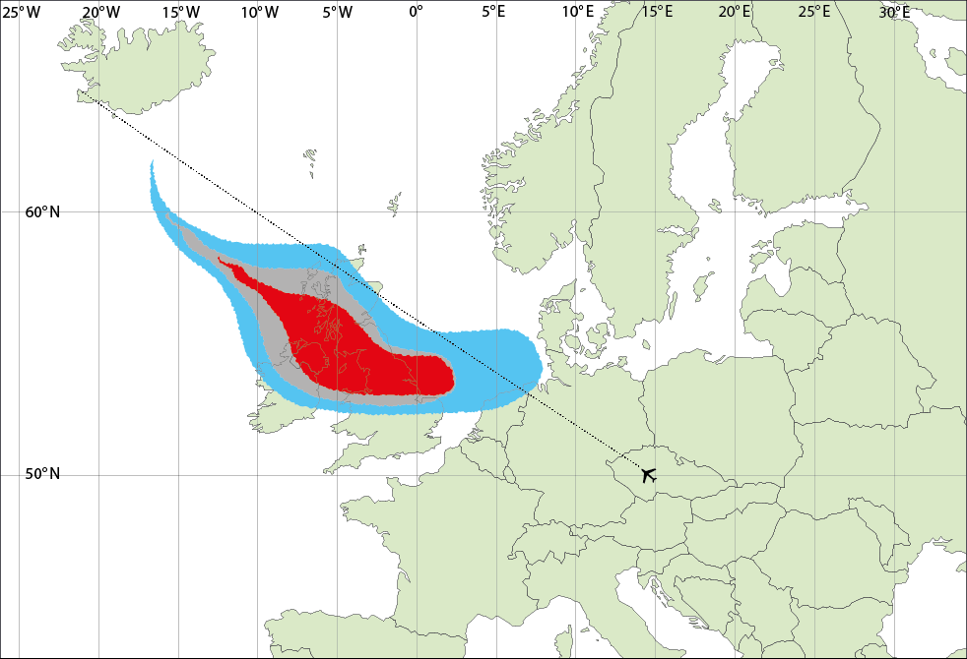

■ 200–2000 µg/m3, ■ 2000–4000 µg/m3, ■ >4000 µg/m3

This image shows the forecasted extent of different peak concentrations of volcanic ash from an eruption for all cruising altitudes from two different models. The same flight path is shown on both forecasts. Both forecasts were issued 3 hours ago and are valid now, when this flight will take off. Assume you are approved to fly through medium levels of ash concentration (2000–4000 µg/m3) and are flying at a constant altitude. Please answer the following questions about this image.

1. Would you approve the flight path? (circle one)

Yes No

1. How confident are you in your decision? (Mark on the line)

Extremely confident

Not at all confident

1. What information influenced your decision to fly/not fly?

_____________________________________________________________________________________________

_____________________________________________________________________________________________

_____________________________________________________________________________________________

_____________________________________________________________________________________________

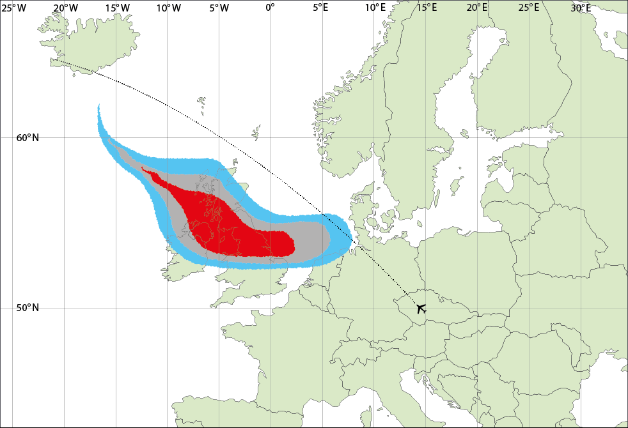 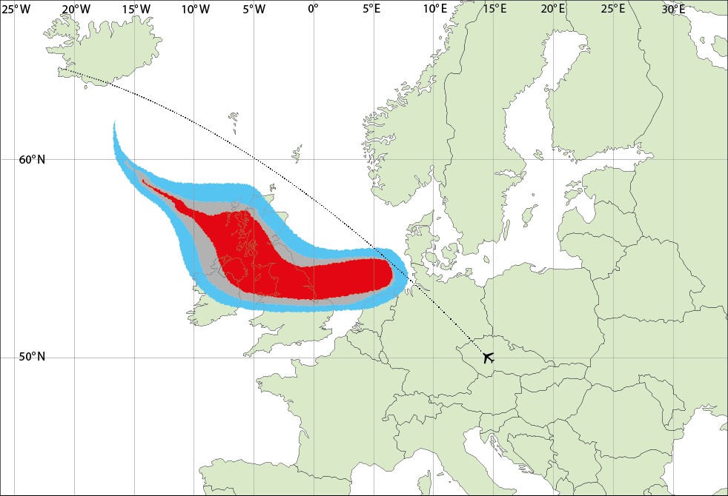

■ 200–2000 µg/m3, ■ 2000–4000 µg/m3, ■ >4000 µg/m3

This image shows the forecasted extent of different peak concentrations of volcanic ash from an eruption for all cruising altitudes from two different models. The same flight path is shown on both forecasts. Both forecasts were issued 3 hours ago and are valid now, when this flight will take off. Assume you are approved to fly through medium levels of ash concentration (2000–4000 µg/m3) and are flying at a constant altitude. Please answer the following questions about this image.

1. Would you approve the flight path? (circle one)

Yes No

1. How confident are you in your decision? (Mark on the line)

Extremely confident

Not at all confident

1. What information influenced your decision to fly/not fly?

_____________________________________________________________________________________________

_____________________________________________________________________________________________

_____________________________________________________________________________________________

_____________________________________________________________________________________________

1. What further information would help you make a decision to fly/not fly given

conflicting model outputs?

____________________________________________________________________________________________

_____________________________________________________________________________________________

_____________________________________________________________________________________________

_____________________________________________________________________________________________

**Part B**

1. How familiar are you with the following products? (Examples are provided)
   1. Volcanic Ash Graphics (VAGs) (Mark on the line)

Never seen before

Have seen frequently

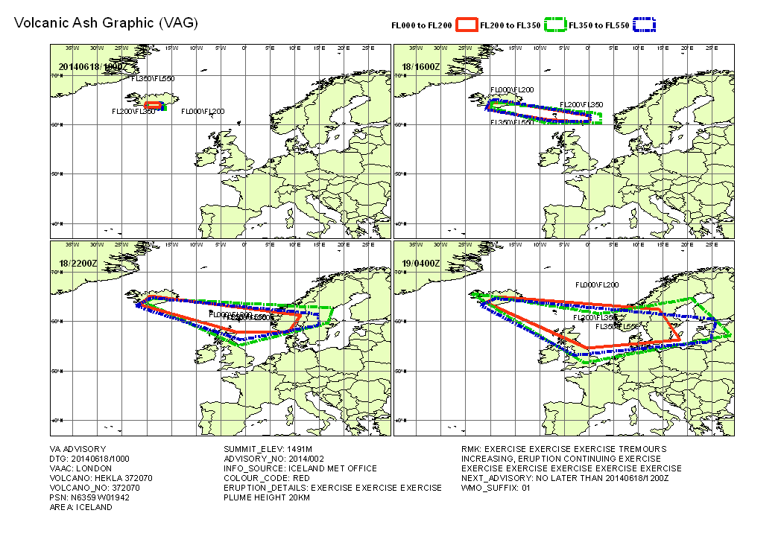

* 1. Modeled Ash Concentration (Mark on the line)

Never seen before

Have seen frequently

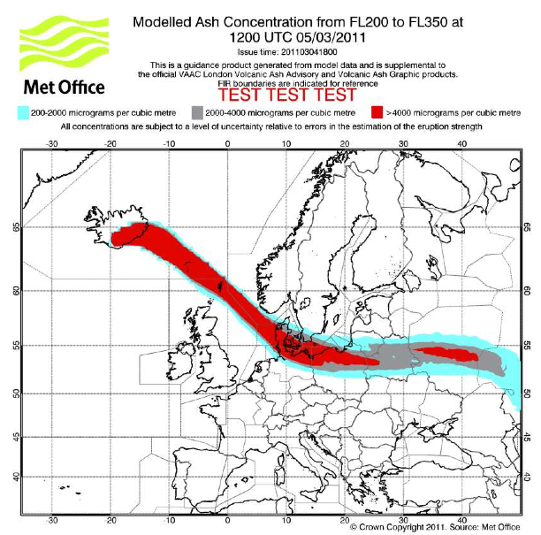

* 1. Satellite Ash Retrieval (Mark on the line)

Never seen before

Have seen frequently

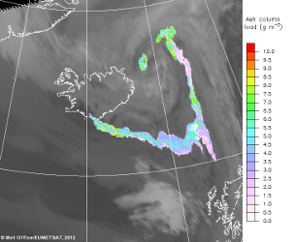

1. How trustworthy do you find the following products?
   1. Volcanic Ash Graphics (VAGs) (Mark on the line)

Not at all trustworthy

Extremely trustworthy

* 1. Modeled Ash Concentration (Mark on the line)

Not at all trustworthy

Extremely trustworthy

* 1. Satellite Ash Retrieval (Mark on the line)

Not at all trustworthy

Extremely trustworthy

* 1. Other _______________________________ (Please specify and mark on the line)

Not at all trustworthy

Extremely trustworthy

Please explain the ratings of trustworthiness you have given above.

_____________________________________________________________________________________________

_____________________________________________________________________________________________

_____________________________________________________________________________________________

_____________________________________________________________________________________________

1. Which product do you prefer? (Circle One)
2. Volcanic Ash Graphic
3. Modeled Ash Concentration
4. Satellite Ash Retrieval
5. Other _______________________________

Please explain why you prefer the product chosen above.

_____________________________________________________________________________________________

_____________________________________________________________________________________________

_____________________________________________________________________________________________

_____________________________________________________________________________________________

1. To be more confident in your decisions, what further information would you need from the different graphics? Please explain.

Volcanic Ash Graphic   
  
_____________________________________________________________________________________________

_____________________________________________________________________________________________

_____________________________________________________________________________________________

Modeled Ash Concentration

_____________________________________________________________________________________________

_____________________________________________________________________________________________

_____________________________________________________________________________________________

Satellite Ash Retrieval   
  
_____________________________________________________________________________________________

_____________________________________________________________________________________________

_____________________________________________________________________________________________

1. Rank the following types of uncertainty information in order of how useful it would be to you in a volcanic ash forecast (1 is the most useful and 5 is the least useful).

* Uncertainty in concentration or density of volcanic ash
* Uncertainty in geographic location of volcanic ash
* Uncertainty in altitude of volcanic ash
* Uncertainty in timing of the volcanic ash forecast
* Other_______________________________________________

Please explain your ranking.

_____________________________________________________________________________________________

_____________________________________________________________________________________________

_____________________________________________________________________________________________

_____________________________________________________________________________________________

1. In what industry or sector do you work? _______________________________________________
2. What is your job position?

_____________________________________________________________________________________________

_____________________________________________________________________________________________

1. How long have you been working in your current position? _______________ years
2. What is your age? _______________
3. What is your gender? _______________
4. If you have any further comments, please write them below.

_____________________________________________________________________________________________

_____________________________________________________________________________________________

_____________________________________________________________________________________________

_____________________________________________________________________________________________