- ABOUT THE DATASET
Title: Lerwick Observatory monthly mean Potential Gradient by hour of day 1964-1984
Creators: Hripsime Mkrtchyan, Giles Harrison, Keri Nicoll
Department of Meteorology, University of Reading, UK
Rights-holder(s): University of Reading
Publication year: 2024
Description: Atmospheric electricity measurements from Lerwick Observatory, Shetland, UK, provide a rare long-term series of hourly Potential Gradient (PG) data during the twentieth century. The Lerwick PG records have contributed to understanding climatological trends in atmospheric electricity. This archive is a subset of the full dataset, and provides monthly mean PG values for each hour of day, derived from summary sheets between 1964 and 1984, capturing typical daily and seasonal variations in PG.
Cite as: Hripsime Mkrtchyan, Giles Harrison, Keri Nicoll (2024): Lerwick Observatory Monthly Mean Potential Gradient by hour of day 1964-1984. University of Reading. Dataset. https://doi.org/10.17864/1947.001367
Related publications: Harrison and Riddick (2022); Harrison (2003); Harrison and Nicoll (2008);

Related data submissions
Dataset | Contents
Harrison, Giles, Nicoll, Keri and Mkrtchyan, Hripsime (2023): Lerwick Observatory monthly mean Potential Gradient 1925-1984. University of Reading. Dataset. https://doi.org/10.17864/1947.000505 | Monthly mean PG values
Harrison, Giles, (2022): Atmospheric electricity data for El Niño-Southern Oscillation studies. University of Reading. Dataset. https://doi.org/10.17864/1947.000409 | Includes daily values of Lerwick PG, by hour, for December only (1927-1954)

- TERMS OF USE
Copyright 2024, University of Reading. This dataset is licensed under a Creative Commons Attribution 4.0 International Licence: https://creativecommons.org/licenses/by/4.0/.

- PROJECT AND FUNDING INFORMATION
The Lerwick data, which contain atmospheric Potential Gradient (PG) data from Lerwick Observatory, Shetland was initially collected by the Met Office. The measurements ceased in 1984.
These data were obtained as part of ongoing atmospheric electricity research by Prof Giles Harrison in the Department of Meteorology, University of Reading, during the past twenty years without external project funding. The data archive is currently partially digitised. A Citizen Science project on the Zooniverse platform led by Dr Hripsime Mkrtchyan under a Marie Curie Fellowship is progressing to complete the full digitisation of the Lerwick dataset, which will provide the individual hourly values on each day of recording.
The records were originally published annually by the Met Office in The Observatories’ Yearbook (OYB), and subsequently recorded on unpublished observatory summary sheets, described in Harrison et al (2023). To ensure long-term preservation, the Hadley Centre of the Met Office scanned these summary sheets in 2003 under the supervision of Prof. Harrison. This scanning process created images solely to ensure preservation, and the data values were not transcribed into computer-usable form.
Newly digitized monthly hourly mean dataset from 1964-1984 have been created with the assistance of Armenian students under the supervision of Dr Hripsime Mkrtchyan, completing the digitization process within a few months in 2023. In this effort, data values were carefully keyed in, with checks applied to identify and correct any discrepancies. In cases where discrepancies remained after verification, the values as originally published in the OYB were retained for consistency in the data submission.

- CONTENTS
This data submission contains observations of the Potential Gradient (PG) as the Mean Diurnal Cycle for each month, recorded under fair weather and non-hydrometeor conditions.
The vertical electric field is the most frequently measured parameter in atmospheric electricity, represented as the Potential Gradient (PG). At the Earth's surface, the PG is the voltage difference between the ground and a point located 1 m directly above it with units of volts per metre (Vm⁻¹). The PG is positive in fair weather with values generally from 100 Vm⁻¹ to 150 Vm⁻¹. The measurements are corrected to those taken over level ground, by applying a reduction factor which was independently determined. A general description of atmospheric electricity measurement methods is given in Harrison & Bennett, (2022), and an account of the atmospheric electricity measurements at Lerwick Observatory is given in (Harrison & Riddick, 2022).
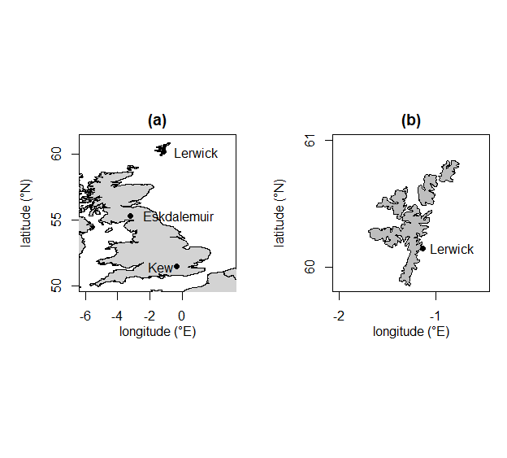
Figure 1. Maps of (a) the UK and (b) the Shetland Islands, showing the position of Lerwick. (The two further atmospheric electricity monitoring sites at Kew and Eskdalemuir are also marked) (adopted from Harrison et al 2023).
From 1964-1984 the data were classified by identifying the hour of recording as having “fair weather” or “no hydrometeors” conditions. The meteorological conditions were either those of no precipitation (i.e. without rain, snow or hail), described as “no hydrometeors” (NH), or, more demandingly, fair weather. A discussion of the criteria for identifying fair weather in atmospheric electricity is given in Harrison and Nicoll, (2018).
Note that the early part of this record, 1964 to 1967, is affected by radioactive contamination from nuclear weapons test. The data from 1968 seems unaffected. Also, the data values for June 1979 are missing.
Monthly mean values from the original Lerwick data tabulations (OYB or Archive sheets) are presented here. There are 4 files:
Filename | Contents | Data format
FW_PG_1964-1984.xlsx (.csv) | Monthly mean PG values by hours from 1964-1984 for fair-weather conditions. | Table 1
FW_hours_1964-1984.xlsx (.csv) | Duration of "Fair Weather" hours in the averaged FW PG. | Table 2
NH_PG_1964-1984.xlsx (.csv) | Monthly mean PG values by hours from 1964-1984 for “No Hydrometeor” conditions. | Table 1
NH_hours_1964-1984.xlsx (.csv) | Duration of "No Hydrometeor " hours in the averaged NH PG | Table 2

The data can be found in both xlsx and csv formats. The files are plain ascii text files, comma separated, with each line of data values in columns running from left to right. They are organised as described in Tables 1 and 2 below. Each file has eight header lines. Missing values are indicated as NAN.
Table 1. Lerwick monthly mean PG (FW or NH) by hour of day
Column number | Quantity | Description | Unit
1 | Year | Time variable (value runs from 1964 to 1984) | GMT
2 | Month | Time variable (value runs from 1 to 12)
3 - 26 | PG by hour of day | Monthly mean PG by hour of day with “Fair-weather” (“No Hydrometeors”) for this hour of day | Vm⁻¹

Table 2 Lerwick monthly duration of “Fair weather” (or “No Hydrometeors”) hours, by hour of day.
Column number | Quantity | Description | Unit
1 | Year | Time variable (value runs from 1964 to 1984) | GMT
2 | Month | Time variable (value runs from 1 to 12)
3 - 26 | Number of hourly measurements used in the average for the hour concerned | Duration of “Fair weather” (“No Hydrometeors”) in hours, for this hour of day | Count of hours

- REFERENCES
Harrison, G. and Bennett, A.: Electricity measurements, in: Handbook of Atmospheric Measurements, edited by: Foken, T., Springer Nature, Switzerland, 431–456, 2022.
Harrison, R. G.: Twentieth-century atmospheric electrical measurements at the observatories of Kew, Eskdalemuir and Lerwick, Weather, 58, 11–19, https://doi.org/10.1256/wea.239.01, 2003.
Harrison, R. G. and Nicoll, K. A.: Air-earth current density measurements at Lerwick; implications for seasonality in the global electric circuit, Atmos Res, 89, 181–193, https://doi.org/10.1016/j.atmosres.2008.01.008, 2008.
Harrison, R. G. and Nicoll, K. A.: Fair weather criteria for atmospheric electricity measurements, J Atmos Sol Terr Phys, 179, 239–250, https://doi.org/10.1016/j.jastp.2018.07.008, 2018.
Harrison, R. G. and Riddick, J. C.: Atmospheric electricity observations at Lerwick Geophysical Observatory, Hist. Geo Space. Sci, 13, 133–146, https://doi.org/10.5194/hgss-13-133-2022, 2022.
Giles Harrison, Keri Nicoll, Hripsime Mkrtchyan (2023): Lerwick Observatory monthly mean Potential Gradient 1925-1984. University of Reading.

