Silsoe campaign notes/logs/guides

Overview of the experiment

CO₂ sensors- K30-FR CO₂ sensors
Figure 1: Google sketchup of the box design for the sensors
Figure 2: Google sketchup of the lid of the box for the CO2 sensors
-Raw electronics, sensitive to static.
-No lag from usb extensions.
-Estimated data size- 700mb for 12weeks.
-File type- .csv file
Software- Gas lab. Easy to use, type is 126 for k30 frs. Ensure that all details are sorted for one sensors before connecting another.

Release guides given to others

Using the Gaslab K-30 sensors.

These sensors are all logged using the program Gaslab (icon made up of 3 lines spiralling together). The program can be ran off any laptop with usb ports and is very light weight. Download here-http://www.co2meter.com/pages/downloads. Once downloaded, open it up and then plug in a k-30 sensor (it should install the driver, but if not, follow the steps in the software manual for gaslab about getting the drivers). Do this for all sensors one at a time.
This program is a little temperamental and after logging for a while, will eventually freeze up and not respond. When this happens, use task manager to close gas lab and then restart it. DO NOT DISCONNECT THE SENSORS BEFORE CLOSING THE PROGRAM.

Process
- Restart or start gas lab. Disconnect and reconnect the sensors at will (as long as the program is not logging) to figure out which one corresponds to which COM port (it isn't always the same)
- Choose the com port and the Product is CM-0126 for all the sensors -it should fill in all the rest. If not, they're k series k-30 FRs @2hz for the other drop down menus (depends on the software version).
- Hit connect and you should get a 'connecting to sensor' message briefly, if it takes a while, it's because it needs you to fill in the product details, so hit cancel and fill it in according to the step above.
- Repeat this for all sensors until they're all connected
- Untick only show selected sensor and you should get a graph of all 3.
- Change the Auto logging to every 0.5 seconds (or slower if you need to), and set the time to 1 forever.
- Start logging and keep the default name(day) or give it a new one.
- Traces should show up and log away merrily in near real time. It does experience slow down over time, so it is best to do short experiments with these by simply stopping it logging and restarting it again under a different file name.
- If you want to check that the sensors are functioning, simply breathing on the sensors should cause them to top out at their maximum (10,000 ppm) due to flooding of the sensor. You should then see it decay away- you can increase this by flushing with fresh air with a fan.
- To stop it hit 'stop logging' and wait a minute or so until it does actually stop. If it crashes (generally only after long term measurements) use task manager (see above).
- Do not amend to the previous log as it causes issues in post processing. It will automatically add a number to the default name.
- Files are stored in Documents- Gaslablogs - they don't take long to transfer.

Top tips & wise words
Be careful when handling the circuit board. Knocking the usb connections can cause issues.
If you get a message saying the port is closed, disconnect the sensors (using the program), close everything and begin again. If you're still having issues, restart the entire computer with the sensors disconnected.
Raw electronics-> sensitive to static.

Gas release
- Check CO2 sensor program hasn't crashed. If it has, close it (Normally needs task manager) and then disconnect the sensors. If it hasn't stop it logging and then restart.
- Restart gas lab
- Choose the com port and the Product is CM-0126 for all the sensors -it should fill in all the rest. Give the sensor a name and then hit connect.
- Sensors are best connected in this order- COM3- (Label it east), COM 4- Low, COM 6- mid sensor.
- Untick only show selected sensor
- Change the Auto logging to every 0.5 seconds, and set the time to 1 forever.
- Start logging and keep the default name or give it a new one.
- The three traces should show up and log away merrily.
- To stop it hit stop logging and wait a minute or so until it does actually stop. If it crashes (generally only after long term measurements) use task manager.
- I generally start a new file after one or two gas releases- do not amend it to the previous log as it causes issues in post processing. It will automatically add a number to the name.
- Files are stored in Documents- Gaslablogs - they don't take long to transfer.
- After all the experiments- Stop it logging and disconnect all the sensors. Copy the files onto the harddrive, and replug them in before starting them off logging again- it can't cope with taking one sensor out and adding another in.

Gas release.
- Put the regulator on the gas bottle- we're using the one on the trolley at the moment, the one inside has a low flow.
- Check for any leaks (you can normally feel them around the pipe, and we have added an extra seal.)
- Connect up the big tube to the little tube.
- Shut the door and turn the gas on- I do it until the black and silver balls on the flowmeter are above the top measurement but it doesn't really matter- control this via the black handle on the regulator.
- Make a note of the conditions and the time of the experiment. Estimated wind direction, rain, cloud cover etc, wet or dry in the cube.
- I put in 10 minutes of gas- been getting up to 3000ppm.
- Leave it for 1/2 hour- time and conditions
- Repeat.
- Reset the file on gaslab and repeat.

Locations of gas sensors
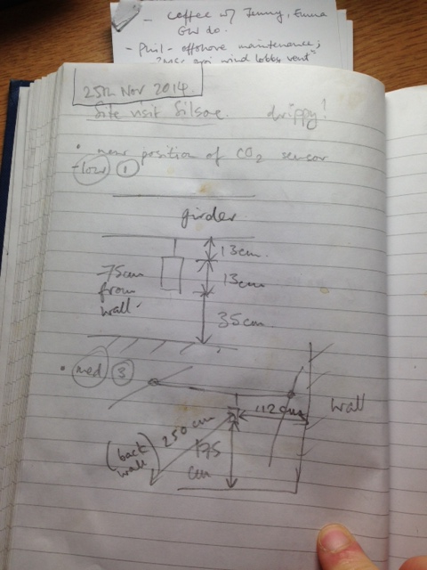
Figure 3: Locations and dimensions of the K30's on 25th November 2014

Thermocouples
Thermocouples- 4 sets of 4 sensors and 1 set of 8 sensors in the horizontal.
Drop | Location | Sensors | Lengths (m) | Logger
1 | Front right | 1,5,9,13 | 5,3.5,3,2 | 363
2 | Front left | 2,6,10,14 | 5,3.5,3,2 | 345
3 | Back right | 3,7,11,15 | 5,3.5,3,2 | 363
4 | Back left | 4,8,12,16 | 5,3.5,3,2 | 345

Logging method- 2X TC-08 Pico tech thermocouple loggers- 8 thermocouples (2 drops per logger)
Log rate- 10Hz
Serial numbers- 363 and 345
Calibration- Certificates in date and with instruments
Input type- USB.
Software- On disks in boxes. Picolog recorder.
Logging limitations- 1 million pieces of data per file, will reset and re-sync every hour. 104 minutes max per file @ 10Hz
File output- PLW, can be changed manually to txt.
Notes- No deterioration of performance with USB extensions used. Needs to be set before starting. Each TC-08 needs to remain in the same USB port in order for the program to work.

Guideance given to others for thermocouples
Using the thermocouples
You will need to install the Picolog software off the disk. You can also download it from here- https://www.picotech.com/downloads and select Picolog data recorders, TC-08 (name of the junction) then whatever 'bit' suits your system.
The logo for this software is a turquoise PL and is very simple to use.
If you're opening the program after booting up the laptop just double click on the icon to be taken to Picolog recorder. If you already had an instance of it running, it might open up Picolog viewer- You don't want this, so go to task manager-> processes and close down any exe's (plw32.exe for my pc) with the Picolog name or symbol and then re-open it. If not, restart the PC.
If you installed the software and had units attached during it, it may pop up a warning message on program start with 'TC-08 Junction X is missing, no units attached' (see image). Just hit OK and ignore however many there are. This is often due to it trying to default to whatever settings you had previously.

The Blue boxes connect via USB and the program tends to pick them up automatically.
First, go to file->new settings
Settings-> recording Allows you to change the behaviour of the logging. For Silsoe, we had the real-time continuous recording, and at the end of the run we repeat immediately. You can set a delay on the restart if you want.
You also need to tick 'use multiple converters' in order to allow it to 'see' all the junctions.
Settings->sampling allows you to control the sampling time. These can go up to 10 Hz comfortably so set to 100 ms.
'Stop after' sets how long each file will log for. So stop after 6 hours was used at Silsoe, but you can reduce it. Readings per sample should be set to as many as possible.
Input channels-> This is where you select your input converters (the Blue junction converters) It will pick them up automatically- if not get it to refresh. Two of the blue boxes have the serial number scribbled on them so you should be able to tell which one is which. The other unmarked one is 538.
Click add to add the Junctions. Once selected you can click edit to add the thermocouple channels. Make a note of the number of the thermocouple, the channel it's on and the location in the room. The actual part of the sensor that takes the reading is the tiny loop at the end of the wire.
Once you've saved your settings File-> Save as, Go to File-> New data and chose your file name. Avoid numbers in it as the program with save consecutive runs by adding a number onto the end automatically.
The format they're stored in is .PLW which should mean they are only compatible with the Pico Software. HG has a matlab code (sourced from the internet) that converts it to mat files if needed.
The display can be changed from a list of the instruments and their current recordings (updated every second) to a graph via view-> and whatever option you need.
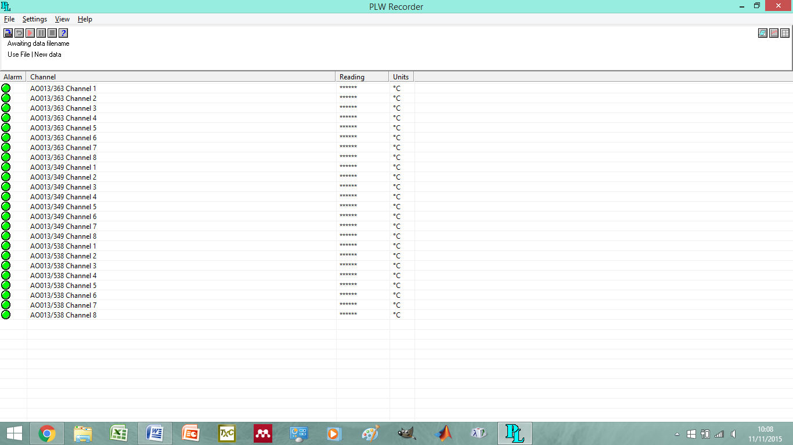
Figure 4: View of the Picolog program

Names of thermocouple files:
Silsoetest-1hour-15/9-1/10
westtemps 1/10-1/10
3thermos1lap- 1/10- 7/10
07thoct- 7/10-16/10
16thOct- 16/10- 3/11
Nov-3/11- 10/11
Nov10nov- 10/11-17th/11
Nov17th- 17/11-25/11
nov24stuff- 25/11-10/12
deccol 10/12-12/12
dec12leave- 12/12- 16/12
dec16start- 16/12-08/01
janstart 08/1-15/1
jan15leave 15/1-20/1
Jan20leave- 20/1-5/2
fab20leave- 5/2-18/2
leeds- 18/2-18/2
feb18leave- 18/2-26/2
feb-26/02-4/3
march-16/03-23/03
endmarch- 23/3-27/3
marchendend 27/03-21/05
isolatedcube 21/05-28/5
iso- 28/05-9/06
june 09/06-11/06
junejune-11/06-15/06
junejunejune- 15/06-18/06
junefour 18/06-25/06
julynear-25/06-06/07
Homerun-06/07-09/07

Pressure taps
Each line shows "Z","C","R" as appropriate. The number of minutes the Z/C/R sections run for is user selectable in the software (Equipment button). The default is 1 min Z, 1 min C and 11 min R (making a total of 15 minute run ZCRCZ). This is what I remember happening with previous systems.
The columns in the data file after the "Z/C/R" are UVW & SoS first sonic, UVW & SOS second somic (or zeros if not connected) and then 32 channels of voltage from the A/D systems. I've labelled the A/D boards "0" and "1" and these are daisy chained together so there is just one USB connector for the laptop. If used in this way board 0 gives the first 16 channels and board 1 give second 16 channels in the data file. If you connect them separately you will need to be careful to figure out which is which in the data file. All channels are +/-10V setting at present but this can be changed within the code if required.
The final column (or two columns if you have 2 sonics connected) are the bytes in the input buffer for the relevant sonic. This allows a post-processing to check/correct sonic alignment if required. If you are using one sonic it should always be zero unless something odd is happening.
The software is configured to keep logging one file after another until stopped. So for example in default it logs 15minute files (ZCRCZ) one after another using the same filename + a different filenumber each time. All files are plain text. The files are about 3Mb per 15 minutes but zip down to a much smaller size (about 400kb).

Notes on data collection
A restarted run that's amended on has difficulties, have to find and delete the new titles- then it works- gaslab
All data is corrected for gmt as of 26/11/2014.
Decision made not to use the split thermocouple data for the laptops.

Cardington Data
Example: In the card_20150118_30.dat file, the first line of the file after all the header lines starts like this:
| 2.500000e-01 | 3.249710e+00 | 3.379406e+00 | 5.400893e+00
Where “|” is the flag meaning that the data is okay. The other flags are H, D, c, m, ?, and X, which all mean that the data is suspect for one reason or another.

Useful Files

Experimental proposal from 2014
Site details
The 6$m^{3}$ instrumented cube is located in a rural area at the Silsoe Research institute, Wrest Park in Bedfordshire, and is constructed from a smooth, double layer metal sheet, which is commonly seen in low rise industrial constructions (Yang, 2004). The cube can be rotated and tilted with only the former being used in this experiment. Panels can also be removed to create a ventilated cube.
The prevailing wind direction is assumed to be Southwest, with the site having good exposure to winds from Southwest to East (Richards and Hoxey, 2012). A wind rose will be generated from the nearby Cardington Met-Office site, once access to the data is granted. The profile of the site is well represented by a log-law profile with roughness length, $z_{0}$ in the range of 0.01m to 0.04m (Richardson et al, 1995). This range of $z_{0}$ for the prevailing wind direction can be described as ‘open’, ‘Level country with low vegetation and isolated obstacles with separations of at least 50 obstacle heights, though this is dependent on the crops in the adjacent field, with maize increasing the roughness length to 0.20 (Wieringa, 1993).
Figure 1 displays the surrounding fields and obstacles with approximate heights added.
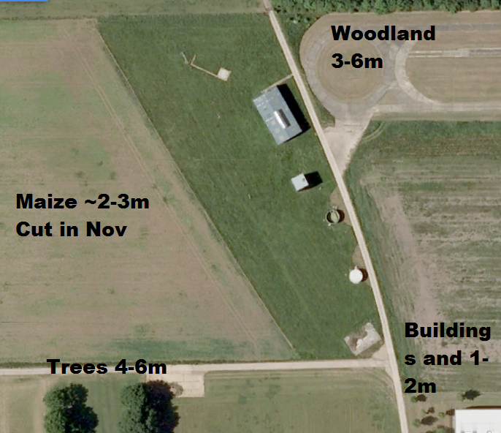
Figure 5-Google Map's screenshot of the site, with nearby obstacles labelled.
The site has been risk assessed by all parties involved, with safety procedures put in place.
Observation period.
The experimental start date is 5th September, with installation commencing the week before. The total run time is likely to be between 8-12 weeks, depending on the spread of atmospheric conditions encountered. The experiment will consist of a sealed case, a single sided ventilation case and a cross ventilated case. Building of the array is expected to take one week, being managed by the University of Birmingham with the installation of equipment also expected to take approximately one week. In the change-over between isolated and array cases, a one week period of maintenance is scheduled to allow for any changes to instrument layout.
Array Layout
A staggered array of ~6$m^{3}$ cubes will be built around the instrumented cube using bales of wheat and barley straw, with a layer of rapeseed straw upon the roof of the cube to provide a waterproof layer and to reduce construction cost. The cubes are likely to vary by 10-30cm in height due to the materials involved, with the tops of the cubes unlikely to be completely level. The straw will be uncovered, though the microscale roughness is not thought to influence the large scale roughness to an extent where it will affect the overall results.
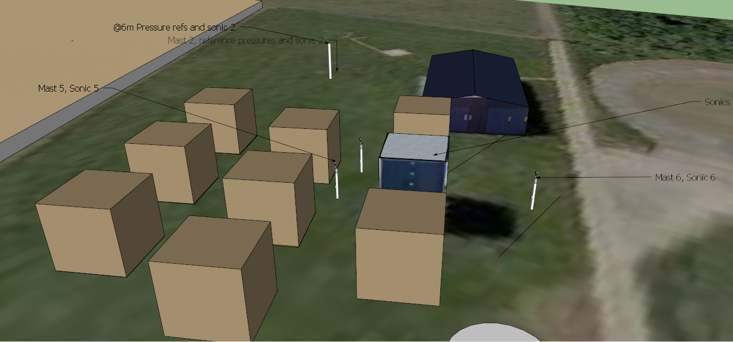
Figure 6-Cube array
Using bales of straw will look more natural than temporary wooden cubes and is less likely to draw complaints from local residents. This creates a layout that represents a simplified residential area, free from irregular building arrangements, trees and the effect of human activities.
The array will be built facing the Southwest, with the prevailing wind being perpendicular to the cube’s frontal face, with no channels in the array. The plan area density ($λ_{p}$), the ratio of the obstacle surface area to the total surface area, is 0.3.
This layout has been chosen so that the data can be compared to a variety of different flow experiments, such as the direct numerical simulation results from Coceal et al (2007) and the wind tunnel experiments by Cheng and Castro (2002). Inspiration for the layout of the sensors is taken from the regular array field experiment ran as part of the COSMO project by Inagaki and Kanda (2008). The height to distance between obstacles ratio is 1, meaning that the array will be a skimming flow regime, with not much mixing in the air above the array and a single recirculation in the street canyon (Oke, 1987).
Array Instrumentation
Flow measurements are needed over periods of at least 6 weeks in order to be a reliable set of reference data (Kaimal and Finnigan, 1994), with the reference measurements remaining in the same positions throughout the experimental campaign.
Measurements of the background conditions will be taken from reference masts around the array. Cabling for these masts will run through stands above the ground to prevent cables being eaten by wildlife. Power will be tapped from within the instrumented cube.
A 12m mast (Mast 1) will be positioned in line with the prevailing wind direction (South Westerly) and be located at approximately 30m away from the array. This mast will be concreted into the ground and remain for the entire experiment. A 10Hz sonic anemometer (Sonic 1) and a Vaisala WXT520 weather station will be positioned at 10m to provide basic reference measurements to a low degree of accuracy.
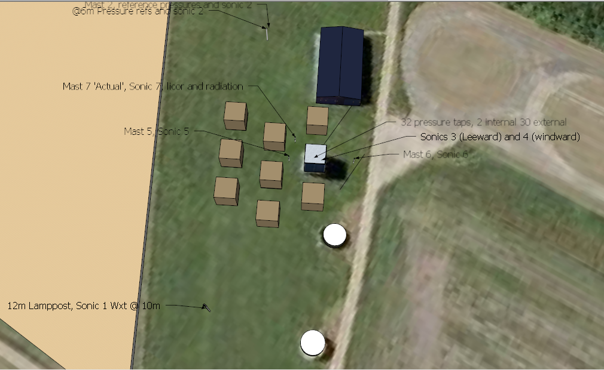
Figure 7-Overview detailing the positions of all masts.

Using a lighting pole as a reference mast, at 6m (Building height), the reference dynamic pressure will be measured at the start of the observation period using a directional pitot tube, with the calibration method described by Straw (2000) being used for the pressure taps. This calibration needs to be undertaken throughout the observation period at half-hourly intervals to correct drifting instruments. A 10Hz sonic anemometer (Sonic 2), and a static pressure probe will be positioned at 6m, with the mast being referred to as mast 2 (see Figure 4).
Within the cube array, two masts will be positioned in front of the windward wall to provide measurements of the incoming turbulence and wind speed. Mast 5 is 4.5m away from the windward opening, with Mast 6, being in the same position for the leeward opening. These masts will be 2.8m tall, with the head of a 10Hz sonic being at 3.5m, level with the centre of the opening. Mast 5 holds Sonic 5 (3.5m) and Mast 6, Sonic 6 (3.5m) and are logged by the Moxa system.
Mast 7, the ACTUAL mast is positioned 4.5m away from the corner of the windward face of the cube with sonic anemometer 7 , an infra-red hygrometer (Licor Li-7500) for measuring background CO2 fluxes, and a net radiometer (Kipp and Zonen CNR4) . This will be logged by it's own control box located inside the instrumented cube.
Tracer gas
An ideal tracer gas is required to have certain properties in order to be considered effective (Sherman). The tracer should not be considered a hazard to the people or materials with and around the test area and should be non-toxic and non-flammable. The tracer should not react with any part of the system under study and should be recognisable from all other constituents of air, or be distinguishable from a background concentration whilst not affecting the air flow or air density. However, practical considerations, such as the cost of the tracer and the required instrumentation as well as the availability of the gas will factor strongly into the selection of a suitable tracer gas, with no tracer gas currently meeting all of these requirements (Sherman).
To make ventilation measurements with a tracer gas, a zonal assumption is made, with the tracer techniques being used to determine the exchange of flow between the internal and external environments, but not the flow of the zone itself. Any outside air or injected tracer is assumed to be instantaneously dispersed within the zone and become well-mixed, leading to homogeneity in the zone. It is also assumed that there is no re-entrainment of the tracer or a buffer zone between the zone and the outside surroundings (Sherman).
Constant injection technique
To determine an air change rate for a room a known amount of tracer gas is constantly emitted over a certain period of time. The tracer gas concentration increases with time and will reach a stable value known as the equilibrium concentration. This equilibrium concentration is dependent on the room volume, the emission rate and the air change rate.
Sampling for this method, should only be started when the tracer gas is nearing 95% of it's estimated equilibrium value, with the time until equilibrium is reached depending on the air change rate.
The advantage of this method over others is that it provides a constant source of information, especially if the wind speed and the wind direction can be recorded; however, it requires a larger volume of tracer gas when compared to other techniques. The amount of gas required can be reduced by careful selection of the tracer gas, the detection level of the instruments being used and the concentration of tracer gas required (Cheong, 2001). This technique is more suited to higher air change rates due to the reduction in time taken to reach equilibrium with an increase in air change rate.
Due to regulations limiting the use of specialist tracer gases, the tracer gas is CO₂ for this experiment. A heated regulator is required to ensure that the CO2 does not freeze upon release, which, coupled with a flow-meter, will be releasing the CO2 at 40lpm for the ventilated cases and 3lpm for the sealed cases, due to the limitations of the CO2 sensors. The gas canisters will be stored in a locked cage outside the cube, with the gas piped in. A small desk fan may be required to ensure that the cube is well mixed.
The two CO2 sensors are K-30 fast response CO2 meters, set to log at 2Hz and with a maximum detectable CO2 concentration of 10,000ppm.
Pressure tapping of the cube
Pressures on the cube surface will be measured using pressure taps; simple 7mm diameter holes located centrally on 0.6$m^{2}$ steel panels, which are mounted flush to the cladding of the structure to minimise their impact on the measured pressures (Straw, 2000). Though insulation of the cube would be ideal to prevent the interior of the cube warming and affecting the measurements of temperature, it is also costly in terms of set up. These also need to have some method of drainage to prevent lost data and require individual transducers for simultaneous measurements (Straw, 2000).
Straw, (2000) notes a slight change in the internal pressures throughout the experiment but does explicitly measure this. Whilst there is little literature on this, two pressure taps will be placed internally under the openings to monitor any changes which could occur.
There will be 30 external pressure taps logging at approximately 10Hz for the duration of the experiment though this is dependent on cable length and location.
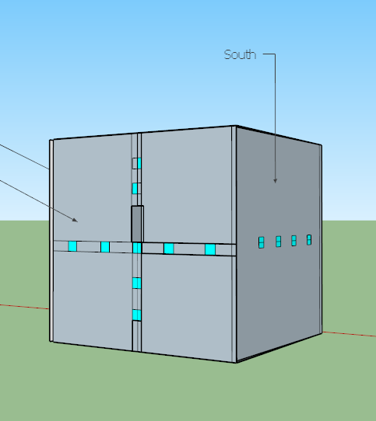 | 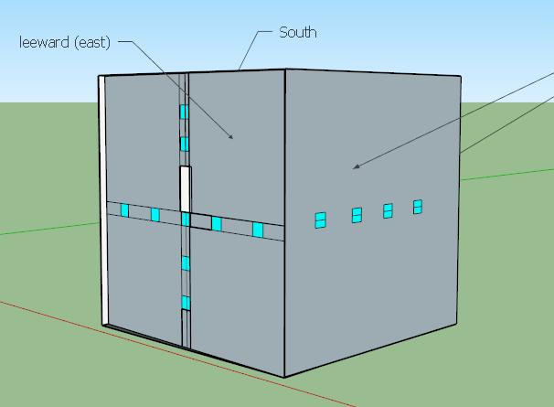
Windward (west) and south sides | Leeward (east) and North sides | Roof and leeward (east) side
Figure 8-Locations of the pressure taps on all cube sides
Inside the cube
T he insides of the cube will be completely cleared so that all data logging software can be housed in the cube alongside instruments during the ventilated cases.
Temperature measurements
An array of 16 type k thermocouples will be utilised inside the cube in order to gain a better understanding of the heat flow around the cube. The positioning of these is dependent on the structures inside the cube but it is envisioned that four drops of four thermocouples will be created at 5m,3.5m,3m,2m from the ground, being logged by a Tc-08 USB thermocouple logger.
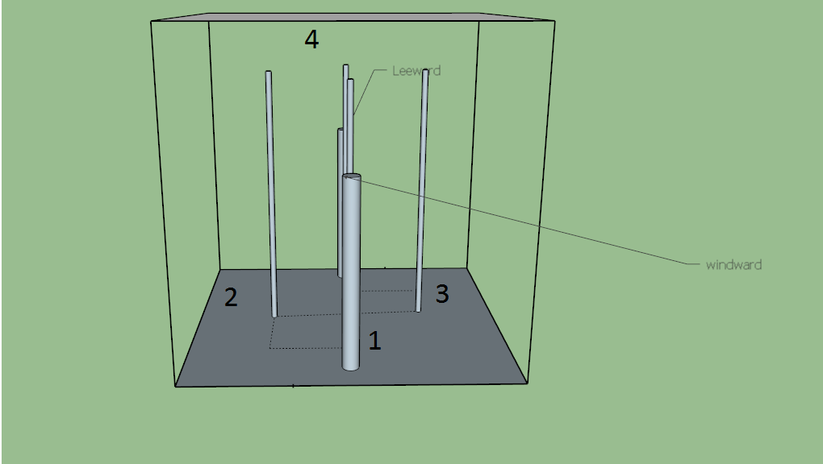
Figure 9-thermocouple drops
Cube arrangements
The run time for each set-up is dependent on the wind conditions and the presence of maize in the fields.
- 2 weeks Cross ventilated array
- 2 weeks single sided array
- 1-2 weeks sealed array
- 2 weeks isolated sealed cube
- 2 weeks single sided isolated cube
- 2 weeks cross ventilated isolated cube
Ventilated cases
A single sided case will run for a dynamic time length to ensure that a wide range of atmospheric stabilities are captured. Tracer gas experiments will be undertaken during this time period in order to gain a representation of the ventilation rate of the building, using either a pulse release, or a constant injection technique.
The 0.4$m^{2}$ opening will be introduced in the windward (South west facing) face, 3m above the ground. Sonic 3 will be positioned at 3.5m on Mast 3, set slightly back from the opening so flow interference is kept to a minimum. Sonic 4 would be positioned in the middle of the cube and mounted so that the head of the sonic is initially at 3.5m, though Mast 4 is flexible in terms of positioning and height. Mast 3 is fixed in position whereas Mast 6 is a SQT12 -8 10m pump up mast and is likely to be moved throughout the experiment. Care will be taken to ensure that Mast 6 does not sag.
During the cross ventilated cases, Mast 6 will be moved closer to the rear opening.
References
Burba , G. and D. Anderson. A Brief Practical Guide to Eddy Covariance Flux Measurements: Principles and Workflow Examples for Scientific and Industrial Applications. LI-COR Biosciences, 2010, pp37

Cheng, H., and I. P. Castro, 2002: Near wall flow over urban-like roughness. Boundary-Layer
Meteorology, 104, 229-259.
Coceal, O., T. G. Thomas, I. P. Castro, and S. E. Belcher, 2006: Mean flow and turbulence
statistics over groups of urban-like cubical obstacles, Boundary-Layer Meteorology, 121,
491-519.
Coceal, O., A. Dobre, T. G. Thomas, and S. E. Belcher, 2007: Structure of turbulent flow over regular arrays of cubical roughness, Journal of Fluid Mechanics, 589, 375-409.
Davidson, M., et al, 1996: Wind tunnel simulations of plume dispersion through groups of obstacles. Atmos. Environ., 30, 3715–3731.
Edward Ng, Chao Yuan, Liang Chen, Chao Ren, Jimmy C.H. Fung: 2011. Improving the wind environment in high-density cities by understanding urban morphology and surface roughness: A study in Hong Kong, Landscape and Urban Planning, 101, 59-74.
Hoxley, R.P and P.J Richards, 1992: Structure of the atmospheric boundary layer below 25m and implications to wind loading on low-rise buildings. J. Wind.Eng. Ind. Aerodyn. 41-44, 317-327

Hoxey, R. P., P. J. Richards and J. L. Short , 2002: A 6m cube in an atmospheric
boundary layer flow Part I. Full-scale and wind-tunnel results. Wind and
Structures, 5(2-4), 177-192.
Inagaki, A., and M. Kanda, 2008: Turbulent flow similarity over an array of cubes in near-
neutrally stratifed atmospheric flow, Journal of Fluid Mechanics.615, 101-120.
Kaimal, J.C and J.J Finnigan, 1994: Atmospheric Boundary Layer flows. Their structure and measurement. 1st edition. Oxford university press. 289pp
Longley, R.W 1959: Eddy sizes as determined by the temperature fluctuations at O'Neill, Nebraska, August and September 1953. J. Meteorology. 16, 140-143
MacDonald, R. W., Griffiths, R. F., & Cheah, S. C. (1997). Field experiments of dispersion through regular arrays of cubic structures. Atmospheric Environment, 31(6), 783–795.
Oke, T.R 1987: Boundary Layer climates. Methuen, London U.K. 464pp.

Ramamurthy, P., E. R. Pardyjak, J. C. Klewicki, 2007: Observations of the Effects of Atmospheric Stability on Turbulence Statistics Deep within an Urban Street Canyon. J. Appl. Meteor. Climatol., 46, 2074–2085. doi: http://dx.doi.org/10.1175/2007JAMC1296.1
Richards, P. J., & Hoxey, R. P. (2012). Journal of Wind Engineering Pressures on a cubic building — Part 2 : Quasi-steady and other processes. Jnl. of Wind Engineering and Industrial Aerodynamics, 102, 87–96. doi:10.1016/j.jweia.2011.11.003

Richardson, G. M., Hoxey, R. P., Robertson, A. P., Short, J. L., 1995: The Silsoe
Structures Building: The completed experiment part 1. Wind Engineering Retrospect
and Prospect: Papers from the 9th International Conference, vol. 3.
Roth, M., 2000: Review of atmospheric turbulence over cities. Q.J.R. Meteorol. Soc. 126 pp 941-990
Straw,M.P, 2000: Computation and measurement of wind induced ventilation. PhD thesis, University of Nottingham

Wieringa, J., 1993: Representative roughness parameters for homogeneous terrain.
Boundary Layer Meteorology, 63, 323-364.

Yang, T., 2004: CFD and Field Testing of a Naturally Ventilated Full-scale Building. PhD thesis. University of Nottingham

Locations of kit before horizontal thermocouples introduced
Before 25th November set-up.
Mast | Height | Instruments | Logging | Location
1 | 12m Instruments at 10m | Sonic 1  WXT 520 | Cr1000 own system | Away from array
2 | 6m Lamppost | Sonic 2, pitot tube, static pressure probe | Laptop 1 | North of array
3 | 3.5m Pump up mast | Sonic 3 | Moxa-laptop 1 | Inside the cube
4 | 3.5m | Sonic 4 | Moxa-laptop 1 | Inside the cube
5 | 3.5m | Sonic 5 | Moxa-laptop 1 | Outside, in-front of opening- prevailing wind direction
6 | 3.5m | Sonic 6 | Moxa-laptop 1 | Behind the cube, level with openings
7 | 3m | Sonic 7  Licor  CRN4 Radiation | Logging on own system (Already set) | At an angle to the front face of the cube

Instruments | Numbers | Heights (m) | Logging | Location
Thermocouple drop 1 | 1,5,9,13 | 5,3.5,3,2 | TC-08 363+ laptop 1 | Inside the cube front windward
Thermocouple drop 2 | 2,6,10,14 | 5,3.5,3,2 | TC-08 349+ laptop 1 | Inside the cube middle left
Thermocouple drop 3 | 3,7,11,15 | 5,3.5,3,2 | TC-08 363+ laptop 1 | Inside the cube  Middle right
Thermocouple drop 4 | 4,8,12,16 | 5,3.5,3,2 | TC-08 349+ laptop 1 | Inside the cube leeward back
Co2 Sensor | 1 | 3m | Laptop 2 | Under the prevailing vent
Co2 Sensor | 2 | 3m | Laptop 2 | Under the back vent
Pressure taps | 1-32 | Varies | ?? | See cube diagram

Number of taps | Numbers | Location
10 |  | West side | 1 internal
10 |  | East side | 1 internal
4 |  | North side
4 |  | South side
4 |  | Roof

Visit and experimental logs
01/10
Westside CO2 meter lower than background- going back for calibration
problem with WCC laptop power
Swapped sensor 1 for sensor 3
Date wrong on the CO2 sensors on the east side- one day out
Powercuts on the 27th Sept- knocked old laptops offline, newer ones survived- time taken 2-3 hours. Moxa frozen
Thermocouple array 3 set up.
7/10
sensor1-east
sensor2-west
Thermocouples now at 6 hours intervals
Previous rainfall- equipment all ok- some drips on thermocouples.
Attempted a tracer gas experiment- more research needs to be done into pumping the gas in to a high conc. 10mins at 10lpm not good enough- more research needs to be done
John reset Moxa
Licor and regulator retrieved.
16/10
Power cut 10am ish. Pressure taps restarted, moxa restarted.
Sens1 back into the test rig
Mast Straightened
Wet inside the cube, water build up on tarpaulin.
New extension for gas regulator- not waterproof
Pressure tap data 27.3138 all collected, useful from 8th Oct.
pressure tap have new file name
29/10
POWER CUT 12:15 ish.
Co2 sensors down from that time. Possibly earlier.
03/11
Cold and damp, air temp 7C, inside the cube 11-15C. 11:30 arrival, left at 3:30
Problems with the gas logger software- too low hz no longer logging- removed test and it improved.
Off and on rain.
Wxt aligned differently- straightened the WCC mast, Un-calibrated licor now back on the mast.
Waterproof flex and tracer tubes fitting for easy access when cube door closed.
Test sensor working fine but laptop struggling with three. East sensor hung up on thermocouple line for tracer gas experiment.
Moxa survived power cut no problem.
Lots of the cables are now slack.
10m mast is leaning slightly
3rd nov first file, east and west had the wrong names.
10/11
arrived 11:30 left 3:30
Installed gas network.
Started using the big gas canister
Took measurements for the relative locations of the mast to each other.
Slight sagging of the cubes.
Did a test with a fan.
changed co2 sensor positions
Temperature of the co2 gas when leaving the canister is 10C
Very muddy.
Clear to begin with, cloudy at 1ish and then clear again, until rain at 3:30pm
Logger card swapped over
Gas release at 13:45 for 10 minutes,@ 24l/min. Left for 15mins
5minutes of gas in left for 10mins 3:10ish
5 minutes of gas in before canister dismantled.
17/11
arrived 11:30
cold, damp
More mud in the cube
think the problem due to data is the time stamp on all the clocks
1 hour backward 26th oct 2014- data before this point needs re analysing otherwise old codes work fine- now all done 20th Nov
check laptop clocks
2am clocks go back
Didn't get card data.
Co2 sensor swapped out for spare needs to go to the manufacturers
odd wind direction- easterly?
fan installed
all laptops are on gmt
need to check cr1000 logger
some water on thermocouples
10m mast leaning.
john got sonic layout
router removed
cubes damp all the way through
Perspex for covering boxes in cube
water a problem 4 co2 sensors
12:59 gas in for 10mins with fan 26 min wait
13:45 gas in 4 10 mins no fan 20min wait
everything in working order as far as we can tell
some sonic disconnect whilst checking positions.
west sensor now in centre of cube
18/11
We have turned the fan off and removed the west vent, approx. time 13:45
25/11
Centre sensor dead- drowned in too much water- still seen by the PC but no power.
Sensor 3 put back in.
Vent open- extra plastic sheet put in for shielding on the instrument boxes and some perspex.
Lots of condensation in the cube.
Overcast conditions- frosts on previous days, little wind, picking up towards the end of the site visit.
Sensors, apart from the east sensor have been moved .
CNR4 leveled at 13:40
haybales beginning to shift- throughly damp.
1 short term experiment- 2:15, and one long term experiment, 2:45.
6m sonic and 10m sonic- 10m sonic's pole is now shifting, was 9 degree difference to begin with, now 20C. Possible cause is high winds. Slight tilt to this mast
26/11
Fan turned off 11:00am
28/11
Gas delivery scheduled.
29/11
2X new cannisters arrived
10/12
wcc mast blown down-found 11:30, righted 11;35
damage to crn4- only to plastic casing
cold sw winds
dry inside the cube
co2 loggers stopped 9/12- possible full data file?
pressure tap data from 24th Nov collected- full chunk of 17th also collected
cubes in good condition
clear skies @ 11:30
photos taken of co2 sensor locations
co2 sensor logging ordered east, low, mid, com 3,4,6
co2 reading much lower on low sensor
8-9C in cube
router died
gas can now inside for ease- slight blips on tracer gas decay curves to be expected
fluff on west sonic, removed at 2pm.
crn4- data downloaded to look at when the mast fell- card data has not been collected! downloading the other ones- but slowly...
less condensation
9/12 @3:20 looks suspicious- rise in sw out of 0.5. all other numbers remain the same.
no fan experiments
12:51 12 mins gas in
wcc straightened 12:55
left until 2:10- (coffee!) decayed fully to background levels
gas started 2:20 no fan- clouding over with a change in wind direction?
15 mins of gas, 30mins of rest
fan in gas on 10mins 15:05
15:15 gas off
left 4 1/2 hour
disturbed 15:45
long term experiment left overnight after data collection.
site locked up 4pm.
11/12
Arrived on site 8:20, clear skies towards the east, thick, low cloud to the west.
fan on for all gas experiments
run 1- Gas started 8:33 stopped 8:46.
Wind picking up- starting to drizzle when gas stopped.
winds from west- driving drizzle.
left for 1/2 hour
can see the channelling effect of the cubes in the grass
gas 2 on 9:19 4 15 minutes
cube soaked on the North side.
calming down 9:40. rain almost stopped.
Picked up again 10:10
gas on for 20mins at 10:15
Low cloud is moving to the east, still windy
change of direction- now from the south?
10:36 gas off
cube face now dry
Adam arrived- smoke machine and drone now underway 11:06
Some problems with the regulator and gas bottles freezing up- swapped gas bottles out, bottle back outside, was calm
12-1 smoke in the cube. smoke took around an hour to clear fully.
Lunch break- 1-2
gas started 14:23
winds now increasing.
gas on 15:00
Gas on 15:40, these two runs were 20mins
Not long term.
12/12
Windy, heavy rain overnight, low cloud cover, warmer than yesterday
Inside of the cube is muddy, CO2 sensors look fine
on site 8:20
gas on 8:39 gas off 8:49.
low sens is 60-80ppm lower than other sensors in bg- need to correct for this.
gas on 9:23, gas off 9:33
gas on 10:00, gas off 10:20 some improvements but not much
10:30-10:45 second vent removed.
10:45-11:00 smoke test on inside of cube
no channelling effect can be seen, videos taken.
11:07 both vents now open
gas started.
11:28 gas off
data grabbed - have wxt data- card may be full?
12:14 gas on
12:24 gas off
Home-time
16/12
Cold and clear conditions, few cirrus clouds.
Wet in the cube, frost this morning- clear on arrival
Arrival 11:20.
Low wind, picking up throughout the day
SW-NW wind (I think?)
WCC card swap 11:50
Spider web on mid gas sensor cleared @ 11:40
11:43 gas on 10 mins
11:53 gas stopped
12:32 gas on
Smoke machine set up and warming
12:45 smoke machine footage taken of back vent
When smoke is not pumping out, west opening becomes and outlet as well. Smoke not dropping to bottom area- blown upwards out vent
Gas on 1pm- 1:12 off
ladder placed on front wall- smoke machine mounted in opening
clouding over
Smoke tests 1:30-2
14:39 gas in- left, all data collected
Fan not needed for the x-vent experiments- no difference in fill and decay- in 16th dec (3) file
363 channel 5 thermocouple 5C higher than the rest- why?
19/12
I've deleted the pressure files up to 31st Nov on the laptop. I've got copies on my PC
I've put the fan and regulator in the cabin and also a tool box that John left behind.
22/12
Tracer gas decay release (Pete)
com 3 sensor 1
com 6 sensor 2
com 4 sensor 3
15:06 start time
WSW windy dry and cloudy
23/12
Tracer gas decay release (Pete).
Light cloud and dry
05/01
Tracer gas decay release (Pete)
Light cloud and dry.
08/01
Arrival 12pm
Gas, sonic, pressure tamp and temp data collected.
Heavy rain throughout night, over cast and clearing throughout site visit.
Cube insides are muddy. Sensors, bales and masts all seem to be holding fine.
Little wind.
Logger card changed
Less condensation within the cube
Channels to be concerned about for temperature
ch 2 363- set 4 3.5m
channel 5 363 set 3 1m- higher readings due to people?
ch 7 363 set 4 2m up
ch 8 363- 2.5m up on set 4- reading 2-3 C warmer than others
ch 2 538 3rd out from the west wall
ch 6 538 2nd out from the east wall
12:45 gas on 15mins
Left for 20mins, decayed
Smoke vids of sealed cube and of flow outside the cube.
Stratification of the top layer of the cube noted.
2:24 gas on 10mins, gas canister nearly empty.
Left at 3pm.
20/01/15
Arrival 10:00. Clear getting overcast at 1pm. frosty still and card.
Power cut on pressure tap and moxa laptop. 13:45 Jan powercut
Photo order- from back of cube, door face, east face, south face.
Thermal and normal images of inside, outside and array.
Holes blocked up with foam. Photos taken
Smoke vis done at 1:30 inside the cube and 1200 ish outside the cube around the array.
Smoke comes out of machine a little warmer than air temp.
tracer in 14:30
18/02/2015
other visits in the meantime by Christos and John
Tests by John for tracer gases
18/2
250-260 east sonic north
300-315 west sonic North
Damp in cube, cold wind but clear skies and full sun.
Marco arrived with mannequin 11-12.
11:35 experiment for 15 minutes, smoke machine as well
Little bit of movement of the plume, strat but spread to all levels but within 15minutes
2.63m high on mid co2 sensor.
laptop 1 on box been raised up
12:35 gas in for 10mins left 4 20- Back to background levels
gas on 1:50pm
gas on 2:50pm
data collected
290-320 WCC wxt north
23rd/02
Pressure tap logger crashed at 8:30am
24/02
tool made for gas releases,
Pressure tap plug socket replaced.
Gas release, midday
16/03
Arrival 11:30
warm overcast conditions, cleared halfway and then clouded over, few spots of rain during last runs.
Easterly direction
First gas run 11:50
All working- file open error on co2 sensors becoming more common- this is fixed by a pc restart.
Vent block is used for all experiments.
Temp sensors hadn't been logging since previous site visit
Easterly winds
Dry- still a few drips inside the cube
Problem with regulator on first gas release.
Smoke test also done- not as still.
BT Sonic is set to spar mode.
4.5 gas runs taken.
18/03
East vent removed, west vent back in.
Gas run
23/03
arrived 11:30, cloudy, overcast, little wind, picking up and clearing towards 12.
Both vents open, blocking one of the vents in attempt to increase tracer gas concentration.
Dry. No condensation on the inside of the cube.
Co2 sensors seem to be coping better in the warmer and drier conditions- still able to shut the program down the normal way rather than rebooting.
Canister changed over
Cross vent runs started at 11:37.
Birds possibly nesting, cross vent taking 20mins to fully disperse
27/03
Arrival on site 9:20
gas on 9:34
crn4 making weird noises
Windy and clear and cloudy.
Wind picking up throughout the day.
31/3 high winds.
Site all fine
09/4
mid co2 sensor dead.
28/4
3 cubes down, data grab.
21/05
10:30 arrival
One gas release done with a cover on
Haybales collected 11:00 am.
Photos take of this.
8-9 tracer gas releases done.
Wind and windy, overcast and 50% sky coverage at tie
CO2 sensors reset- low seems to have dropped it's background caliberation to 280
Bacon sarnie
all seems to be logging just fine- all data collected
Problem with copying sonic data in chunks
tracer gas not up to high levels
Card data not collected.
28/05
Arrival 11:30.
Blustery winds
Grass is high around masts- patchy
Crop in field beginning to grow.
RH reports problem with pressure tap 9 on the east side of the roof. (Set 2 tap 7). tap blocked, cleared am on 28/05, unsure of when block started- to ask roger about this and how to spot it in the data. possible problem also with set 1,15, and internal 16.
Can see breeze in the cube- cannot find blocking stick. was last left in the cube
Grass acting as an added block around the base of the cube.
Thermal imaging pictures taken.
Card data collected- co2 sensors seem to be holding same calibration as previous visit.
first gas release froze over- still useable.
Wind visible inside the cube
Can't find the smoke machine- will buy one.
2/06
Still problem with blocked tap. Pete and John moving some equipment to access it.
9/06
power cut on Friday, Pete restarted pressure logger system. site arrival 8:00. Unable to restart sonic system. gas releases and smoke tests. Changed to single sided 9:30
10/06 Pete gas release
11/06
Sonics online 11:30, site arrival 11:15. Graffiti on the cube- WCC mast appears slack. Canister nearly empty, overcast and warm but windy. Warmer inside the cube than outside- humid. Copying data from logger. Big co2 sensor crash-fixed 11:40. 10m may have shifted again
Smoke run of this. straightened WCC mast. data grab. plan made. canister swapped
15/06
11:40 arrival, warm, convective clouds, easterly winds, little wind. grass is long.
18/06
Site visit. Arrival 11:20. Chanageable winds, alternating between clear and cloudy. No fan- possibly nw-w winds?
22/06
Vent in 1:45 local time, gas release done.
25/06
arrival 11:30. Vent now back out- gas release on 11:40. over cast, few gusts of wind.
Fan on
2/7
John site visit
4/7
Power cut in the early hours of the morning
6/7
visit, packing removed moxa survived the power cut. Gas can changed.
7-8th power cut
9/7
site taken down.
Everything switched off 8:30
Inside masts remain, as do 6m and 10m. All other masts have been dismantled. Thermocouples taken down.

Other notes

Interesting days
Array
-----------------
19th Oct 2014- Infiltration
10-12th Jan 2015- infiltration
Isolated
--------------------
2nd June 2015- cross vent
8th June 2015- cross vent

