1. PROJECT

Title: Sacred Heritage and Monastic Archaeology: Interpreting Medieval Identities and Beliefs
Dates: October 2014 – September 2018
Funding organisation: NA

2. DATASET

Title: Monastic Magic and Healing
Description:
The dataset was created during research for Professor Roberta Gilchrist’s Rhind Lectures in 2017 and subsequent publication on Sacred Heritage (Cambridge University Press, forthcoming). The Rhind Lectures are hosted annually by the Society of Antiquaries of Scotland.

Part of this research concentrated on establishing the range of archaeological evidence for magic and healing practices from later medieval monastic and church contexts in Scotland (c. 1000 AD – c. 1600 AD). This was collected from published excavation reports and from Historic Environment Scotland’s Canmore Database, and was recorded in a Microsoft Access database. Evidence was chosen for inclusion in the database based on current understandings of medieval magic and healing, and the potential forms this could take in the archaeological record. It is comprised of burials, objects and environmental data, such as medicinal plant remains, amulets, evidence for surgery and pathology on human skeletal remains. This is the first regional synthesis of the archaeology of magic and healing from medieval Scotland and marks a first step towards understanding this under-researched area of archaeology.

Publication Year: 2018

Creator: Gemma Watson
Organisation: University of Reading
Rights-holder(s): University of Reading

3. TERMS OF USE

© University of Reading 2018
This dataset is licensed by the rights-holder under a Creative Commons Attribution 4.0 Licence: https://creativecommons.org/licenses/by/4.0/.

4. CONTENTS

Microsoft Access is required to access the database. The database is composed of the following:

Tables

The database is divided into the following tables and they were used to construct the database:

The principal tables are:
Evidence – data on the evidence recorded (eg. site name, evidence type, spatial context, etc.).
Burials – data on burials (eg. age, sex, pathology, etc.). It is linked to the Evidence Table via EvidenceID (unique identifier assigned to each record)

Other tables include:
BurialTypes – list of burial types (eg. supine, prone, alignment, coffin, etc.)
Environmental – list of environmental data categories (eg. plant remains, burnt material, animal bone, etc.)
EvidenceTypes – list of evidence categories (object, burial, environmental)
MonOrders – list of the monastic orders (eg. Benedictine, Cistercian, Carmelite, etc.)
Objects – list of object types (eg. amulet, coin, seal matrix, etc.)
Sex – list of sex categories for human skeletal remains (male, female, unknown)
SiteLocations – list of countries (Scotland, England, Wales, Ireland, France) NB. The database was originally created to include data from Britain, Ireland and France, but Scotland became its sole focus after the research rationale was refined.
SiteName – list of sites included in the database (eg. Aberdeen Carmelite Priory)
SiteTypes – list of site categories (eg. abbey, priory, hospital, parish church, etc.)
SpatialContext – list of areas within monasteries where evidence for magic/healing was found (eg. infirmary, church, cloister, etc.)
Themes – list of themes assigned to evidence (Magic, Healing, Memory Practice, Weird, Ritual Practice)
UseContext – list of contexts that the evidence was used in (eg. industry, burial, medicine, etc.)

Relationships

The database relationships can be seen below:

Forms

Forms were used for entering data into the database:

Evidence – data on the evidence recorded (eg. site name, evidence type, spatial context, etc.) and was based on the Evidence Table (see above). This form also included the Burials form as a subform. It was used as the principal interface for entering data into the database and is the best means for viewing records.
Burials – data on burials (eg. age, sex, pathology, etc.) and was based on the Burials Table (see above).

An example of a record in the Evidence form can be seen below.
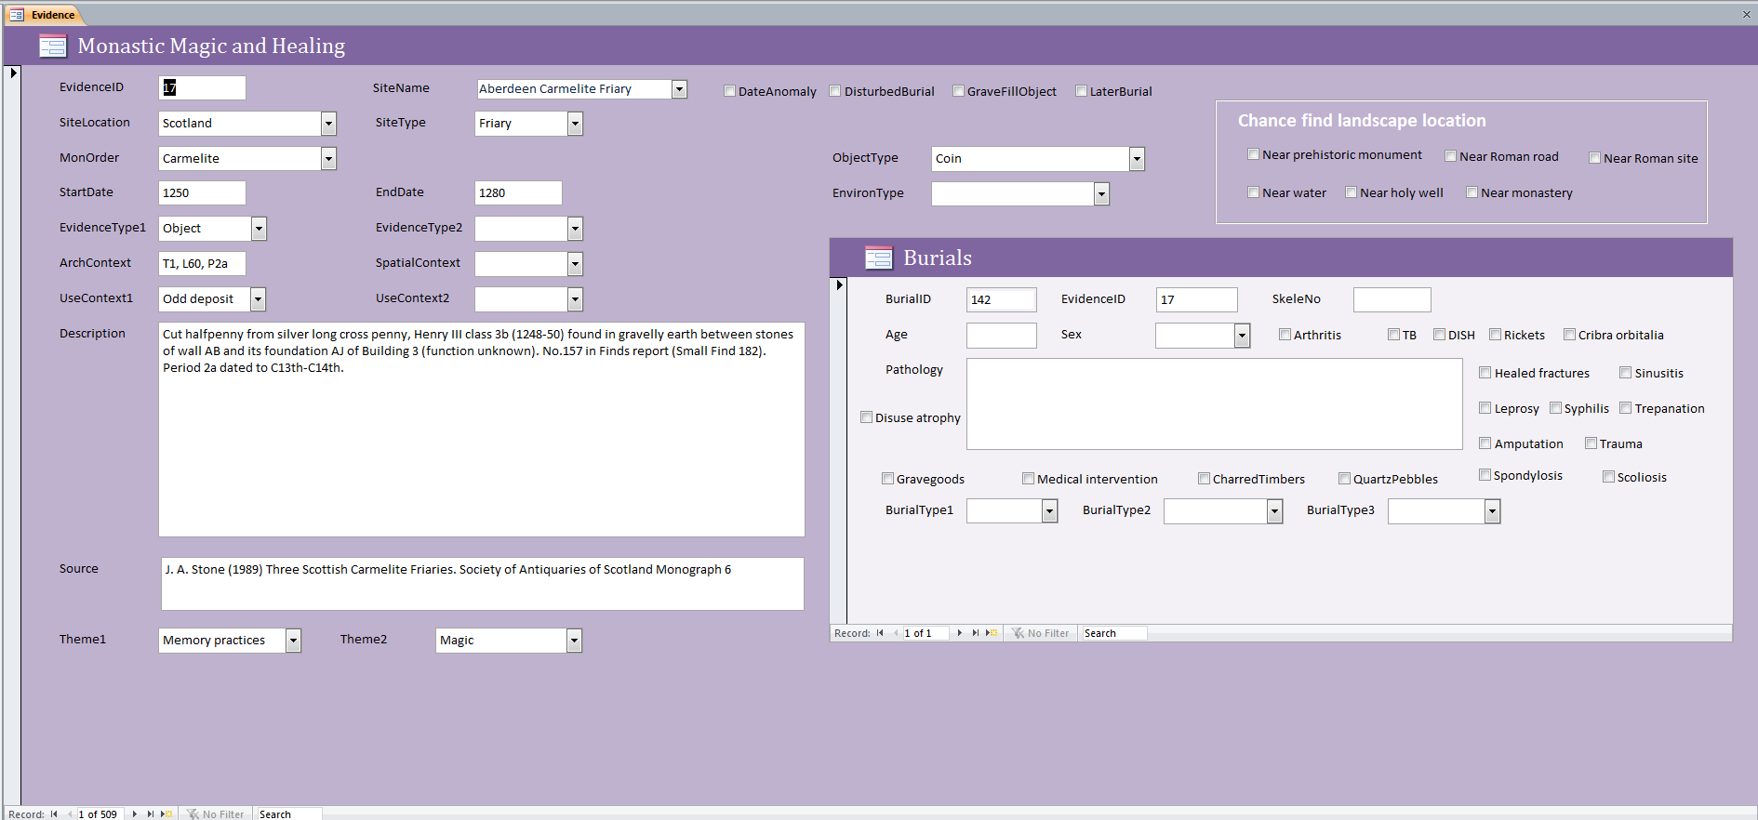

The following information was recorded in the Evidence form: the name of the site, the country the site was in, the type of ecclesiastical site it was and its monastic order (if applicable), a start and end date (if applicable), the type of evidence being recorded, the context given by the excavator (if applicable), its use and spatial context where it was found, the type of object or environmental data (if applicable), a description to provide more information, the source where the evidence was found and any themes that could be assigned to it. Tick boxes were also utilised for evidence that had a date anomaly attached (eg. antique objects found in medieval contexts), to show whether the burial had been disturbed, if an object was from a grave fill, and if an individual had been buried after the Reformation. If a chance find (eg. Scottish Treasure Trove found by metal detecting), then its’ landscape location was recorded. For burials, the information recorded included the skeleton number, age, sex, pathology (if applicable) and type of burial. Tick boxes were utilised to record specific pathologies and to indicate if the burial was interred with grave goods, quartz pebbles or charred timbers.

Queries

The database can be searched by creating Queries based on the information in the tables and forms. For instance, the database can be queried by theme, object type, site name, burial type, date anomaly, etc. Several searches have been saved as queries in the database. They include:

Amulets – data relating to amulets (eg. dress accessories with sacred inscriptions)
GraveGoods – data relating to burials with grave goods
InfantBurials – data relating to infant burials
JetObject – data relating to jet objects
PilgrimSouvenirs – data relating to pilgrim badges and ampulla
QuartzDeposits – data relating to quartz deposits in graves and other contexts

How to use the database

To view the database records select the Evidence form and scroll through using the arrows in the bottom-left corner.

To create a query select Create on the top menu bar and then Query Wizard. A window will appear called New Query. Select Simple Query Wizard from the list on the right-hand side of this window and then click OK.

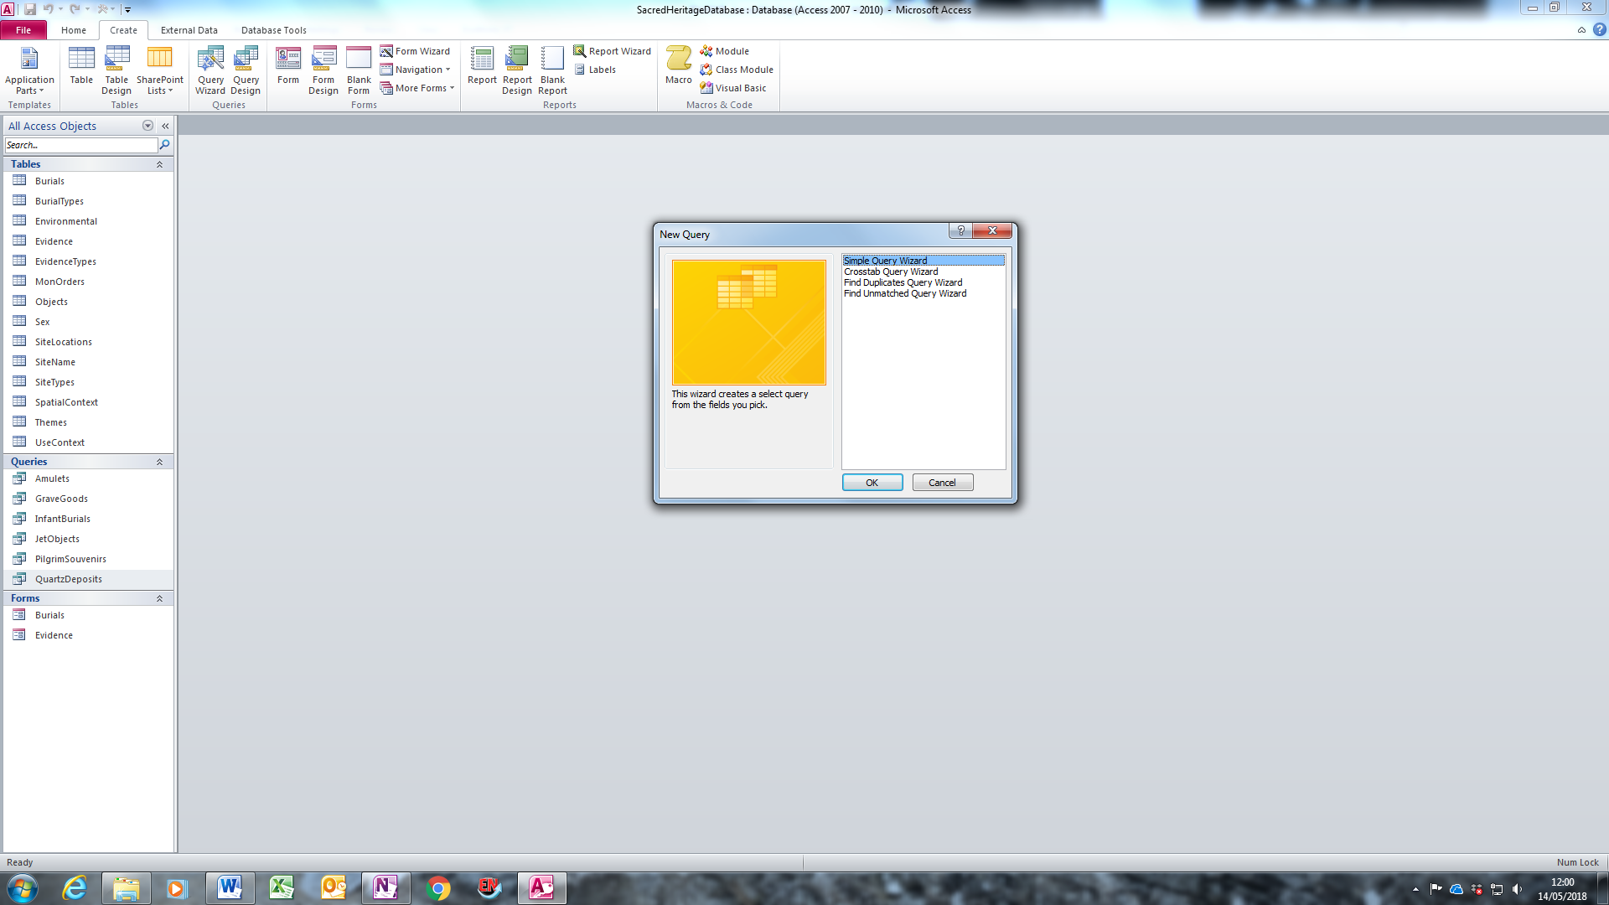

Select the Evidence table from the drop-down menu and a list of the available fields will appear on the left-hand side.

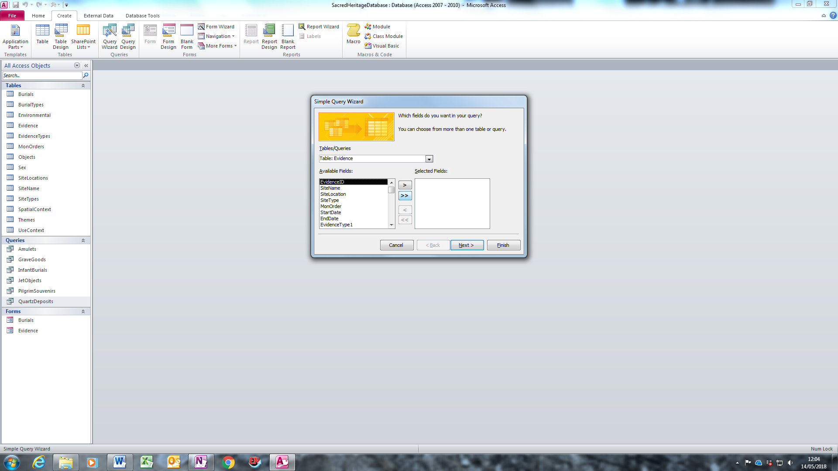

Click on the double arrow to move these fields into the Selected Fields box.
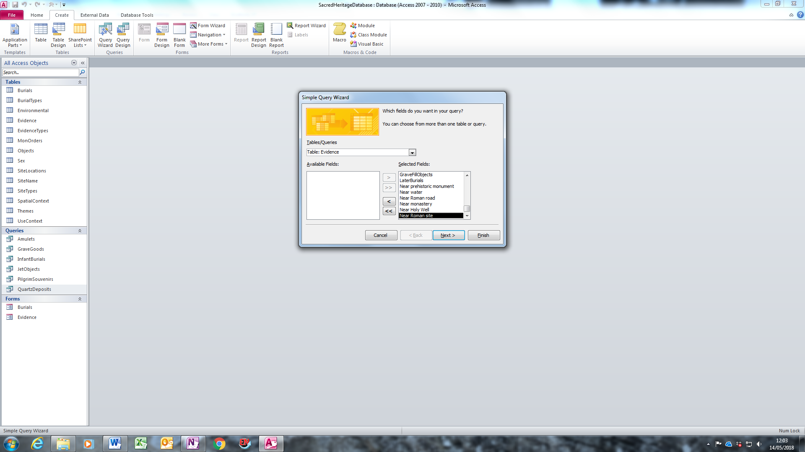

Repeat with the Burials table and click Next.

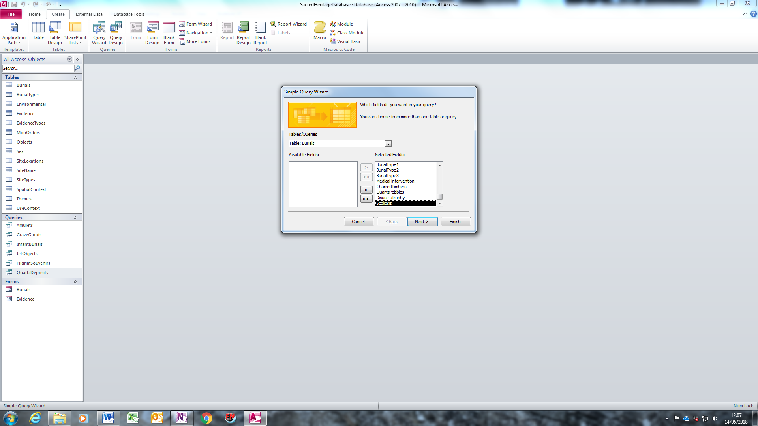

Select Detail (shows every field of every record) and click Next

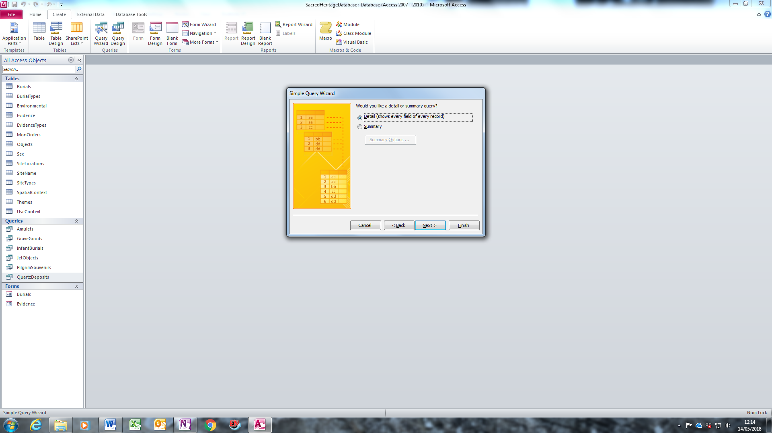

Choose a title for your query and click Finish.

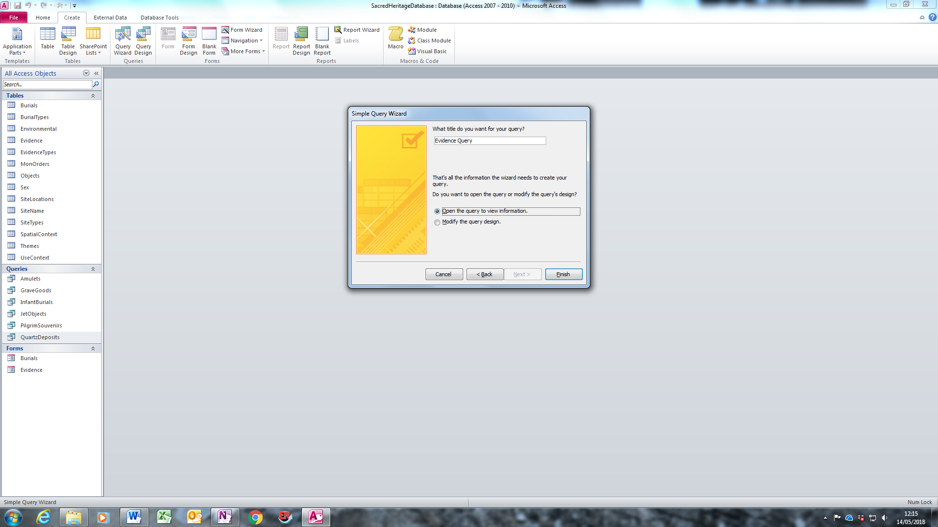

This is what will then appear:
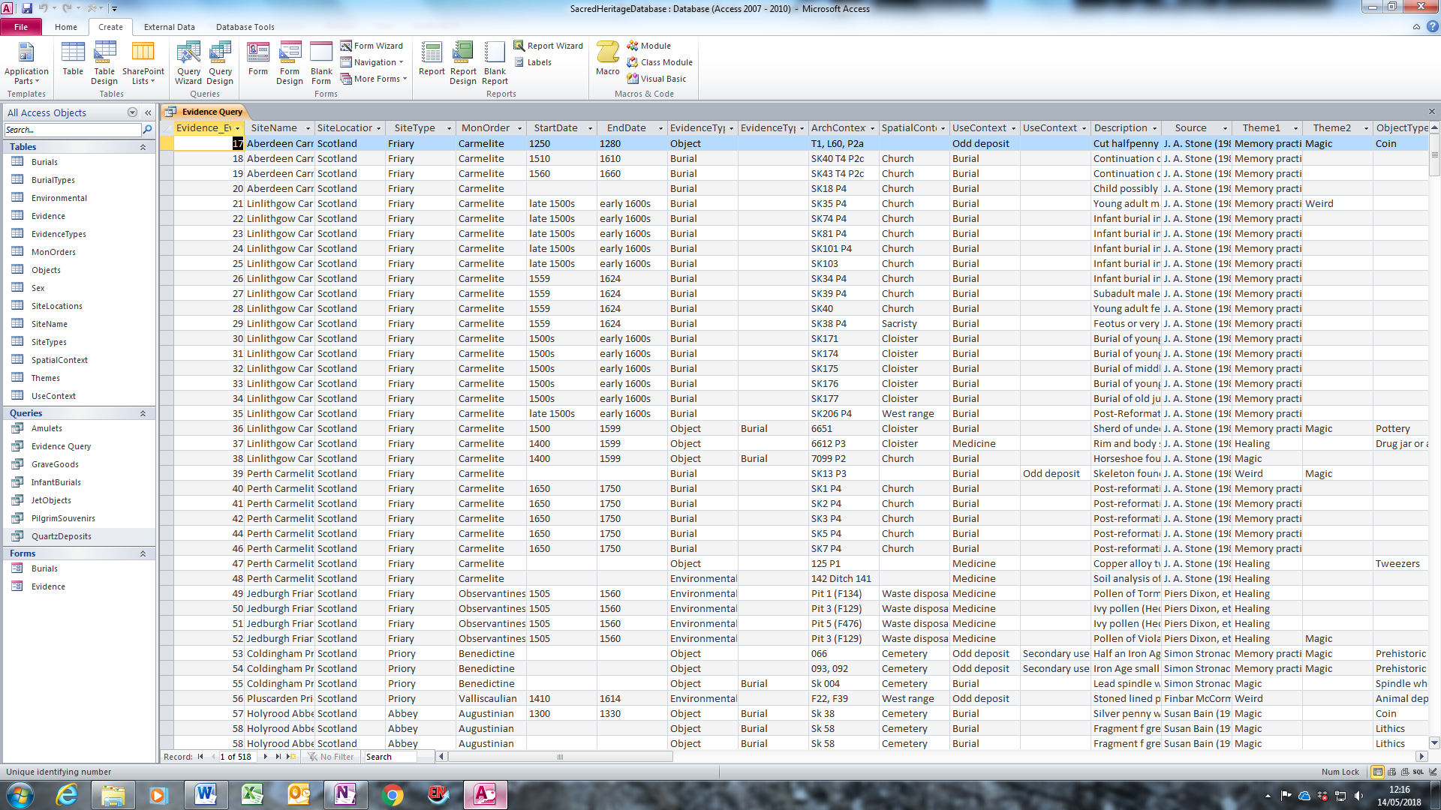

Select Home on the top menu bar and click View in the top left-hand corner:

The Design View will then appear which will allow you to start searching the database:
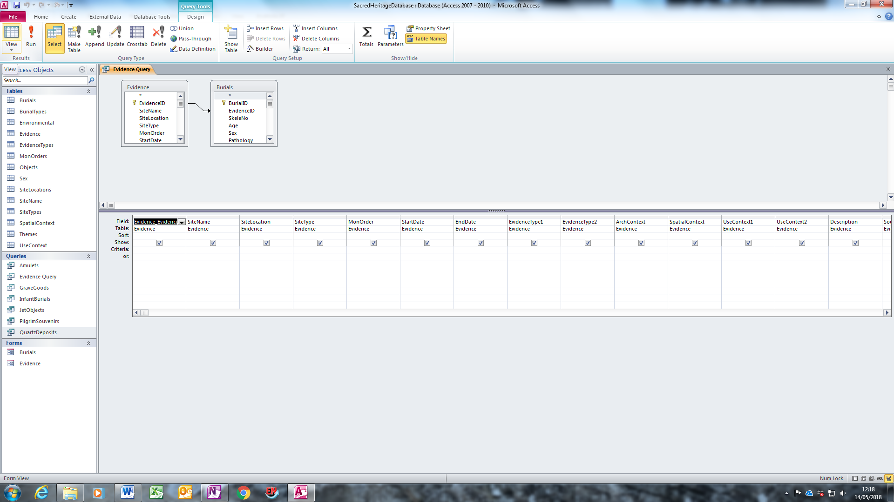

Let’s take an example: you want to see all records of coins found in grave fills.

Type “coin” in the Criteria line under ObjectType and type Yes under GraveFillObjects.

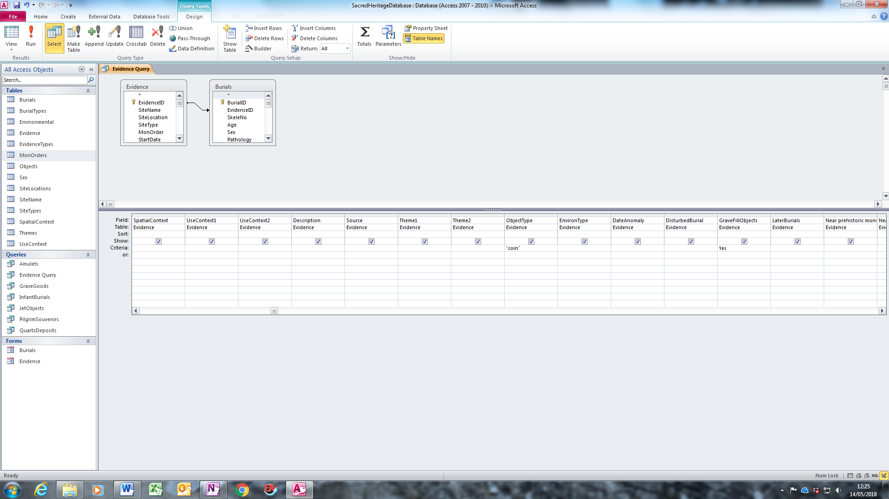

Then select View in the top left-hand corner to view all the fields that meet this criteria:

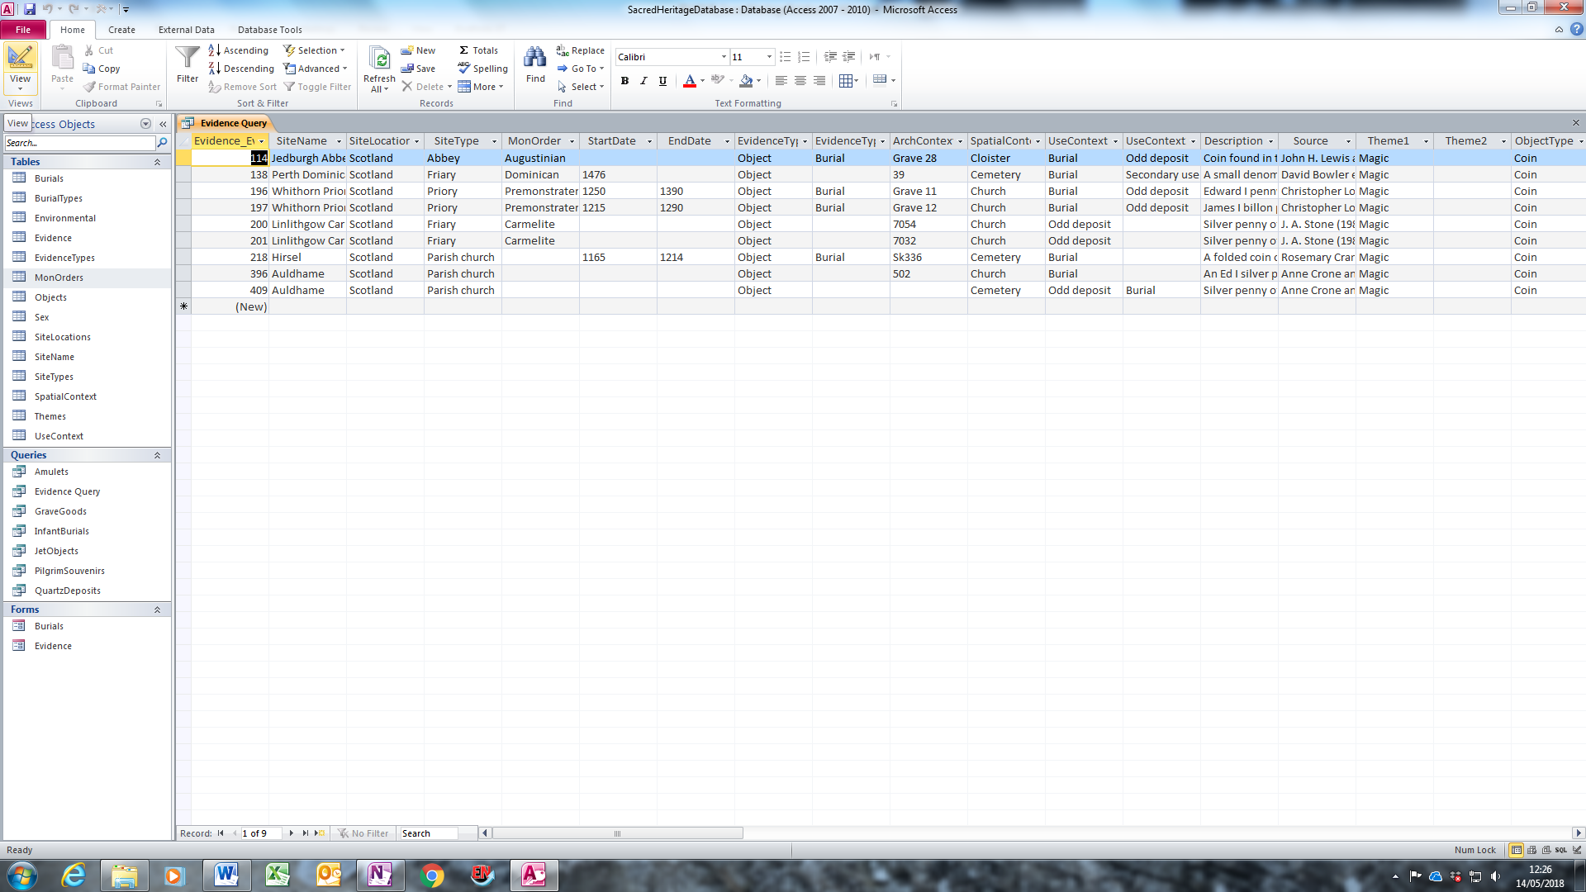

To return back to Design View, click View again.

5. METHOD and PROCESSING

Microsoft Access 2010 was the software used to create the database

Data from this database is discussed in this forthcoming Open Access publication:
Roberta Gilchrist, Sacred Heritage and Monastic Archaeology: Interpreting Medieval Identities and Beliefs (Cambridge: Cambridge University Press, in preparation)

