1. Project

Title: PMIP 2 Diagnostic For Mid-Holocene Precipitation Over Northern Africa
Dates: 2018
Funding organisations: No funder
Grant number: -

2. Dataset

Title: PMIP 2 Diagnostic For Mid-Holocene Precipitation Over Northern Africa
Summary description. Pollen evidence indicates that grassland and xerophytic woodland/scrubland occurred in areas of northern Africa characterised by desert today during the mid-Holocene (Jolly et al., 1998a, 1998b). Mid-Holocene pollen assemblages for sites south of 23° N do not contain taxa with desert affinities (Dominique Jolly, unpublished analyses), indicating that the region south of 23° N was characterised by grassland and not desert. The increase in mean annual precipitation required to support grassland at each latitude from 0 to 30° N compared to the modern precipitation at that latitude, zonally averaged over the range 20° W to 30° E longitude, has been calculated using the water-balance module from the BIOME3 equilibrium vegetation model (Haxeltine and Prentice, 1996) (see Joussaume et al., 1999).
This dataset provides the latitudinal distribution of biomes (reconstructed at individual pollen sites) in northern Africa today and during the mid-Holocene (6000 ±500 yr B.P.) and the maximum and minimum estimates of the increase in precipitation (ΔP) required to support grassland at each latitude. This is visualised in Figure 1. To use this graphic as a model benchmark, simulated changes in ΔP is required to lie above/within the ΔP required to support grassland (grey band in Figure 1) at all latitudes from 0-23° N.
If you wish to use these data as a diagnostic, please give the DOI of this dataset as a citation for the data and cite Joussaume et al. (1999) as the first application.
This dataset is a republication of a dataset first published in 1999. The original URL is no longer accessible and there was no DOI.
Publication year: 2018
Creators: Sandy P. Harrison, Iain Colin Prentice
Organisation: Geography and Environmental Science, University of Reading, UK and Department of Life Sciences, Imperial College London, UK
Rights Holder: University of Reading, Imperial College London

3. Terms of use
This dataset is licensed by the rights-holder(s) under a Creative Commons Attribution 4.0 International Licence: https://creativecommons.org/licenses/by/4.0/.

4. Contents

There are 3 CSV files:
- biomes_used_0ka.csv which contains modern latitudinal distribution of biomes in northern Africa
- biomes_used_6ka.csv which contains mid-Holocene latitudinal distributions of biomes in northern Africa
- precipitation.csv which contains the maximum and minimum estimates of the increase of precipitation required to support grassland at each latitude.

Data visualisation: Figure 1 visualises the data within the 3 CSV files.

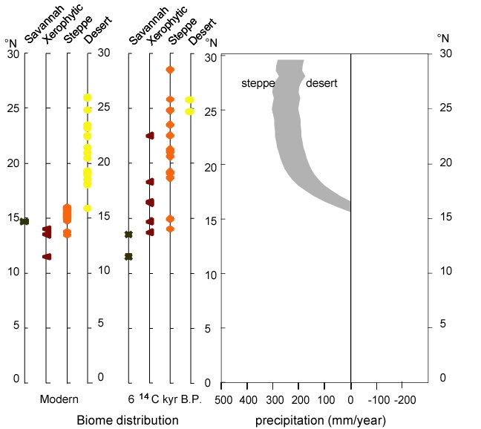
Figure 1. Plot of latitudinal distribution of biomes (reconstructed at individual pollen sites) in northern Africa today and during the mid-Holocene (6000 ±500 yr B.P.), and the maximum and minimum estimates of the increase in precipitation (mm/year) required to support grassland at each latitude.

5. References

- Haxeltine, A., and Prentice, I. C. (1996). BIOME3: An equilibrium terrestrial biosphere model based on ecophysiological constraints, resource availability, and competition among plant functional types. Global Biogeochemical Cycles 10(4), 693-709.
- Jolly, D., Harrison, S. P., Damnati, B., and Bonnefille, R. (1998a). Simulated climate and biomes of Africa during the Late Quaternary: Comparison with pollen and lake status data. Quaternary Science Reviews 17(6-7), 629-657.
- Jolly, D., Prentice, I. C., Bonnefille, R., Ballouche, A., Bengo, M., Brenac, P., Buchet, G., Burney, D., Cazet, J. P., Cheddadi, R., Edorh, T., Elenga, H., Elmoutaki, S., Guiot, J., Laarif, F., Lamb, H., Lezine, A. M., Maley, J., Mbenza, M., Peyron, O., Reille, M., Reynaud-Farrera, I., Riollet, G., Ritchie, J. C., Roche, E., Scott, L., Ssemmanda, I., Straka, H., Umer, M., Van Campo, E., Vilimumbalo, S., Vincens, A., and Waller, M. (1998b). Biome reconstruction from pollen and plant macrofossil data for Africa and the Arabian peninsula at 0 and 6000 years. Journal of Biogeography 25(6), 1007-1027.
- Joussaume, S., Taylor, K. E., Braconnot, P., Mitchell, J. F. B., Kutzbach, J. E., Harrison, S. P., Prentice, I. C., Broccoli, A. J., Abe-Ouchi, A., Bartlein, P. J., Bonfils, C., Dong, B., Guiot, J., Herterich, K., Hewitt, C. D., Jolly, D., Kim, J. W., Kislov, A., Kitoh, A., Loutre, M. F., Masson, V., McAvaney, B., McFarlane, N., de Noblet, N., Peltier, W. R., Peterschmitt, J. Y., Pollard, D., Rind, D., Royer, J. F., Schlesinger, M. E., Syktus, J., Thompson, S., Valdes, P., Vettoretti, G., Webb, R. S., and Wyputta, U. (1999). Monsoon changes for 6000 years ago: Results of 18 simulations from the Paleoclimate Modeling Intercomparison Project (PMIP). Geophysical Research Letters 26(7), 859-862.

