1. ABOUT THE DATASET
------------

Title: Legibility of Chinese-English direction signs: how the spatial presentation of bilingual typography in two different scripts affects sign legibility

Creator(s): Zhang Yuchan

Organisation(s): University of Reading

Rights-holder(s): Zhang Yuchan.

Publication Year: 2022

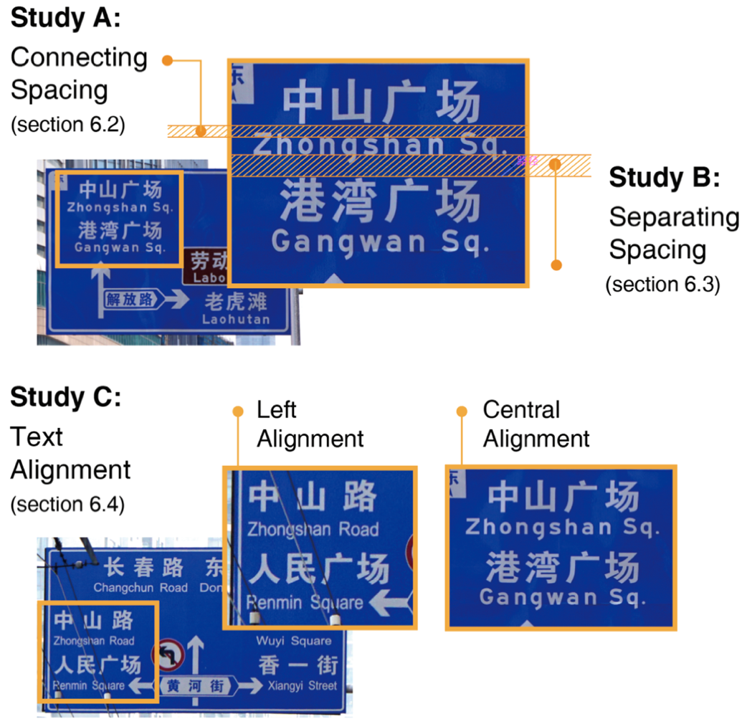
Description: The main research question of this study is how can sign legibility be improved by the spatial presentation of bilingual location name(s) comprised of Chinese and English. Three studies, Study A, B and C, were investigated to examine the effects of adjusting the spatial presentation of Chinese/English legends on the legibility of Chinese-English bilingual traffic signs (cebts). The adjustments included changes in connecting spacing (vertical distance connects Chinese/English into a bilingual legend) (Study A), separating spacing (vertical spacing separates bilingual legends) (Study B), and text alignment (Study C). Figure 1 illustrates the main variables investigated in each study.
Figure 1. The main tested variables in each study and illustrated on the photographed sign samples. Illustrated by the author and the samples were photographed by the author, Dalian, 2018.
In particular, Study A was designed to test if adjustments to connecting spacing (4 levels, 1/6H, 1/3H, 1/2H, and 3/4H) affect sign legibility. It also looked at sign complexity (2 levels, simple and complex) and length of English information (3 levels, 8 letters, 10 letters, and 12 letters) to investigate the effects of the connecting spacing according to these two factors. Study B aimed to determine whether the separating spacing (3 levels, 0.5H, 0.75H, and 1H) has an impact on sign legibility and, if it has an impact, explored how large the space between bilingual place names should be. It also examined whether the separating spacing changes according to sign combination (refers to an association that joins sign complexity, the total number of place names on a sign, and the number of place names per direction indicated), and 10 sign combinations (A1-A2. B1-B3, C1-C5) (see Figure 2 on the last page of this document) were tested. Study C aimed to evaluate whether there is a difference between the two alignments of the bilingual location names, central- or left-aligned, in the legibility of cebts. If differences are found, it will also consider which one could improve sign legibility. Study C was made up of Study C-I and Study C-II. Study C-I aimed to investigate whether the difference between the two alignments may relate to the levels of separating spacing (0.5H and 0.75H were tested). Study C-II aimed to explore whether the two alignments may cause a significant difference in sign legibility without the impact of separating spacing. The dataset records the response times and accuracy of the participants reading the stimuli.

Cite as: Zhang Yuchan (2022): Legibility of Chinese-English direction signs: how the spatial presentation of bilingual typography in two different scripts affects sign legibility. University of Reading. Dataset. https://doi.org/10.17864/1947.000379.

Related publication: Zhang, Y. (2021). Effects of text space of Chinese-English bilingual traffic sign on driver reading performance. Displays, 67, 102002.
Zhang, Y. Effects of the vertical spacing of a two-line bilingual legend in two different scripts. Information Design Journal, 2021. (Submitted).

Contact: zhangyuchaneasd@gmail.com

2. TERMS OF USE
-----------------

Copyright 2022 Zhang Yuchan. This dataset is licensed under a Creative Commons Attribution 4.0 International Licence: https://creativecommons.org/licenses/by/4.0/.

3. PROJECT AND FUNDING INFORMATION
------------

Title: Legibility of Chinese-English direction signs: how the spatial presentation of bilingual typography in two different scripts affects sign legibility

Dates: 17-09-2017 to 29-04-2022

Funding organisation: China Scholarship Council

Grant no.: 201808060296

This research is funded by the China Scholarship Council, which is gratefully acknowledged. Zhang Yuchan is the copyright owner of this dataset.

4. CONTENTS
------------
File listing

It contains a README file providing a detailed description of the dataset.

Three text files are Participant Information and Consent Forms used in participant recruitment, and they are:
STUDY_A_Info_Consent_Form.docx
STUDY_B_Info_Consent_Form.docx
STUDY_C_Info_Consent_Form.docx

Each Study contains two SPSS files recording the response times and accuracy separately. And they are:
STUDY_A_ResponseTime.csv
STUDY_A_Accuracy.csv
STUDY_B_ResponseTime.csv
STUDY_B_Accuracy.csv
STUDY_C_ResponseTime.csv
STUDY_C_Accuracy.csv

5. METHODS
--------------------------
The approach to the three Studies was a threshold method combined with a search task and accuracy check. Participants were asked to indicate which direction they might take by viewing a series of video stimuli and making an immediate response when they had identified each target. The stimuli simulated the view a driver would have on a road in which they were driving towards a road sign at consistent speed. The response time and accuracy were recorded.

In Study A, a within-subject design was used. It was evaluated under two sign complexities (simple and complex). In each complexity, three levels (8 letters, 10 letters, and 12 letters) of English text length are tested, and each length level is tested by using four levels of connecting spacing (1/6h, 1/3h, 1/2h, and 3/4h). In total, there are 24 (2×3×4) combinations and each combination is presented four times in a different random order for each participant, resulting in a total of 96 stimuli to be presented to each participant. Study A recruited 40 participants (see Table 1) and took around 40 minutes per participant, including short breaks in the session.

Table 1. The number of participants recruited for each age and the distribution of the drivers and non-drivers.
18-25 years old |  | 25-55 years old |  | Above 55 years old
Driver | Non-driver | Driver | Non-driver | Driver | Non-driver
3 | 5 | 20 | 9 | 2 | 1

In Study B, 39 participants who met the age requirements (25-55 years old) were recruited. A between-subject factorial design was prepared. 39 participants were systematically allocated to three groups, each with 13 participants. Each group received a different ‘separating spacing condition’:
- 0.5h group: participants viewed all 10 sign combinations with 0.5h separation;
- 0.75h group: participants viewed 10 sign combinations with 0.75h separation;
- 1h group: participants viewed 10 sign combinations with 1h separation.

In Study C, 36 participants were recruited in total, and they did both Study C-I and C-II; C-I was followed by C-II for all participants. In Study C-I, the participants’ tasks were tested in three levels of sign complexity separately. In each condition, the two alignments (central-aligned and left-aligned) and the two levels of separating spacing (0.5h and 0.75h) were tested. Study C-I used a within-subject and between-subject mixed design. All 36 participants viewed both alignment groups: reading stimuli where the location names were central-aligned and also reading stimuli where the location names were left-aligned. The order in which participants received each stimulus was random, with the 36 participants being systematically split into two groups: (a) 18 participants were shown both alignments under 0.5h separation (b) another 18 participants were shown both alignments under 0.75h separation. Each stimulus was presented three times to each participant. In Study C-II, 36 participants performed a cross-over design by receiving six stimuli resulting of two alignments across three levels of sign complexity (2×3). Each stimulus was presented only once to each participant, and the stimuli were displayed in random order.
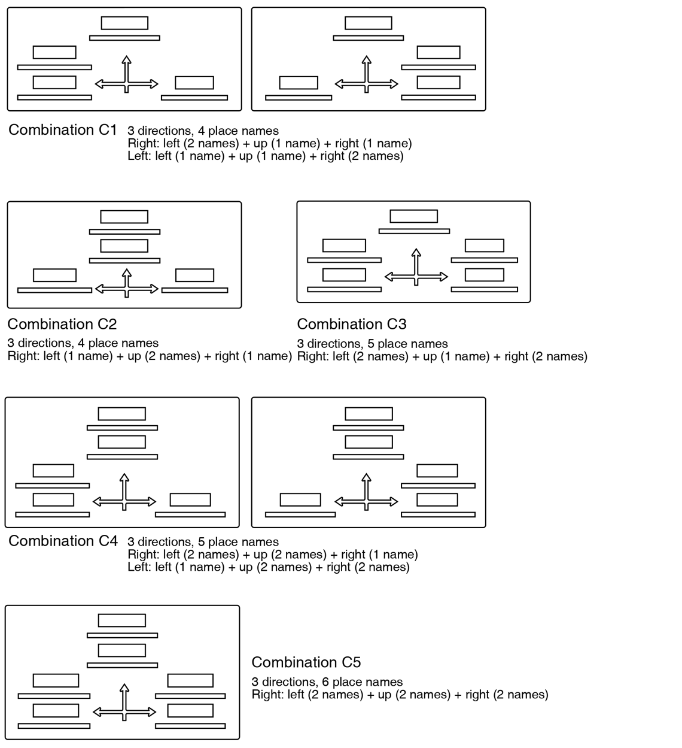
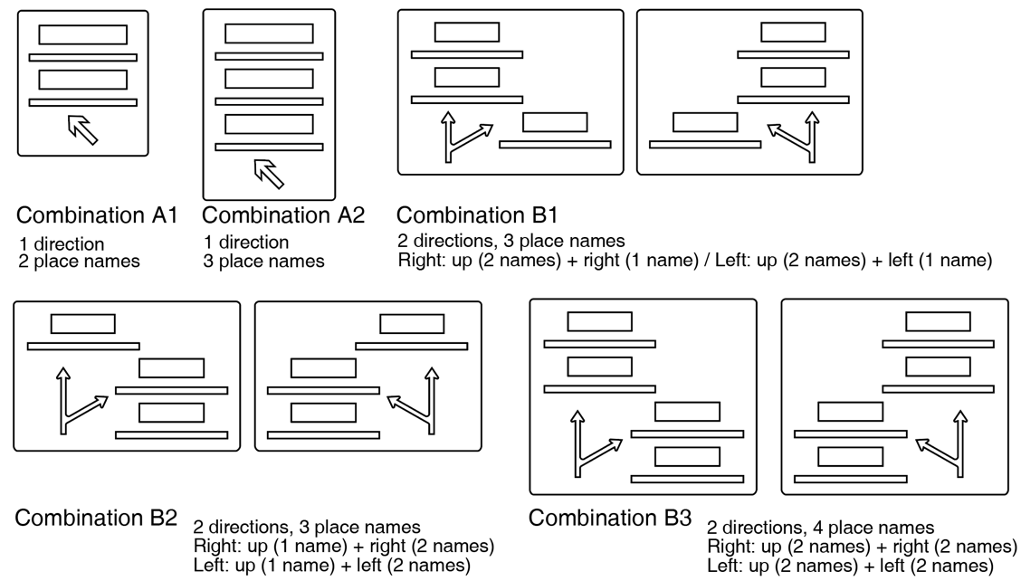
Figure 2. Mapping out all possible combinations of total number and direction number across three sign complexities and excluding the simplest combinations. Drawn by the author.
Figure B. Mapping out all possible combinations of total number and direction number across three sign complexities and excluding the simplest combinations. Drawn by the author.

H refers to the height of one Chinese character.

