1. ABOUT THE DATASET

Title: Mid-career Academic Women in Higher Education in China: Barriers and Strategies.

Creator(s): Zhao Jiayi (https://orcid.org/0000-0003-0411-2627)

Organisation(s): University of Reading

Rights-holder(s): Zhao Jiayi

Publication Year: 2022

Description: In order to explore the barriers and difficulties that present in the progression to senior leadership positions of mid-career academic women in Chinese higher education, a sequential mixed method was adopted in this research. This dataset contains the results of an online questionnaire with a sample of 391 academic career women in Chinese higher education. The quantitative data was analysed through SPSS version 23.

Cite as: Zhao, Jiayi (2022): Mid-career Academic Women in Higher Education in China: Barriers and Strategies. University of Reading. Dataset. https://doi.org/10.17864/1947.000425

Contact: datemtwtfss@hotmail.com

2. TERMS OF USE
------------
Copyright 2022 Zhao Jiayi. This dataset is licensed under a Creative Commons Attribution 4.0 International Licence: https://creativecommons.org/licenses/by/4.0/.

3. PROJECT AND FUNDING INFORMATION
This dataset was not created in the course of a funded project, and was created as part of the researcher’s PhD research.

4. CONTENTS
------------
File listing

A questionnaire in both English and Chinese:

JZ_Questionnaire.docx

Two files containing the results of the questionnaire, one generated in SPSS version 23, and one exported in .csv format:

JZ_QuestionnaireData.sav
JZ_QuestionnaireData.csv

5. METHODS
-----------
This research was designed in the mixed methods field, and the explanatory sequential mixed methods were chosen in this study. This research began with a questionnaire survey in China mainland universities, and the questionnaire was disseminated online via the WJX website (the link to this questionnaire has expired, so the visit will be refused, a Chinese/English copy of the questionnaire is included). The questionnaire was published online from 29/04/2019 to 17/07/2019. By using the snowball sampling method, finally, 395 female academics’ responses were collected, among which, 391 copies were valid. The replies came from 32 provinces, autonomous regions or municipalities in China mainland, and their age ranged from 24 to 60 years old. Please refer to the following figure about the distribution of the female teachers participating in the survey from different regions:

Figure 1. The Distribution of Questionnaire Respondents' Regions
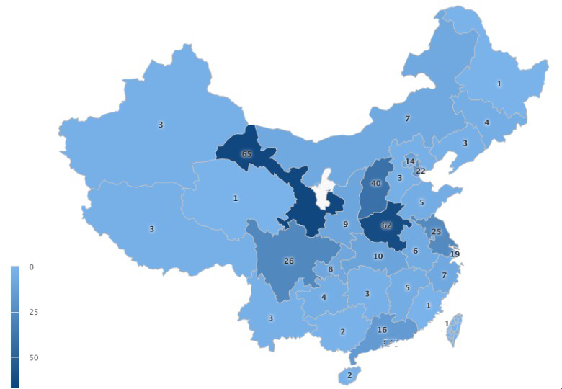

After the data collection, the questionnaire data was sorted and imported in SPSS version 23 to analysis, and descriptive and inferential statistics were utilised to analyse the data. All data will be used to write a doctoral thesis and subsequent written reports and articles, as well as presented at national and international conferences.

